Epithelial sheets form specialized 3D structures suited to their physiological roles, such as branched alveoli in the lungs, tubes in the kidney, and villi in the intestine. To generate and maintain these structures, epithelia must undergo complex 3D deformations across length and time scales. How epithelial shape arises from active stresses, viscoelasticity, and luminal pressure remains poorly understood. To address this question, we developed a microfluidic chip and a computational framework to engineer 3D epithelial tissues with controlled shape and pressure. In the setup, an epithelial monolayer is grown on a porous surface with circular low adhesion zones. On applying hydrostatic pressure, the monolayer delaminates into a spherical cap from the circular zone. This simple shape allows us to calculate epithelial tension using Laplace’s law. Through this approach, we subject the monolayer to a range of lumen pressures at different rates and hence probe the relation between strain and tension in different regimes while computationally tracking actin dynamics and their mechanical effect at the tissue scale. Slow pressure changes relative to the actin dynamics allow the tissue to accommodate large strain variations. However, under sudden pressure reductions, the tissue sdevelops buckling patterns and folds with different degrees of symmetry-breaking to store excess tissue area. These insights allow us to pattern epithelial folds through rationally directed buckling. Our study establishes a new approach for engineering epithelial morphogenetic events.

*Keywords*: epithelial monolayers, actomyosin cytoskeleton, morphogenesis, mechanobiology, microfluidics

# Introduction and motivation

The central focus of this thesis is the epithelial tissue monolayer. From the perspective of a mechanical engineer, these monolayers are endlessly fascinating. They are remarkable in their ability to change shape, self-heal, and continuously deform or jam as needed (Xi et al. 2018). They represent the simplest system for gaining a physical understanding of biological morphogenesis, as epithelia can be found everywhere in the body, covering the skin and lining various cavities and organs. The shapes of epithelial monolayers can range from simple spherical blastocysts to highly branched and folded lungs, and they are formed and maintained through constant adaptation and renewal. This thesis aims to explore the physical principles behind epithelial shape by combining theoretical and experimental approaches in the study of simple epithelial monolayers.

The chapters in this part serve as a comprehensive overview of all the key topics related to my PhD research. They begin with a brief introduction to epithelial tissues and their constituent parts, followed by a discussion on the role of mechanics in morphogenesis and various modeling approaches. This part concludes with a review of the growing field of "bottom-up" morphogenesis, where researchers are building biological systems from scratch.

## Epithelial Layers

### Introduction



**The Anatomy Lesson of Dr. Frederik Ruysch**, 1670 by Adriaen Backer. (Adriaen Backer Wikipedia 1670)

The term “epithelia” was first introduced by Dutch botanist Frederick Ruysch in the early 18th century (see fig 1.1). He used it to describe the tissue he observed while dissecting the lips of a cadaver, and the word is derived from Greek roots “epi,” meaning top, and “thele,” meaning nipple. [1] A few decades later, Swiss scientist Albrecht von Haller began using the term “epithelium/epithelia” to describe the fibers of the body, following the old Renaissance theory that the body was made of fibers, which were believed to be a fundamental building block of living things. [2] It was thought that these fibers and tissues arranged in different arrays gave rise to biological structures (MacCord 2012; Zampieri, Coen, and Gabbiani 2014). This theory was not far off, as epithelial tissues make up more than 60% of the cells in a vertebrate’s body and are found ubiquitously, covering the organs both inside and out (Alberts 2015).

r5cm

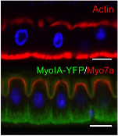

Epithelial cells are polarized, i.e., their apical side (typically facing the lumen of the organ), which differs in shape and composition from the basolateral side (see fig [fig_1_2]). Its polar organization is reflected in the vectorial functions like creating and maintaining concentration gradients between separated compartments (Marchiando, Graham, and Turner 2010). Typical examples of these are transporting epithelia such as those of the renal tubule, absorptive epithelia of the intestine, and secretory epithelial cells like hepatocytes (Alberts 2015). In addition, polarized epithelia guide the developmental process by determining the fate of cells leading to symmetry-breaking events in the embryo (Kim, Korotkevich, and Hiiragi 2018).

### Key components

The function of epithelia primarily depends on the tissue’s structure and the surrounding microenvironment. It can be divided into three aspects: cell structure, microenvironment, and cell-matrix interactions.

#### Cell structure

The cell cytoskeleton plays a crucial role in maintaining cell shape and supporting vital functions such as cell division and migration (Alberts 2015). The Eukaryotic cell cytoskeleton is composed primarily of filamentous proteins, including three main types of filaments that differ in size and protein composition: microtubules, actin filaments, and intermediate filaments (see fig 1.2). Microtubules, with a diameter of approximately 25 nm, are the largest and made of the protein tubulin. Actin filaments, with a diameter of only 6 nm, are the smallest. Intermediate filaments, with a diameter of around 10 nm, are composed of several different subunit proteins and have a diameter intermediate between the other two types (Mofrad 2009). All three filament types dynamically respond to signals from the microenvironment and cell networks.

Mechanically, actin filaments have higher extensional stiffness than microtubules but break at lower extensions. Intermediate filaments have intermediate extensional stiffness and can sustain larger extensions while showing a nonlinear stiffening response (Wen and Janmey 2011). Differences in strength and stability arise from the properties of individual subunits. The persistence length can range from $1μm$ for intermediate filaments to $1mm$ for microtubules (Fletcher and Mullins 2010). Actin filaments, most relevant to this thesis, have a persistence length of a few microns.

The assembly and disassembly of these filaments are dictated by the dynamics of their macromolecular components and accompanying proteins. The combination of actin filaments and myosin motors forms the actomyosin cortex, which is essential in producing intra- and intercellular forces. In an epithelial tissue, the actomyosin cortex and intercellular junctions make cell-to-cell contacts stronger and provide tissue integrity (Braga 2016) (see fig 1.3). A good example of these tissue-level structures can be observed in wound healing assays, where cells surrounding the wound create a ring of actin to close it (Brugués et al. 2014). In Chapter 3, we will delve into the actomyosin network in more detail.

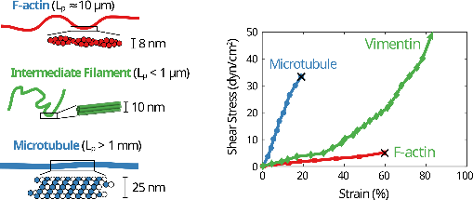

**Mechanics of cytoskeletal filaments**: Schematic and sizes of actin filaments, intermediate filaments and microtubules; along with the strain response to shear stress. *Adapted from (Leggett et al. 2021)*

Multiple membrane molecules can facilitate cell adhesion, including cadherins. Cadherins are a crucial component for epithelial cell cohesion and the formation of adherens junctions, which transmit forces between cells. This key factor is involved in the mechanical regulation of cell division and tissue rearrangement during development and homeostasis (Godard and Heisenberg 2019; Mertz et al. 2013). Desmosomes, another type of intercellular junction, are coupled with intermediate filaments and provide mechanical resilience to cell layers (Hatzfeld, Keil, and Magin 2017; Latorre et al. 2018). Tight junctions serve as a barrier and regulate the active transport of ions across epithelial layers, playing an important role in controlling fluid pressure in tissues (Marchiando, Graham, and Turner 2010; Chii J. Chan and Hiiragi 2020).

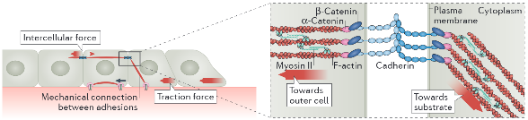

**Intercellular forces through actomyosin cables and cadherins**: Schematic showing mechanical connections between adhesions and tissue force transmission with actomyosin cytoskeleton and adhesion proteins. *Adapted from (Ladoux and Mège 2017)*

#### Microenvironment

The extracellular matrix (ECM) is the substrate or cell environment to which cells adhere. It is also referred to as the matrix, mesenchyme, or cellular microenvironment. The ECM serves many functions. It endows tissues with strength, thereby maintaining their shape. Additionally, it serves as a biologically active scaffolding that allows cells to migrate or adhere. The ECM also plays a role in regulating the phenotype of cells. It provides an aqueous environment that facilitates the diffusion of nutrients, ions, hormones, and metabolites between the cell and the capillary network (Alberts 2015).

Moreover, the ECM is subjected to mechanical forces such as blood flow in endothelia, air flow in respiratory epithelia, or hydrostatic pressure in the mammary gland and bladder (Waters, Roan, and Navajas 2012; Walma and Yamada 2020). It has been shown that the ECM regulates cell shape, orientation, movement, and overall function in response to biophysical forces (Alberts 2015).

The ECM is a fibrous network of proteins, consisting of collagen, elastin, and proteoglycans as its primary structural components. Collagen is one of the most abundant proteins in the body, while elastin is the most elastic and chemically stable protein. Proteoglycans can sequester significant water as well as growth factors and proteases. The water content of the ECM allows it to deform as a poroelastic material, absorbing water upon stretching and releasing it under compression, causing a hydraulic fracture effect (Casares et al. 2015). The collagen network can also remodel under the influence of cells and mechanical forces (Humphrey, Dufresne, and Schwartz 2014).

Most ECM components undergo continuous turnover, some quickly and some slowly. For example, the half-life of collagen in the periodontal ligament is a few days, whereas that in the vasculature may be several months (Humphrey, Dufresne, and Schwartz 2014). In response to altered physical stimuli, disease, or injury, the rates of collagen synthesis and degradation can increase many times, allowing for a rapid response.

#### Cell-Matrix interaction

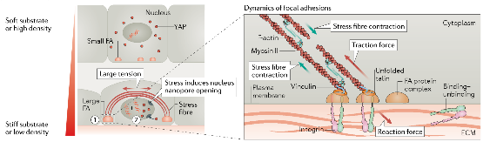

**Cell-matrix interaction with respect to matrix stiffness and cell density**: In higher tension condition, the nucleus is deformed triggering mechanotransduction and causing alterations in cytoskeleton and tractions. *Adapted from (Xi et al. 2018)*

The cells and the extracellular matrix (ECM) are in a dynamic relationship, constantly exchanging information and influencing each other. The cells sense the biophysical cues in the ECM through sensors such as integrins and focal adhesion complexes, which are responsible for cell-substrate adhesion (Kechagia, Ivaska, and Roca-Cusachs 2019) (see fig 1.4). These adhesions allow cells to respond to various stimuli such as matrix stiffness, ligand density, and chemotactic gradients (Fortunato and Sunyer 2022). It has also been shown that cells can respond to the viscoelasticity of the matrix (Elosegui-Artola et al. 2022).

In addition to sensing the ECM, cells also contribute to its composition by secreting ECM components or remodeling the substrate (Malandrino et al. 2018). This interplay between the cells and ECM can impact the tissue behavior fundamentally, as the connections between focal adhesions and the nucleus can affect the expression of transcriptional factors (Venturini et al. 2020; Lomakin et al. 2020). The precise control of cell-cell and cell-substrate interactions enables cells to transform into intricate shapes, such as curved forms in cell sheets (Schamberger et al. 2022).

### Role in disease and development

Maintaining epithelial integrity and homeostasis is crucial for survival, and mechanisms have evolved to ensure these processes are sustained during growth and in response to damage. Epithelial cells have one of the fastest turnover rates in the body, with the entire gut cell lining turning over in 5–7 days (Barker 2014). This constant cell division and death pose a risk for tumor formation; it is know that 90% of cancers emerging in simple epithelia (Torras et al. 2018; Eisenhoffer and Rosenblatt 2013). Additionally, the high rate of cell turnover can disrupt the barrier function, as gaps should not emerge around dividing or dying cells.

If the fluid compartmentalization goes awry, it can have profound implications for epithelial and stromal homeostasis, fluid and electrolyte balance, and the development of inflammatory states. Several bacterial toxins are known to target junctions, causing changes in the tight junction protein ZO1, which compromises the barrier function and leads to pathologies such as diarrhea and colitis (Fasano et al. 1991). In cancer, the compromised ZO1 barrier is essential to allow metastatic cells to break into and out of blood vessels. The leaky barrier also enables a growing epithelial tumor to access luminal fluids as an additional source of nutrients (Mullin et al. 2005).

Furthermore, epithelia participate in physiological events such as epithelial–mesenchymal transition (EMT), which is a developmental process where epithelial cells gradually transform into mesenchymal-like cells by losing their epithelial functionality. EMT plays a vital role in normal biological functions such as repair and differentiation, as well as abnormal pathological activity such as organ fibrosis and promoting carcinoma progression (Alberts 2015). EMT endows cells with stem cell properties, enabling cell migration to distant organs and subsequent differentiation into multiple cell types during development and the initiation of metastasis (Thiery et al. 2009).

Epithelia undergo drastic shape changes with deformation and reorganization from the embryonic to the adult stage. It’s not surprising that any malfunction in this process can lead to damage and disorder, resulting in congenital malformations, which are a major cause of infant mortality worldwide (Clarke and Martin 2021). Additionally, epithelial dysfunction is a precursor to diseases such as chronic obstructive pulmonary disease, asthma, cystic fibrosis, and pulmonary fibrosis (Carlier, de Fays, and Pilette 2021).

### Forms of epithelia

The structure and arrangement of epithelial cells are crucial for maintaining the integrity and homeostasis of tissues and organs (see fig 1.5). Simple epithelia are single-cell layers where all cells come in contact with the underlying basal lamina and have a free surface on the apical side. The shape of the cells can vary, ranging from flat to cuboidal to columnar. Stratified epithelia, on the other hand, have two or more layers of cells. Additionally, there are pseudostratified epithelia, which appear to be stratified, but are monolayers where the cell nuclei are positioned in a manner that gives the appearance of a stratified epithelium.

The classification of epithelia was first established in the XIXth century based on their structure and physiological characteristics. Germ layer theory, developed by embryologists, further expanded the epithelial nomenclature (MacCord 2012). During early embryogenesis, three layers emerge: endoderm, mesoderm, and ectoderm. The ectoderm forms the epithelia lining the skin, mouth, and nervous system, while the endoderm gives rise to the digestive tract, respiratory system, and liver. The mesoderm, in turn, develops the endothelia covering much of the circulatory and lymphatic systems.

It is important to note that not all tissues classified as epithelia, mentioned in this thesis, are purely composed of epithelial cells. They may be a mixture of different cell types that have epithelial-like characteristics. The focus of this thesis is on packed cell monolayers, which can form and self-organize into various 3D shapes, ranging from simple spheres to complex branched tubules. The thesis will explore the role of mechanics in epithelial morphogenesis.

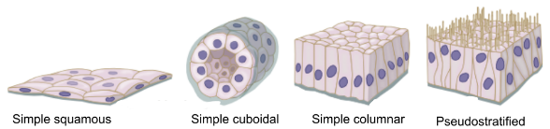

**Forms of epithelial tissues**: Simple squamous, cuboidal, columnar epithelia and pseudostratified epithelia. *Adapted from (“Animal Tissues. Covering Epithelium. Atlas of Plant and Animal Histology.” n.d.)*

## The mechanical basis of Morphogenesis

### The complexity of the morphogenesis

Epithelial cells play a crucial role in the formation of transient structures during embryonic development, such as the neural tube, somites, and precardiac epithelium, which serve as the precursor for the development of complex organs. During this process, different types of epithelia acquire distinct morphological forms and perform specific functions, including branched lungs, looped gut, kidney tubules, thyroid follicles, and sinusoids in the liver. The regulation of epithelial morphogenesis is a complex and hierarchical process that involves coordinated events at multiple spatial and temporal scales (Trepat and Sahai 2018).

Some processes appear to be happening fast at the local level, such as cell shape changes through apical constrictions, which lead to global changes, such as the formation of a ventral furrow in a Drosophila embryo (Martin, Kaschube, and Wieschaus 2009). At the same time, chemical signaling events that activate these processes are slow and occur at a global level. The same complexity can be seen in *in vitro* systems, where a cluster of dissociated stem cells can assemble into an organoid or gastruloid and undergo global folds in response to appropriate culture conditions (Collinet and Lecuit 2021).

The underlying mechanisms of epithelial morphogenesis are intricate and involve multiple factors, including genes responding to morphogen gradients, molecular machinery involved in apical constriction, and mechanical stresses that cause tissue-scale deformations. To fully understand the phenomenon of epithelial morphogenesis, it is essential to study these processes in detail, at multiple levels of complexity (Schöck and Perrimon 2002; Lecuit, Lenne, and Munro 2011).

Rudolf Virchow’s third tenet of the cell theory states that “omnis cellula e cellula,” meaning “all cells come from cells” (Virchow et al. 1860). [3] Although all tissues originate from cells that contain essentially the same genetic information, each tissue has a distinct architecture and function. This raises several questions, such as: what makes cells different from each other? Are differences due to genes, environmental factors, or both? What drives shape changes in tissue morphogenesis? Over the last two centuries, the field of developmental biology has addressed many of these questions, but it has also raised new issues and left others unanswered.

Until last decade, the focus of the field had been on tracking and mapping patterns of cell movements to patterns of gene or protein expression (Gorfinkiel and Martinez Arias 2021). While these studies are influential and important for understanding morphogenetic patterns, they fall short in explaining how cells and tissues are physically shaped (Veenvliet et al. 2021; Odell et al. 1981). This is because the physical understanding of tissues has been limited to kinematic descriptions, which only describe tissue deformation or cell motion. However, we know that cells and tissues actively drive shape changes and movements through the generation of mechanical forces (Lecuit, Lenne, and Munro 2011). Thus, to have an integrated understanding of morphogenesis, we must consider the role of forces and mechanics.

### On growth and form

Throughout history, the form of both animate and inanimate objects has been closely linked to their intended function. In fact, the XXth century architecture principle “Form Follows Function” highlights the idea that the organization of a structure should be based on its intended purpose. Similarly, in developmental biology, self-assembling systems such as intestinal organoids, cancer spheroids, and gastruloids are perfect examples of this principle in action, as each structure emerges from a set of cells in a suitable environment, adapting to perform a specific biological function (Nikolce Gjorevski et al. 2016; Ishiguro et al. 2017; Morizane and Bonventre 2017; Vianello and Lutolf 2019).

However, the opposite design principle appears to be at work in numerous *in vitro* experiments that involve a controlled cellular environment. In such experiments, geometric constraints appear to drive biological function (Xi et al. 2018). For instance, seeding stem cells in a bio-printed three-dimensional geometry of the gastrointestinal tract led to the production of functional tissues with physiological characteristics of the intestine. The curvature of the structure can even control the formation of villus-like structures (Brassard et al. 2021).

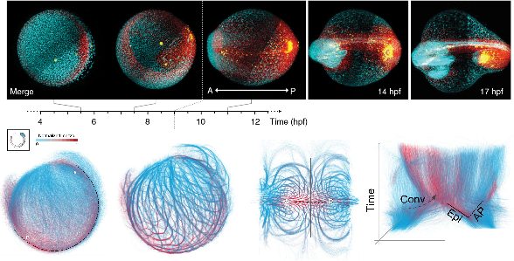

**Multiscale imaging and tracking of embryo cell dynamics**: Top panels show in toto imaging of germlayer specification; red is mesendoderm, blue is epiblast, and yellow is endoderm. Bottom panel shows data analysis of long term pan embryo cell dynamics (Shah et al. 2019)

In a way, assembly of biological systems treads the line between self-organization and programmed material. Advanced microscopy techniques have allowed us to witness the intricacies of developmental processes with unprecedented clarity (see fig 2.1). We can now observe cells and their motion throughout the morphogenetic process, from the formation of a spherical embryo to the creation of a complete organism (Shah et al. 2019). Cells undergo shape changes and large-scale flows as they undergo morphogenesis, driven by mechanical forces in concert with biochemical processes (Labernadie and Trepat 2018; Trepat and Sahai 2018; Lecuit, Lenne, and Munro 2011). Thus, the dichotomy of form and function is incomplete without considering the physical laws of mechanics.

Over a century ago, D’Arcy Wentworth Thompson wrote the influential book “On Growth and Form” (Thompson 1979), in which he explored the relationship between geometry, physics, and biology in the context of morphogenesis. Thompson used examples to show how mathematical principles can explain biological phenomena, such as his theory of transformations, which demonstrates how related species can be represented geometrically (see fig 2.2). According to Thompson’s daughter, he even used to draw pictures of dogs on rubber sheets and stretch them to show children how poodles could become dachshunds (“Are All Fish the Same Shape If You Stretch Them? The Victorian Tale of On Growth and Form,” n.d.). This distortion of shape represents significant alterations in various forces or rates of growth throughout the developmental processes of different organisms.

Thompson’s approach was highly speculative, but his goal was to identify general principles behind the diverse forms and patterns found in biology. He compared growth curves of haddock, trees, and tadpoles, and found logarithmic spirals in shells, horns, and leaf arrangements. [4] Essentially, this book emphasized two points: first, all material forms of living things—cells, tissues, and organs—must obey the laws of physics, and second, quantitative measurements are necessary to unravel the physical principles of biology.

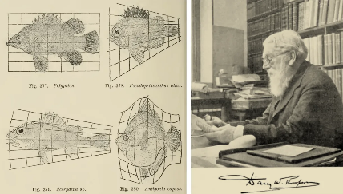

**D’Arcy Thompson’s fishes** and his theory of transformation. (Wolfram 2017; Thompson 1979)

Thompson’s work continues to inspire researchers even today. Right as I began my Ph.D., the centenary of the book’s publication was being celebrated in the fields of developmental biology and biophysics (Heer and Martin 2017; “The 100-Year-Old Challenge to Darwin That Is Still Making Waves in Research” 2017; “A Ton for Thompson’s Tome” 2017). Even more so by the field of mechanobiology, an interdisciplinary field that studies the role of biophysical forces in cell and tissue functioning.

### Mechanobiology

The cells within epithelial tissue can be viewed as mathematical systems that integrate multiple input cues to result in an output behavior. These inputs can be mechanical or chemical, such as the stretching of lungs or the presence of morphogen gradients during embryonic development. The outputs can include cell deformation, migration, differentiation, or proliferation (Kumar, Placone, and Engler 2017). Some outputs can even feedback into the system as an input, such as when cells remodel the matrix (Malandrino et al. 2018). Mechanochemical switches at the membrane, cell-cell junctions, or cell-matrix adhesions mediate the sensing of the environment, triggering a biochemical cascade that leads to a cellular response (Roca-Cusachs, Conte, and Trepat 2017). This interplay between biochemistry and mechanics is known as mechanotransduction.

During morphogenesis, mechanotransduction occurs at various scales, ranging from a single cell to complex multicellular tissue. To understand the role of different variables, experiments at different scales are necessary. It has been observed that individual cells can sense their environment and respond by altering their behavior through mechanical or biochemical processes. Whereas, multicellular systems can transmit forces and information at a longer length scale, allowing for emergent characteristics such as collective migrations, oscillations, rearrangements, and even turbulent flows (Heer and Martin 2017; Lecuit, Lenne, and Munro 2011; Trepat and Sahai 2018).

An excellent demonstration of the interaction between tissues and their environment is provided by the phenomenon of durotaxis. Epithelial cells can detect changes in the stiffness of the extracellular matrix and migrate towards areas of higher rigidity. This migration towards stiffer regions has been observed both *in vitro*, where cells in a monolayer collectively expand and relocate to stiffer areas, and *in vivo*, such as during the migration of neural crest cells in *Xenopus laevis* (Sunyer et al. 2016; Shellard and Mayor 2021). It is worth noting that the migration of neural crest cells themselves generates the durotactic gradient. In another example, during Drosophila oogenesis, the disorganized matrix is remodeled by cells to create a polarized matrix that aligns with the actin bundles in the follicular epithelium. This alignment is achieved through the coordinated rotation of cells and can guide the directed motion of cells along the polarized fibers (Haigo and Bilder 2011; Cetera et al. 2014).

The interplay between individual cells, their neighbors, and exogenous stimuli makes it difficult to decouple various biophysical aspects of the environment, such as forces, pressures, matrix stiffness, spatial confinement, porosity, or viscoelasticity. Direct force measurements in and out of tissues are also challenging. To address these challenges, researchers from various disciplines have attempted to recreate experimental systems with precise control over the biochemical and mechanical environments of cells (Xi et al. 2018). This has been made possible through continuous technological advancements in fluorescent probes, imaging, microfabrication, and force measurements (Roca-Cusachs, Conte, and Trepat 2017). In the following section, I will provide an overview of relevant techniques and experiments in the field of mechanobiology.

#### Synthetic substrates

The use of Polyacrylamide and soft PDMS gels has enabled researchers to investigate mechanical interactions at cell-substrate adhesion (see fig 2.3 A). Simply seeding cells on hydrogels of different stiffnesses reveals a significant impact on the actin cytoskeleton, cell shape, and lineage specification (Yeung et al. 2005; Engler et al. 2006). These substrates, because of their known elastic response, are also utilized in techniques like traction force microscopy (TFM) to measure the forces exerted by cells and tissues on the substrate (A. K. Harris, Wild, and Stopak 1980; Gómez-González et al. 2020) (see fig 2.3 D). TFM studies have shown that cells and tissues can exert greater forces on stiffer substrates as a result of the remodeling of the cytoskeleton (Elosegui-Artola et al. 2016). Higher matrix stiffness has also been found to induce the translocation of Yes-associated protein (YAP) from the cytoplasm to the nucleus, which is considered a sensor for mechanotransduction (Elosegui-Artola et al. 2017). However, increasing extracellular matrix (ECM) ligand density alone can induce YAP nuclear translocation without changing substrate stiffness (Stanton, Tong, and Yang 2019).

#### Geometric control

The shape of cells or tissues on 2D substrates can be controlled using micropatterned adhesion proteins or microfabricated stencils. Protein patterning techniques are used to pattern adhesion promoting proteins and control cell attachment and spreading, while microfabricated stencils physically confine cells in a particular geometry (see fig 2.3 B C). When cells are confined, they respond by reorganizing their actin cytoskeleton and focal adhesion complexes to match the shape imposed on them (Vignaud, Blanchoin, and Théry 2012). Confined tissues undergo larger-scale rearrangements, leading to the formation of fascinating topological defects or oscillations (Tlili et al. 2018; Balasubramaniam et al. 2021; Guillamat et al. 2022). Through these experiments, we can uncover the mechanisms of force transmission and regulation of collective cell migration and epithelial growth in two dimensions (Nelson et al. 2005; Vedula et al. 2012; Deforet et al. 2014).

Embryonic stem cells subjected to 2D confinement have been shown to differentiate based on the shape and size of the confinement. For example, a circular monolayer of stem cells can reproduce the tissue patterning of a 3D gastruloid (Warmflash et al. 2014), and confinement in a triangular shape can lead to high tension at the vertices and activate Wnt signaling, promoting differentiation to mesoderm (Muncie et al. 2020). Moreover, advancements in photopatterning technologies allow for precise control of multiple proteins on the same substrate (Guyon et al. 2021; Prahl et al. 2022), enabling the establishment of complex co-culture systems that mimic *in vivo* events.

Not just 2D shape, epithelial monolayers are also able to respond to curvature by regulating cell migration, orientation, cell/nucleus size, and shape (Marín-Llauradó et al. 2022; Schamberger et al. 2022) (see fig 2.3 C). For example, an epithelial monolayer on hemispheres of elastomers acts as a fluid with increasing curvature (Tang et al. 2022). On a smaller scale, cells attached to corrugated hydrogels show variations in lamins, chromatin condensation, and cell proliferation rate in response to curvature (Luciano et al. 2021). Bio-printing of three-dimensional tissue architectures can also create functional tissues (Brassard et al. 2021; Breau et al. 2022).

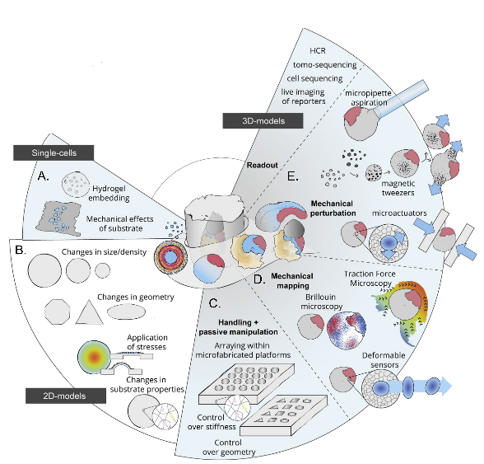

**Mechanobiological strategies for studying morphogenesis** *Adapted from (Vianello and Lutolf 2019)*

#### Mechanical control

Living systems have mechanical control in addition to spatial control, as physical forces emerge from growth, deformation, and remodeling of the extracellular matrix (ECM) and fluid pressure in closed geometries. For example, the intestinal epithelia are stretched during peristaltic movements in the gut and lung alveoli deformations during breathing. Compression can also guide morphogenetic events that involve tissue bending and folding, such as the formation of the optic cup, gut villi, and cortical convolutions in the brain (Okuda et al. 2018; Shyer et al. 2013; Tallinen et al. 2016).

To study tissue behavior under external perturbation, cells and tissues are probed at the molecular and subcellular scales using techniques such as atomic force microscopy, magnetic beads, optical tweezers, and micropipettes (Bao and Suresh 2003) (see fig 2.3 E). At a larger scale, various types of stretching devices, tissue rheometers, and force plates can be used (Xi et al. 2018). These experiments reveal that cells exhibit complex viscoelastic behavior at different levels of deformation and different regions of the cytoskeleton (Mofrad 2009). The response of tissues to stretching can vary depending on the timescale of the stretch and the reorganization of cells within the tissue (Guillot and Lecuit 2013). Rheological experiments also help to uncover the role of signaling pathways, such as YAP transcription factors, in mechanosensation (Wagh et al. 2021).

The microfluidic system, also known as “cells on a chip,” has emerged as a valuable tool for investigating cell behavior under controlled biophysical conditions that mimic *in vivo* conditions (Ingber 2018). This system allows for the application of stretch or shear forces, as well as the creation of a controlled microenvironment that mimics the organ-level cues present in the body. For instance, the surface tension at the air-liquid interface in the lungs and the fluid flow through the vasculature, as well as the cyclic mechanical stretch of the tissue-tissue interface due to breathing, can be replicated using this approach (Huh et al. 2010).

In the context of developmental biology, the use of microfluidic systems has allowed for the study of self-organization and embryo functions under controlled physical conditions. The co-culture of iPSC-derived motoneurons and brain microvascular endothelial cells in a microfluidic system has produced the *in vivo*-like maturation of spinal cord neural tissue, representing a new avenue for exploring the complex interplay between physical and biological factors in development (Sances et al. 2018; Samal et al. 2019).

As mentioned earlier, the tissue-matrix interaction plays a critical role in sensing and rapidly transmitting forces (Tambe et al. 2011; Sunyer et al. 2016; Serra-Picamal et al. 2012). However, in early embryonic epithelia where little or no ECM is present, stresses generated by actomyosin contraction of the cells in one tissue are transmitted over long ranges via intercellular adhesions to other tissues. Thus, studying a simple free-standing epithelial monolayer is very appealing in terms of characterizing the mechanical response to stretch at different time scales.

Only two techniques are available for this: first, Harris and colleagues created a suspended monolayer by culturing a cell monolayer on a collagen matrix on two rods, and later removed the matrix using enzymatic digestion (A. R. Harris et al. 2012). Second, epithelial domes, where MDCK cells pump ions to form fluid-filled blisters, have been used (Lever 1979). Recently, my colleagues, Ernest Latorre and Ariadna Marin-Llaurado, have enhanced control over the curvature, shape, and size of the domes (Latorre et al. 2018; Marín-Llauradó et al. 2022), details on this system in the next chapter. These experiments showed that elasticity measurements of the monolayer were two orders of magnitude larger than those of individual cellular parts, and the monolayer could sustain more than 200% strain before the rupture of cell-cell junctions. The cell cytoskeleton, particularly the actomyosin network and cadherin junctions, actively remodel during stretching, while the keratin network reinforces monolayer integrity at higher strains (Latorre et al. 2018; Duque et al. 2023). With sustained stretching, the tissue undergoes significant realignment and rearrangement via division (T. P. J. Wyatt et al. 2015). Experiments on tissue devoid of the matrix also revealed epithelial actions such as superelasticity and buckling (Latorre et al. 2018; T. P. J. Wyatt et al. 2020).

#### 3D systems

*In vitro* experiments with 2D or 2.5D cell systems have improved our understanding of cell mechanics in morphogenesis by allowing us to measure deformations and forces and control environmental conditions that are inaccessible *in vivo*. However, to gain a deeper understanding of cell mechanics, systems closer to the *in vivo* environment must be probed.

Cell aggregates are a promising *in vitro* system for probing cell mechanics, where synthetic matrix and mechanical measurement tools can be used. The response of cell clusters to the matrix, while similar to planar tissues, is more complex and includes sensitivity to matrix stiffness, confinement, and ECM concentration, as well as the ability to undergo 3D shape transformations (see fig 2.3 E). Our lab has demonstrated that cell aggregates perform durotaxis and exhibit wetting behavior dependent on stiffness (Pérez-González et al. 2019; Pallarès et al. 2022). Additionally, cell aggregates in suspension behave like viscous droplets and can be used to measure rheological properties, such as when squeezed between plates or probed with AFM or a micropipette (Xi et al. 2018). The viscoelastic properties of cell aggregates can even be measured by coalescing two aggregates (Oriola et al. 2022).

In recent years, the use of hydrogel systems for the culturing cell aggregates has gained significant attention. Hydrogels, such as polyethylene glycol (PEG), polyacrylamide, collagen, or Matrigel, serve as a supportive environment for cell growth. Naturally extracted hydrogels like Matrigel provide a similar architecture to the native ECM. When embedded into a hydrogel, polarized epithelia tend to form a spherical structure with a hollow lumen, which can be induced to form branching morphogenesis by hepatocyte growth factor (Bryant and Mostov 2008).

Cell-driven self-assembly in organoids leads to tissue formation that mimics organ features, but achieving reproducibility in shape and composition is often challenging (Nelson, Inman, and Bissell 2008; Hofer and Lutolf 2021). Synthetic hydrogels with control over ligand presentation, crosslinking, and degradability have proven useful for epithelial organoids, allowing for control over cell fate (Nikolce Gjorevski et al. 2016; N. Gjorevski et al. 2022).

3D gel-based culture systems with spatiotemporal control over the mechanical properties corresponding to *in vivo*-like functional structures have also been developed (Torras et al. 2018). Interestingly, recent publications show tissue transformation from planar to complex organ-resembling tissue without fine environmental control. For example, intestinal epithelium mechanically compartmentalizes itself, and 2D stem cells transform into a 3D neural tube (Pérez-González et al. 2021; Karzbrun et al. 2021).

In developing embryos, both embryonic and extraembryonic fluids generate frictional and tensional stresses when flowing, or hydrostatic pressures when confined within spaces (Vianello and Lutolf 2019; Chii J. Chan and Hiiragi 2020). The challenge of measuring these forces has led to the use of various techniques, including micropipette aspiration. Micropipette experiments, where a needle is inserted into the embryo to control pressure, have revealed that the internal hydrostatic pressure determines the embryonic size and dictates cell fate allocation (Chii Jou Chan et al. 2019) (see fig 2.3 E). As a fluid-filled structure, the hydrostatic pressure inside the embryo corresponds to tension in its surfaces, and changes in luminal volumes are sensed by cells through increased cortical tension, inducing changes in cell shape and cytoskeleton organization (Chii Jou Chan et al. 2019; Choudhury et al. 2022). Micropipette aspiration has also been effective in measuring the surface tension of individual cells or whole blastomeres (Dumortier et al. 2019), thus providing insight into the role of the actin cortex in regulating preimplantation embryonic contractility (Özgüç et al. 2022; Firmin et al. 2022).

The measurement of forces within embryos has also been approached through the insertion of deformable probes, such as hydrogels, oil, or magnetic droplets (Dolega et al. 2017; Campàs et al. 2014; Serwane et al. 2017). The shape changes of these probes allow for measurement of local forces and osmotic pressures (Mongera et al. 2023).

In addition to embryos, explant systems have been utilized to study organogenesis in the brain, gut, and lungs. Lung explant research has been particularly useful in understanding different aspects of shape formation, which occurs under the influence of pressure and growth factors. The explant system allows for direct control over the chemical and mechanical environment at specific stages of development. Work with mouse airway epithelium has shown that pressure and matrix stiffness impact the number of lung branches (Palmer et al. 2021; Varner et al. 2015; Nelson et al. 2017).

Other tools such as optical tweezers, laser ablation, and optogenetic excitations have been used at different levels to probe the mechanics of development (Lecuit, Lenne, and Munro 2011; Gómez-González et al. 2020). However, independent control over multiple factors remains difficult and force measurement remains indirect.

In conclusion, epithelial tissues are highly sensitive to various biophysical forces and constantly undergo remodeling at different scales and timeframes. There are multiple techniques available to manipulate and study these tissues, from single cells to embryos, with controlled forces and deformation. Due to its dynamic behavior, epithelial tissue can be considered an active material. The focus of this thesis is to develop a system that can control and measure physical forces to understand epithelial behavior as an active material. In the following chapter, we will delve into the molecular machinery responsible for driving these active tissues.

## Active tissue mechanics

### Force generation with actin

In the field of morphogenesis, cells are central to the formation of specific structures through changes in their shape. Early embryologists posited the existence of a mysterious external vital force that guides the morphogenesis of individual cells in tissues (Thompson 1979). However, as research progressed, particularly experiments by Wilhelm His and Wilhelm Roux, it became clear that the physical forces generated within the cell itself (Clarke and Martin 2021). In the present day, we now understand, what was unknowable in the XIXth century, that the machinery responsible for generating these physical forces is the actin cytoskeleton.

Specifically, the actomyosin cortex forms a mesh containing actin filaments and myosin motors just beneath the plasma membrane of a cell (Alberts 2015). This mesh is organized into various higher-order arrays capable of dynamic remodeling, giving rise to the complex shapes and structures we observe in the world around us. We can understand the actomyosin cortex step by step, starting from its basic organization of single actin filaments to higher-order supracellular actomyosin cables.

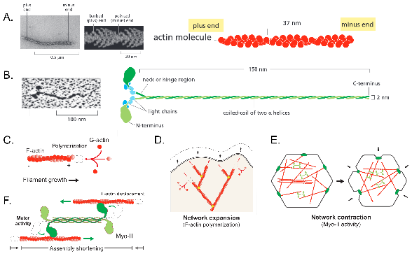

**Actin and Myosin**: (A) Electron micrograph of Actin filament with zoomed in images of barbed and pointed end. (B) Same for Myosin II minifilament with clearly visible two globular heads and a long tail. (C-D) Actin network can apply pushing force through polymerization of single filaments or network expansion. (E,F) While myosin activity would lead to contraction of the networks. *Adapted from A-B (Alberts 2015) and C-F (Clarke and Martin 2021)*

#### Actin filaments

The actin filaments are helical polymers composed of G-actin proteins (see fig 3.1 A). The asymmetrical nature of these proteins leads to the development of two distinct ends, referred to as the barbed and pointed ends, that can be differentiated based on their appearance in electron micrographs. The actin filaments are known for their dynamic assembly and disassembly processes, where the distinct ends have different rates of kinetics. This results in growth in the direction of the barbed end, with the length of the filament can be maintained by a constant flux of subunits from the pool of monomers in the cell and nucleotide hydrolysis. This process is referred to as *treadmilling* (see fig 3.2 A). However, if one end of the filament is capped, it will continue to grow and apply a pushing force in the outward direction.

#### Actin networks

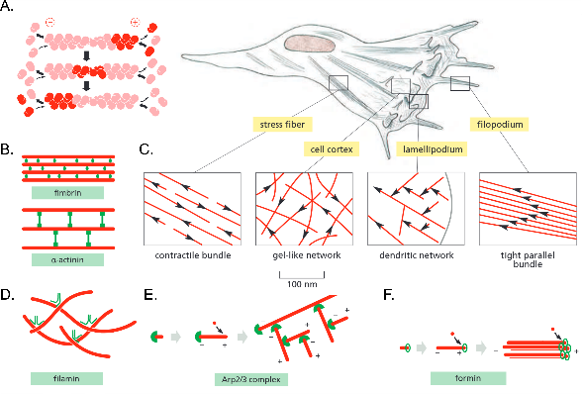

**Forms of actin networks**: (A) Actin treadmilling: where highlighted actins move from positive end to negative end as the filament polymerizes and depolymerizes from both ends. (C) In an adherent cells, there are many different kinds of actin structures from contractile network to gel-like cortex. (B,D,E,F) Actin structures can be thought as meshwork of actin filaments (red) with crosslinkers(green). Different crosslinkers produce distinct form of actin network. *Adapted from (Alberts 2015)*

Actin filaments can also form branched networks, facilitated by the presence of nucleation sites on the filament and proteins containing actin-binding motifs. The actin nucleation can be catalyzed by two primary factors, the ARP 2/3 complex or formins. The ARP 2/3 complex creates a pointed end in the center of a filament, leading to the formation of a new branch from that site. This results in the formation of a tree-like network of branches, capable of generating sufficient pushing forces to move a part of the cell membrane (see fig 3.2 E,F). The formins, in conjunction with profilin, aid in the growth of the filaments, with profilin serving as a staging area for the rapid addition of monomers to the filament. These structures can take the form of dendritic actin networks that enable membrane protrusion at lamellipodia or spike-like projections of the plasma membrane that allow a cell to explore its environment (see fig 3.2 C). The pushing forces generated at the molecular level are of the order of 1 piconewton.

#### Actin cortex

The actin filaments can also form tight or loose bundles, facilitated by crosslinking proteins. Fimbrins enable multiple actin filaments to arrange in parallel, resulting in closely packed bundles that exclude myosin from connecting to the filaments. On the other hand, $α$-actinin crosslinks actin filaments with opposite polarity into a loose bundle, allowing myosin to bind and create contractile bundles (see fig 3.2 B). Myosin II oligomerizes into a bipolar short filament that can connect multiple actin filaments and move across them, resulting in a pulling effect (see fig 3.1 B). This movement is driven by ATP hydrolysis making contracting an active process. The loose bundle forms the gel-like network in the cell cortex. Other actin crosslinking proteins can result in different structures. Filamin creates a loose and viscous gel that is essential for migration, while spectrin creates a strong and flexible web-like network of short actin filaments that allows cells to reversibly deform (see fig 3.2 D). The actomyosin bundles in the cortex can generate two orders of magnitude more force than a single filament (Clarke and Martin 2021).

### Actin structures at a larger scale

During epithelial morphogenesis, individual cells can undergo shape changes by modifying their contractility or actin turnover, resulting in the development of tissue curvature. As mentioned previously, epithelial cells exhibit apicobasal polarity, which results in a non-uniform distribution of the actin cytoskeleton that influences cell shape and tissue architecture.

The geometry of columnar or wedge-like cells in a monolayer determines the specific ways in which they can be organized (Gómez-Gálvez et al. 2021). Columnar cells, when arranged together, produce a flat tissue, while wedge-shaped cells with a narrow top result in convex curvature (see fig 3.4 A ). Conversely, concave curvature with a narrow bottom can also be created. By observing the actin cytoskeleton, we can determine the specific mechanisms of tissue shaping (see fig 3.4 B). For example, apical constriction with concentrated actin cortex on the apical surface is involved in multiple convexly curved tissues, such as the invagination of the intestinal crypt, the Drosophila mesoderm, and the vertebrate lens placode (Pérez-González et al. 2021; Lecuit, Lenne, and Munro 2011; Houssin et al. 2020).

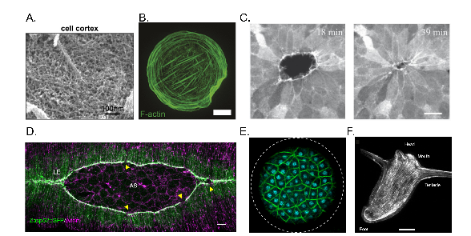

**Actin organization at different scales**:(A) Electron micrograph of actin cortex of mitotic Hela cells (Kelkar, Bohec, and Charras 2020). (B) Different forms of actin organization in circular fibroblast cell (Jalal et al. 2019) Scale $=10μm$. (C) Supracellular actin ring during wound closure (Brugués et al. 2014) Scale $=20μm$. (D) Dorsal closure of amnioserosa with actin network (Ducuing and Vincent 2016) Scale $=10μm$. (E) Supra-cellular organization of actin for cellularization of coenocyte. Circle is $60μm$ (Dudin et al. 2019). (F) Hydra with actin network, whose nematic defects determines morphogenesis (Maroudas-Sacks et al. 2021) Scale $=100μm$.

On the other hand, basal constriction results in opposite curvature, as observed in the optic cup and mid-hind brain fold of zebrafish (Sidhaye and Norden 2017; Gutzman et al. 2018). However, convex curvature can also be produced through basal expansion, as seen in the Drosophila wing disc (see fig 3.4 A). Certain parts of the wing disc can locally relax the basal side without affecting the apical side, leading to basal expansion (Sui et al. 2018). In addition to the apical and basal surfaces, lateral surfaces can also contract or expand due to myosin II activity, which can cause tissue folding in the wing and leg discs of Drosophila (Sui et al. 2018; Monier et al. 2015). Furthermore, cell-cell rearrangements can be produced by altering junction lengths during germ band extension (Yu and Fernandez-Gonzalez 2016; Collinet et al. 2015) (see fig 3.4 C).

Not only do individual cells undergo coordinated actin reorganization during epithelial morphogenesis, but supracellular actin structures can also emerge at the tissue level (see fig 3.3 A-C). Junctional actomyosin organizes to form bundles connected across multiple cells, allowing for important functions such as wound healing and morphogenesis (Brugués et al. 2014; Clarke and Martin 2021) (see fig 3.4 D-F). These supracellular networks can exert forces at the scale of the embryo, as observed in cases such as dorsal closure and parasegment boundary formation in Drosophila and epiboly in zebrafish (Ducuing and Vincent 2016; Calzolari, Terriente, and Pujades 2014). Additionally, these networks can alter the material properties of specific regions in the embryo, making them more prone to deformation and thus aiding in the formation of folds or invaginations (see fig 3.4 G).

During Drosophila gastrulation, tissue-level actin cortex is altered in the direction of the anterior-posterior axis, providing increased bending strength in that direction. This supports the internalization of the mesoderm by promoting folding in a perpendicular direction (Yevick et al. 2019). Interestingly, highly organized actin bundles are also found in even larger systems such as Hydra, vertebrate smooth muscle, and the heart (Maroudas-Sacks et al. 2021; Palmer et al. 2021; Cetera et al. 2014; Helm et al. 2005) (see fig 3.3 D-F). These bundles assist in generating mechanical force patterns that create coordinated tissue movements at a global scale.

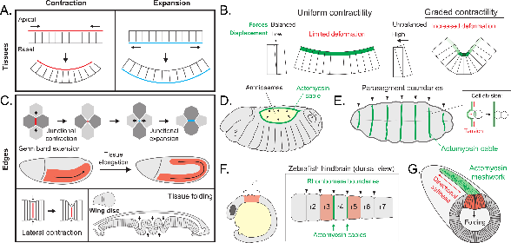

**Morphogenesis driven by actin at tissue scale**: (A) Apical contraction or basal relaxation both results in the same curvature. (B) However, amount of deformation will depend on the contractility gradient. (C) Lateral surface of cells can also undergo expansion or contraction leading to cell rearrangements or tissue folding. (D-G) Supracellular actin cables plays vital role in creating boundaries or causing large scale deformations. *Adapted from (Clarke and Martin 2021)*

### Timescales of the actin cytoskeleton

Morphogenesis, the process of shaping and forming living structures, occurs at varying timescales and requires the cell cytoskeleton to change its shape accordingly. Rheological and mechanobiological experiments have given us insights into how cells respond to forces and deformations based on their magnitude and rate (see fig 3.5 A; reviewed in (T. Wyatt, Baum, and Charras 2016)).

For fast deformations (in the range of milliseconds to seconds), cells exhibit predominantly elastic behavior, as there is insufficient time for the actin cortex to respond or remodel (Deng et al. 2006). The cytoskeleton can store elastic energy and release it. At this scale, there is also flow of cytosol through the cortical mesh, resulting in poroelastic behavior(Moeendarbary et al. 2013).

When forces or deformations are applied over longer timescales (seconds to minutes), cells exhibit an increasingly viscoelastic behavior (Kollmannsberger and Fabry 2011). The actin cortex can flow and is unable to fully store energy. The actin filaments and crosslinkers, such as myosins and actinin, allow the cytoskeleton to remodel in response to mechanical perturbations through turnover in tens of seconds or a few seconds, respectively. Myosin mini filaments, however, can take longer to remodel, up to hundreds of seconds.

At even longer timescales (minutes to hours), cells or tissues may respond through oriented division or rearrangement, allowing them to adapt to persistent forces such as gravity or surface tension. Tissues may resemble a viscous fluid and morph into a sphere, such as a blastocyst. Interactions with the extracellular matrix over hours can lead to adjustments in the constitutive tension of tissues based on biophysical and biochemical forces (Porazinski et al. 2015).

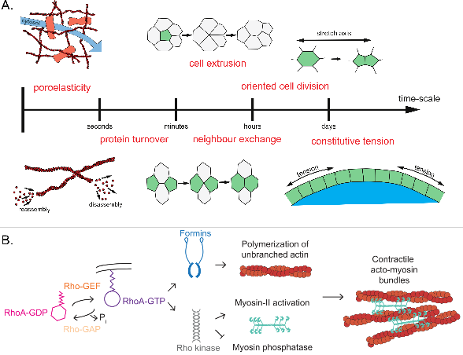

**Molecular pathway and timescale of actin network related processes**: (A) Timescales of different actin driven cellular processes, ranging from cytoskeletal fluid deformation to large-scale tissue deformations. (B) Molecular signaling of RhoGTPase. RhoGEFs return GDP for GTP to activate RhoA. In turn RhoA results in actomyosin contractility. *Adapted from (Kelkar, Bohec, and Charras 2020; T. Wyatt, Baum, and Charras 2016)*.

### Controlling cortical tension

The magnitude of contractile or tensile forces exerted by cells is greatly influenced by the tissue type and its environment. The signaling pathways regulating the crosslinkers and nucleators of actin bundles are responsive to both external biochemical and biomechanical stimuli (see fig 3.5 B; reviewed by (Kelkar, Bohec, and Charras 2020)). The actomyosin bundles, made up of dynamic actin filaments, constantly undergo cycles of contraction, polymerization, and depolymerization, which maintain a homeostatic level of cortical tension in healthy tissues. As a result of the numerous components involved in the actin network, cortical tension can be readily modulated by pharmacological interventions targeting specific molecular targets (Cartagena-Rivera et al. 2016).

For example, the use of Latrunculin, which binds to actin monomers, can result in the depolymerization of the actin network and reduce contractility. Similarly, inhibiting myosin activity with Blebbistatin leads to a decrease in cortical tension due to its hindrance of myosin II ATPase activity. Conversely, Calyculin-A enhances contractility by accelerating the rate of Myosin II phosphorylation. The stability of the actin network can also be impacted by sequestering ARP 2/3 monomers with CK666, which increases cortical tension. Other factors, such as Rho-GTPases and calcium levels, located further along the signaling pathway, can also affect network stability (Valon et al. 2017).

Optogenetic tools offer a more refined and localized means of controlling contractility. For instance, tools based on the regulation of RhoA can be used to locally regulate cell protrusion, tissue tension, and traction (Valon et al. 2017). A recently developed tool controlling Shroom3 provides even finer control over apical constriction and can be used to recreate tissue folding (Martínez-Ara et al. 2022).

### Modeling active tissue dynamics

The advancement of molecular biology and tissue dynamics has increased our understanding of morphogenesis. However, it is becoming increasingly crucial to interpret biological experiments through theoretical models in order to generate new hypotheses and validate them through further experimentation.

Mathematical models at multiple scales are used to describe both physics and biology. At larger tissue scales, hyperelastic continuum material models could be utilized to describe the behavior of the cardiovascular system (Holzapfel, Ogden, and Sherifova 2019). On smaller scales, agent-based models are used to explain epithelial tissue behavior in terms of cell sorting and reorganization (Voss-Böhme 2012). This section aims to provide the reader with a brief overview of the relevant modeling approaches in this field.

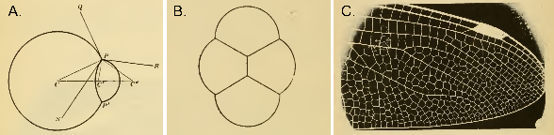

**D’Arcy Thompson’s forms of tissues:** (A-B) Thompson equates cell aggregates to coalescence of bubbles like in a froth. (C) A dragon fly wing is a clear example of this organization. *Adapted from (Thompson 1979)*

#### Vertex models

D’Arcy Thompson, in his chapter on “The Forms of Tissues,” presents an intuitive argument regarding the role of surface tension or capillarity in organizing cells into a tissue (Thompson 1979; Graner and Riveline 2017). He observed this phenomenon in a wide range of biological systems, from two connected cells to the organization of cells in a dragonfly wing, which resemble the associations of soap bubbles or foams (see fig 3.6). [5] In the case of monolayered epithelial tissue, its polygonal cellular pattern on its surface enables the easy description and tracking of cell motion and shape change through the use of vertices and edges.

r5.5cm

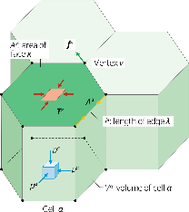

Vertex models have proven to be valuable in understanding the complex interactions between cellular shape, the forces generated within epithelial cells, and the mechanical constraints imposed on the tissue from external sources (as reviewed in (Alt, Ganguly, and Salbreux 2017)). These models can be two-dimensional or three-dimensional, depending on the system being modeled, but cells are consistently defined as having both an apical and basal surface, as well as lateral interfaces between neighbors. Further complexities have been added to describe specific systems, such as intercalations in three-dimensional epithelia, through the use of a geometric shape known as the Scutoid (reviewed in (Gómez-Gálvez et al. 2021)).

To determine the motion of the vertex, mechanics must be specified. It is often done using the virtual work function (W). There are two components: internal $\left(δW_{i}\right)$ and external $\left(δW_{e}\right)$.

$$δW=δW_{i}+δW_{e}.$$

The changes in internal virtual work, $\left(δW_{i}\right)$ can result from changes in the cell volumes $\left(δV\right)$, in the areas of surfaces $\left(δA\right)$, or in the lengths of bonds $\left(δl\right)$. By defining the cell pressure $\left(P\right)$, the surface tension $\left(T\right)$, the line tensions $\left(Λ\right)$, and internal dissipative forces $\left(f_{i}\right)$, the differential of the internal virtual work for vertex movements can be written.

$$δW_{i}=Σ_{cell α}\left(-P^{α}δV^{α}\right)+Σ_{surface k}\left(T^{k}δA^{k}\right)+Σ_{edge λ}\left(Λ^{λ}δl^{λ}\right)-Σ_{vertex ν}\left(f_{i}^{ν}δx^{ν}\right).$$

Similarly, the external virtual work, $\left(δW_{e}\right)$, can be written according to the external forces $\left(f_{e}\right)$ that come from external mechanical forces applied to the tissue through the matrix, or fluid pressure acting on apical or basal cell surfaces.

$$δW_{e}=-Σ_{vertex ν}\left(f_{e}^{ν}δx^{ν}\right).$$

The state of a monolayer is determined by minimizing the virtual work function, taking into account the molecular complexities that contribute to surface tension and line tensions. In the context of epithelial layers, the actin cortex significantly impacts the tensions along the edges. Vertex model simulations in 2D models demonstrate the important role of interfacial tensions in shaping cell orientation, coordinating collective migration, and facilitating tissue rearrangement through cell division.

In contrast, 3D models capture the physics of various morphogenetic processes, such as the formation of appendages on the drosophila eggshell and the mechanical compartmentalization of intestinal epithelia (Osterfield, Berg, and Shvartsman 2017; Pérez-González et al. 2021). These models offer unique insights into cell packing and the transition between jamming and unjamming (Park et al. 2015; Tang et al. 2022). In some cases, phase transitions from a solid to fluid state result from localized proliferation and oriented divisions, showing that the epithelial tissue behaves as an active material (reviewed in (Lenne and Trivedi 2022)).

#### Continuum models

The viscoelastic properties of tissues are captured in vertex models, which are useful for smaller-scale. However, for larger-scale deformations or flows, we can model tissues as a continuous material. There are two tactics for thinking about these models: one focuses on the rheological properties of the tissue, and the other on shape transformations. By thinking of a continuous sheet of cells as an active surface, we can capture the physics of single cells to embryos (Salbreux and Jülicher 2017; Khoromskaia and Salbreux 2023).

Continuum models focus on developing reliable constitutive relations and solving initial-boundary-value problems. Constitutive relations describe how materials respond to applied loads, and they depend on the internal constitution of the material. Determining constitutive relations for epithelial monolayers can be challenging because these tissues are much more complex than simple metals or passive polymers (see fig 3.7 A-B). However, their complex material behavior can be understood by characterizing their mechanical response using standard material testing techniques (Humphrey 2002). Typically, they can be probed mechanically in a biologically relevant manner, such as through biaxial or uniaxial stretching experiments that simulate *in vivo* tissue behavior (Humphrey, Dufresne, and Schwartz 2014). These experiments with epithelial tissues have revealed the viscoelastic nature of these materials (A. R. Harris et al. 2012; Khalilgharibi et al. 2019).

Solids, such as rubber, are considered to have elastic properties, allowing them to deform reversibly when subjected to a force. Conversely, fluids are characterized by their viscosity, meaning they flow in response to an applied force. Viscoelastic materials exhibit both solid-like and fluid-like behaviors (see fig 3.7 C). Simple models can represent these behaviors by combining elastic components, represented as springs, and viscous components, represented as dashpots. The elastic response does not dissipate energy, unlike the viscous response.

$$σ=Eϵ, σ=η\frac{dγ}{dt}.$$

Other material properties like stiffness or Poisson’s ratio can be revealed through quasi-static stretching or compression. However, dynamic properties are better understood through frequency sweep, creep, or stress relaxation experiments (Guimarães et al. 2020). Rheological experiments have been extremely valuable in gaining insight into the mechanical response of various biological materials, ranging from reconstituted cytoskeletal proteins to large multicellular aggregates (Mofrad 2009; Cavanaugh et al. 2020; Xi et al. 2018).

Rheological properties are often linked to physiological state and are crucial for their specific functions (Park et al. 2015; Vedula et al. 2012). For example, many fundamental shape transitions in embryos occur through abrupt change in tissue material properties. (Hannezo and Heisenberg 2022). Therefore, it is important to assess rheological properties in different microenvironments. Mechanical information such as deformation, deformation rates or velocity fields, traction forces exerted by cells on substrates, and intercellular mechanical stress can provide a more complete picture of tissue rheology when combined with information about cellular architecture obtained through imaging (Roca-Cusachs, Conte, and Trepat 2017). These types of experiments shed light on the complex mechanisms of strain stiffening and viscoelastic behavior at different deformation regimes involving various parts of the cytoskeleton.

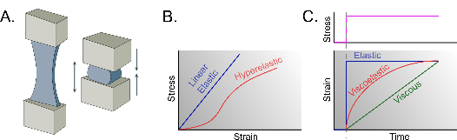

**Stress strain behavior of materials**: (A) materials being stretched or compressed. (B) Quasistatic deformations yield stress-strain curves. (C) Creep test where strain response is characterized at constant stress.

However, in certain cases like modeling cardiovascular mechanics or the growth of organs, we can rely on hyperelasticity or composite material framework. The basic kinematics assumes a mapping, $x=χ\left(X,t\right)$, deformation from reference to deformed configuration. The deformation gradient and Green’s strain tensor are defined.

$$F=∇_{X}\left(χ\left(X,t\right)\right)); E=\frac{\left(F^{T}F-I\right)}{2}.$$

The elastic and growth can be delineated in the deformation gradient through decomposition.

$$F=F_{e}F_{g}.$$

Here, in the theoretical framework of finite elasticity, one can assume a strain energy function relates to stress. The stress-strain data extracted from the experiment allows for predicting the form of the strain energy function.

$$S=\frac{δW}{δE}.$$

The utilization of hyperelastic models has proven to be effective in capturing the material response in various biological tissues, such as the bladder, heart tissue, skin, and arteries (Holzapfel 2000). This type of formulation provides a degree of flexibility, as it allows for the inclusion of additional physical constraints, such as the anisotropy of the tissue microstructure or its incompressibility. Minor modifications to these constitutive relations can be used to capture the material response, such as explaining the phenomenon of strain stiffening, or accounting for the inhomogeneity in the material, such as the collagen content and crosslinking in the tissue (Holzapfel, Ogden, and Sherifova 2019).

These models are also employed in the understanding of growth and remodeling, through the use of kinematical growth theory (Ambrosi et al. 2019). This theory highlights the existence of residual stresses in growing tissues, which allow for compatible elastic and inelastic growth-induced deformations, leading to a modification of the tissue properties into a spatially inhomogeneous and anisotropic state. This process is of great significance in the field of solid tumor growth mechanobiology, as the residual stresses directly impact tumor aggressiveness, nutrient pathways, necrosis, and angiogenesis.

#### Active surface models

At the cellular level, the mechanical properties of tissues are largely determined by the biopolymeric cytoskeleton, which consists of filaments and cross-linkers and molecular motors. These components continuously convert energy, ATP to ADP, through contractions or extensions of the network, resulting in a physical gel-like system due to its cross-linked actin filament network. However, the presence of phenomena such as treadmilling, active polymerization-depolymerization of filaments, and the mobility of molecular motors, such as myosin, makes the tissue system an active gel that lacks time-reversal symmetry due to its continuous energy transduction.

Additionally, the filaments are polar, which allows for the acquisition of orientational order. This has led to the modeling of tissues as active gels, similar to modeling active systems, such as flocks of birds and schools of fish, using hydrodynamics of active matter (Jülicher, Grill, and Salbreux 2018). Active matter systems are a subclass of continuum models used to describe the dynamics of packed active particles, which are based on the liquid crystal theories of soft condensed matter. Like liquid crystals, cells also possess orientation and the ability to move past each other. In this framework, the orientation of filaments in the cytoskeleton or the elongation of cells in the tissue can be characterized by a nematic order parameter matrix (see fig 3.8).

$$Q=\frac{3S}{2}\left(n⊗n-\frac{I}{3}\right), S=\left[cos2θ\right],$$

$$σ_{active}=ζQ.$$

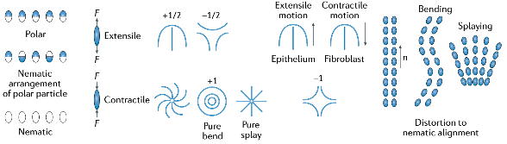

**Active nematics**: Schematics of (A) nematic or polar particles, (B) extensile and contractile force dipoles, (C) Various types of defects and related motion of cells *Adapted from (Xi et al. 2018)*.

The utilization of this formulation is significant in characterizing the active forces produced by the network. The stress is separated into two components: active and passive. The passive stress arises from the viscoelasticity of the material and the bending, splaying, and twisting of the aligned elements. The active stress, on the other hand, is calculated by combining the strength of activity, represented by the parameter zeta, and the nematic order matrix. The sign of zeta determines the type of force dipole generated; a negative sign results in contraction of the system, while a positive sign leads to expansion along the nematic axis.

The active stress plays a crucial role in the motion of the system and can result in chaotic motion even in low Reynolds number systems, as evidenced in dense bacterial systems of *Bacillus subtilis* where jet flows and turbulent patterns have been observed, as well as in expanding monolayers where independent vortices have been recorded (Wensink et al. 2012; Blanch-Mercader et al. 2018). The nematic formulation have proven to be effective in capturing the physics of 2D confined systems and expanding systems (reviewed in (Saw et al. 2018)).

In the context of 3D models, active surfaces are used to describe the actomyosin cortex near cell membranes or epithelium in embryos (Salbreux and Jülicher 2017). This thin sheet of matter generates internal forces and torques that drive shape changes at the cellular or tissue level. The resulting three-dimensional structures can be conceptualized as curved, active two-dimensional surfaces. Forces and torques can be defined in terms of tension ($t$) and moment ($m$), and the model also considers the mirror and rotation symmetries of the surface elements (see fig 3.9).

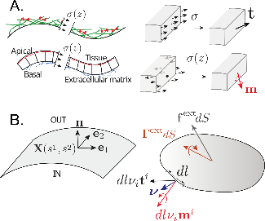

**Active surface models**: (A) Tissues or cell surfaces can be modeled as surface with stresses and torques along the thickness. (B) Internal and external forces actin on a surface element. The kinematics of these surfaces, mathematical tools from differential geometry can be applied, using generalized coordinates ($X$), metric tensor ($g$), and curvature tensor ($C$), where ($dl$) is the length of the line element with tangential unit vector ($v$). *Adapted from (Salbreux and Jülicher 2017)*

Salbreux and Julicher’s work has demonstrated that flat active membranes with up-down asymmetry exhibit stability dependent on active tension and active tension-curvature coupling term. This tension-curvature dependency has been observed in the pancreas of mice, where the morphology of epithelial tumors is determined by the interplay of cytoskeletal changes in transformed cells and the existing tubular geometry (Messal et al. 2019). Specifically, small pancreatic ducts produced exophytic growth, whereas large ducts deformed endophytically, consistent with theoretical predictions. Another example shows that curls of high curvature form spontaneously at the free edge of suspended epithelial monolayers, which originate from an enrichment of myosin in the basal domain that generates an active spontaneous curvature (Fouchard et al. 2020). The extent of curling is controlled by the interplay between internal stresses in the monolayer.

While the molecular level behind epithelial morphogenesis, specifically the actin cytoskeleton, is well understood, there are still gaps in the theoretical and experimental framework that can bridge the gap between molecular dynamics and tissue-scale deformations. Vertex and continuum models have been developed to capture the physics of morphogenesis at the tissue scale, and phenomenological experiments provide insights into the constitutive relations of cytoskeletal components and tissues in specific conditions. However, combining vertex models and active surface mechanics could provide finer control over individual cell surfaces, enabling more precise bottom-up morphogenesis.

## Bottom up morphogenesis

### Learn by building

The mechanics and biology of epithelial tissues are complex, with mechano-chemical signaling and multiscale behavior all intertwined. The lens of active material has been instrumental in illuminating the role of molecular elements in undergoing shape changes during morphogenesis. Mechanistic understanding has been enhanced with new mathematical tools and advanced microscopy, enabling measurement of the forces involved in tissues.

The traditional and successful method for studying mechanics has been to deconstruct the system one component or parameter at a time. By manipulating genes or disrupting cellular processes, we can observe how mechanics change. This perturbative method allows for the alteration of biological systems at various levels, from molecular to tissue, (see fig 4.1) .

However, studying systems like organoids or embryos can only provide limited physical insights into the topological transitions of these structures, as experimental systems have limited physical control and ability to measure forces. An alternative approach is to learn by actively performing morphogenesis or reconstructing biological structures from their basic components.

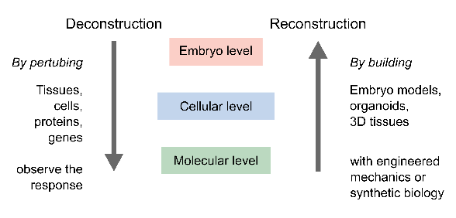

**A conceptual representation of two approaches to understanding mechanics: reconstruction (bottom-up) and deconstruction (top-down).** In reality, they are not separate from each other. These methods inform each other, with past top-down research guiding new reconstruction, and new engineered cells or tissues furthering our understanding of the field in innovative directions.

For years, researchers have broken down biological systems into approachable parts - tissues, cells, proteins - in order to understand the behavior of each component. However, combining existing knowledge of these parts to recreate novel experimental systems could reveal the basic building blocks and effects of scale. This approach would complement top-down approaches in developmental biology. Synthetic biology, a perfect example of reconstruction, seeks to recreate life at various scales, from synthetic proteins to entire cells, in order to gain a deeper understanding of the indispensable components of life.

As active agents exist at every scale, emergent properties can appear at higher scales. Thus, it is essential to focus on higher scales or work with collectives of cells. This reminds me of the example of cars and traffic: Imagine you know the behavior of all individual car components, but this information is not sufficient to understand the behavior of traffic flow. This requires a higher level of analysis. [6] Similarly, biological structures exhibit numerous collective behaviors, such as jamming, nematic order, instabilities, or self-organization (Trepat and Sahai 2018).

Recreating structures from scratch also provides an opportunity to understand the role of physics at different scales. In the spirit of D’Arcy Thompson, we can explore the fundamental properties of matter in biological structures. [7] For instance, we can study the role of surface tension in guiding the shape of cellular aggregates or lumens. In this work, we focus on the mesoscale structures of epithelia $\left(∼10-{10}^{4}μm\right)$.

We present our efforts to engineer an epithelial structure with a controlled microenvironment that is sensitive to self-organization and mechanical instabilities. The following sections will describe the ways of creating these structures from minimal ingredients.

### How to build tissue structures?

Before embarking on the construction of a tissue structure, it is important to consider the desired form and function. Despite the diversity in the shapes and functions of tissues, certain elementary shapes can be seen in many cases, resulting from the interplay between physical forces and biochemical signaling. Examples of such shapes include spherical blastocysts, ellipsoidal embryos, or cylindrical vessels.

After considering the desired form and function of the structure, established cell lines are selected and synthetic structures are constructed using various techniques, such as geometry control and localized folding, as discussed in the 2.3 section. The resulting structures can be further studied to understand the interplay between physical forces and biochemical signaling, as well as their potential applications in various biological systems.

#### Controlling geometry and physical forces

From an engineering perspective, scaffolding is a commonly used approach for constructing synthetic epithelial structures. Scaffolds can be generated through 3D printing or microfabrication techniques, and cells can then be seeded onto the scaffold to attain the desired shape (Torras et al. 2018). This method allows for the creation of a well-controlled microenvironment for the cells in terms of geometry, stiffness, adhesion proteins, and cell culture media (see fig 4.2 A) . Structures generated through this approach can be utilized to investigate tissue behavior in response to forces and curvature.

For instance, cells can be used to form a micro-vessel using a hydrogel with a cylindrical hole (Dessalles et al. 2021). The hydrogel and cells were housed in a microfluidic device that controlled pressure and flow in the vessel, and the authors were able to examine the role of hydrogel poroelastic properties in regulating the dynamics of the vessel. Another exciting study demonstrated the potential of epithelial tissues to form shape-programmable materials by using a collagen scaffold (Mailand et al. 2022).

Scaffolds can also be designed to dynamically change their shape (see fig 4.2 B). For example, a cell monolayer on a flexible membrane can alter its curvature (Blonski et al. 2021), and a combination of stretching and unstretching a cell-laden hydrogel can produce distinctive folds and patterns (H. F. Chan et al. 2018). In some cutting-edge studies, researchers have utilized 4D bioprinting, where 3D printed objects undergo transformation over time (Arif et al. 2022). For instance, a flat hydrogel sheet containing endothelial cells and photo-crosslinking can be transformed into a tube (Zhang et al. 2020).

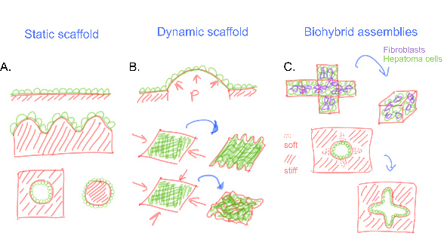

**Controlling geometry and physical forces:** The concept of scaffolding can be divided into two categories: static and dynamic scaffolds. (A) Static scaffolds are microfabricated structures that cells can adapt to and respond to geometrical cues, leading to the formation of a specific tissue organization (Brassard et al. 2021). (B) In contrast, dynamic scaffolds consist of cell-laden matrices that are deformable, and their curvature can change dynamically due to external pressure or mechanical forces (Blonski et al. 2021; H. F. Chan et al. 2018). (C) Biohybrid assemblies can incorporate active contraction or pushing to create hybrid structures, such as origami folding triggered by fibroblast contraction (He et al. 2018), or cells carving out an intestinal crypt-like geometry from a softer matrix (Nikolce Gjorevski et al. 2016).

Additionally, the contractility of fibroblasts and hepatoma cells has been utilized to fold 2D structures into 3D shapes (He et al. 2018) (see fig 4.2 C) . Microplates with an origami folding pattern are created, and the cells apply forces to generate a 3D structure. In other scenarios, cells are allowed to self-organize through the imposition of geometric constraints, which enhances the efficiency of organoid-like systems (Nikolce Gjorevski et al. 2016). In the case of intestinal organoids, controlling the stiffness of the matrix in specific regions leads to growth and differentiation at softer areas, producing a highly reproducible structure (N. Gjorevski et al. 2022).

#### Manipulating biochemical signaling

Another approach to constructing biological structures involves controlling biochemical signaling to induce shape transformation. This approach utilizes natural processes in embryo morphogenesis, such as apical constriction in ventral furrow formation or cell jamming in the normal elongation of the zebrafish. Optogenetic tools, such as controlling Rho signaling, can be used to induce localized apical constriction with spatiotemporal control (Izquierdo, Quinkler, and De Renzis 2018). This technique can also be applied to other proteins, such as Shroom3, to induce synthetic morphogenesis in neural organoids (Martínez-Ara et al. 2022) (see fig 4.3 C).

Epithelial-mesenchymal interaction is another crucial aspect of the tissue folding process. Hughes et al. demonstrated that cell clusters can remodel the matrix to create oriented stresses that lead to budding in tissues (Hughes et al. 2018). By controlling the location and density of these cell clusters, it is possible to manipulate the curvature of the epithelia. Mesenchymal condensation serves as a folding template for the final tissue structure (Palmquist et al. 2022; Shyer et al. 2017) (see fig 4.3 B).

The microenvironment plays a critical role in providing vital signals to tissues and can be manipulated to activate specific cellular functions. Microfluidic techniques can deliver appropriate morphogen gradients to the tissue with precise timing (Hofer and Lutolf 2021). *In vivo*, multiple morphogens often act simultaneously. For instance, during neural tube development, there is an opposing gradient of sonic hedgehog (SHH) and bone morphogenic protein (BMP). With microfluidic devices, stable gradients can be generated, even in opposite directions (Demers et al. 2016), thus mimicking symmetry-breaking events and directional neural tube patterning (see fig 4.3 D).

Moreover, genetic engineering of specific cells can be utilized to control signaling. Human pluripotent stem cells (hPSCs) can be programmed to express SHH (Cederquist et al. 2019) (see fig 4.3 E). Mixing these cells with others could result in a polarized organoid and a patterned cerebral organoid.

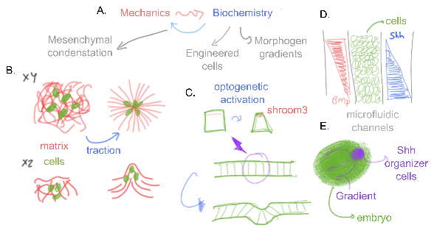

**Manipulating biochemical signaling:** Biochemical signaling and mechanics are interdependent in morphogenetic processes (A). The transport of signaling molecules can affect the cytoskeleton and mechanical properties of cells, while mechanical forces can also influence biochemical signaling. Microfluidics (D) is one method used to control biochemical signaling by providing opposing morphogen gradients through multiple channels (Demers et al. 2016). Alternatively, cells can be genetically engineered to undergo apical constriction (C) or produce morphogen gradients (E) locally to form curved geometries (Martínez-Ara et al. 2022; Cederquist et al. 2019). Mesenchyme condensation (B) is another approach used to program curvature in developing tissues (Hughes et al. 2018; Palmquist et al. 2022).

#### Exploiting mechanical instabilities

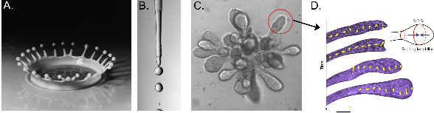

**D’Arcy Thompson compares biological budding to splashes** (A) of fluids and Rayleigh-Plateau instability (Thompson 1979) (B), where liquid splits up into smaller droplets. This mechanism could also be seen in organogenesis of mammary tissue (C, D) (Fernández et al. 2021).

Morphogenesis, the process of shaping and formation of biological structures, often involves spontaneous pattern formation or symmetry-breaking events (Ishihara and Tanaka 2018). These processes are often dictated by mechanical instabilities, which can lead to large deformations in soft matter systems. In material science, these instabilities are typically seen as problematic as they cause rapid breakage. However, in soft matter, large deformations can lead to interesting topological transformations, providing an opportunity for engineers to exploit these instabilities in the development of new actuators or soft robots (reviewed in (Pal et al. 2021)). [8]

The significance of mechanical instabilities was foreseen by D’Arcy Thompson in his comparison of fluid splashes to hydroids (see fig 4.4 A). He wrote that the shapes of a potter’s cup, glass blower’s bulb, and biological structures are simply glorified splashes formed slowly under conditions of restraint that enhance or reveal their mathematical symmetry (Thompson 1979). [9] This conjecture has been confirmed through numerous quantitative studies on various systems, including ripples in leaves and wrinkles in the brain (Liang and Mahadevan 2009; Karzbrun et al. 2018).

There are various instabilities associated with solids and fluids. For example, the Rayleigh-Plateau instability explains why a fluid stream breaks into smaller packets, driven by the fluid’s tendency to minimize its surface area due to surface tension. The same instability can arise when fluid is surrounded by an elastic medium, instead of air, provided the surface tensions can overcome the elastic stresses, leading to budding as observed in alveologenesis in human mammary tissue (Fernández et al. 2021) (see fig 4.4 C-D). However, as tissues are active viscoelastic materials surrounded by viscoelastic medium, the timescales of these instabilities change, slowing down to hours instead of milliseconds in water droplets.

There are several types of mechanical instabilities associated with solids and fluids, including Rayleigh-Plateau instability, Kelvin-Helmholtz instability, Rayleigh-Taylor instability, viscous coiling and folding, and large-scale wrinkling and buckling (Gallaire and Brun 2017; Kourouklis and Nelson 2018). In this study, we aim to harness these instabilities to recreate epithelial structures.

Applying compressive stresses is one of the easiest ways to induce mechanical instabilities in solids. These stresses can occur in biological systems as a result of differential growth, swelling, or morphogen gradients and can lead to various forms of instabilities, including wrinkling, creasing, and buckling. Buckling occurs when a thin sheet is subjected to in-plane compressive stress, and if the stress is above a critical value, the sheet undergoes out-of-plane deformation instead of in-plane shrinkage (see fig 4.5 B). In contrast, wrinkling and creasing occur in similar compressive stresses, but the thin sheet is typically supported by a compliant substrate.

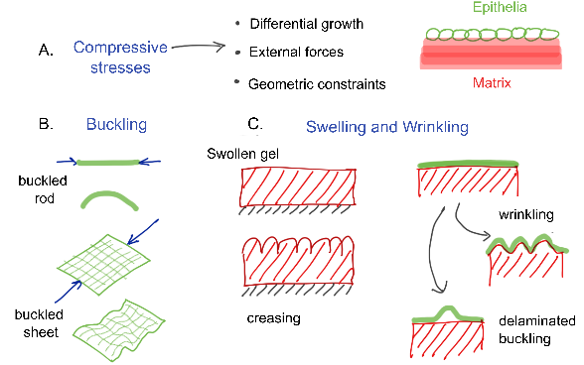

**Compressive stresses** occur frequently in many systems (A). We can consider epithelia and matrix as thin sheet supported by a compliant substrate. Thus, the tissue folding could be understood as buckling of sheets (B) or wrinkling or creasing of thin film supported by an hydrogel (C).

The creation of biological tissues *in vitro* has been a subject of great interest in the field of tissue engineering. To reproduce the characteristics of these tissues, researchers have turned to the use of hydrogels. These materials can be mechanically and chemically manipulated to simulate the behavior of biological matrices, which provide support for epithelial structures.

One of the ways in which hydrogels can be used to recreate the behavior of biological tissues is through the application of physical stress. For example, swelling of the hydrogel can cause it to undergo rapid large volumetric changes, producing crease-like patterns on the surface. If the hydrogel is constrained at the bottom, these creases can become permanent. Alternatively, if the hydrogel is supported by another flexible material, such as another hydrogel or an elastic substrate, the stresses produced during swelling will result in a wrinkling instability (see fig 4.5 A). These instabilities are important for understanding the formation of a variety of structures, including the gyrification of the brain cortex.

In a study by Tallinen et al., the gyrification of the brain cortex was replicated through the programming of materials to produce wrinkling (Tallinen et al. 2016). The researchers created a synthetic brain with an inner core of an inert elastomer and an outer layer of a swellable elastomer. On swelling, the outer layer produced folds that closely matched the process of gyrification (see fig 4.6 A).

Similar mechanisms have been observed in other systems undergoing differential growth, such as the branching of lungs and formation of intestinal villi (Varner et al. 2015; Shyer et al. 2013) (see fig 4.6 B,D). These findings highlight the potential of hydrogels as a tool for understanding the physical mechanisms underlying tissue development. However, it is worth noting that the mechanisms described here are the subject of ongoing research and debate in the field of developmental biology.

The ability to recreate biological tissue growth conditions *in vitro* has been made possible through the use of hydrogels. Researchers have discovered that by mechanically and chemically controlling the hydrogel, they can generate desired mechanical instabilities (Dervaux and Amar 2012). This can be accomplished through the swelling or pre-stretching of the gel, or by manually applying compressive stresses.

One way to simulate growth is through the direct stretching or compression of the gel. Chan et al. showed that the patterns produced can be controlled by modulating the shear modulus of the hydrogel with the epithelial layer and stretch (H. F. Chan et al. 2018) (see fig 4.5 B). By pre-stretching the hydrogel before seeding cells, they were able to produce folded patterns with different wavelengths depending on the type of pre-stretching applied (uniaxial or biaxial).

Another type of instability in bilayers is delaminated buckling, which is often observed in thin film delamination in furniture. This can be induced through compressive stresses created during growth or collective tension. Recent studies have shown that growing epithelia confined in a sphere undergo delaminated buckling after reaching a critical growth-induced stress (Trushko et al. 2020) (see fig 4.6 C), or through intercellular stresses (Oyama et al. 2021) or by placing a biofilm on top of the epithelial monolayer (Cont et al. 2020).

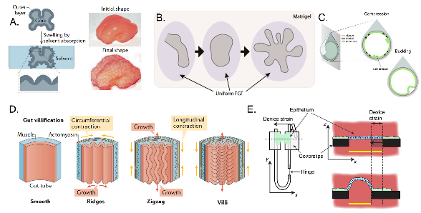

**Examples of mechanical instabilities**: (A) Synthetic mini brains illustrate the wrinkling of the outer layer with swelling mimicking gyrification (Tallinen et al. 2016). (B, D) Other way around where inner layer of lung or intestinal epithelia develops folds when embedded into a hydrogel or muscle shell (Varner et al. 2015; Shyer et al. 2013). (C) It is also shown that simple epithelial tissues embedded into a shell would also buckle (Trushko et al. 2020). (D) (T. P. J. Wyatt et al. 2020) used matrix independent tissue with compression to illustrate that the epithelial tissue itself can undergo buckling. *Panel A, D are adpated from (Collinet and Lecuit 2021) and C from (Matejčić and Trepat 2020)*

The formation of the ventral furrow in the drosophila embryo can also be considered as a buckling event. Although there are multiple explanations for this phenomenon, recent studies have shown that the instability leading to the fold is caused by embryo-level forces (Guo, Swan, and He 2022; Fierling et al. 2022). Apart from instabilities, it is remarkable that the mechanical information can be encoded in the substrate. For instance, the tension produced by the cells in a pre-stretched membrane, on cutting would lead to curling (Tomba et al. 2022), or through stretching a suspended epithelial layer would also do the same(Fouchard et al. 2020).

It is noteworthy that there is currently only one established method for directly applying compressive stresses to suspended epithelial tissue. The Lab of Guillaume Charras has developed a technique using a cell-laden collagen gel sandwiched between two rods, where the gel is digested with collagenase to create a suspended monolayer (see fig 4.6 E). Through extensive experimentation, they have observed that the compression of more than 35% strain produces transient buckling events (T. P. J. Wyatt et al. 2020). Importantly, the actin cytoskeleton plays a crucial role in buffering deformations in this system.

### Tissue hydraulics

#### Hydraulic control of morphogenesis

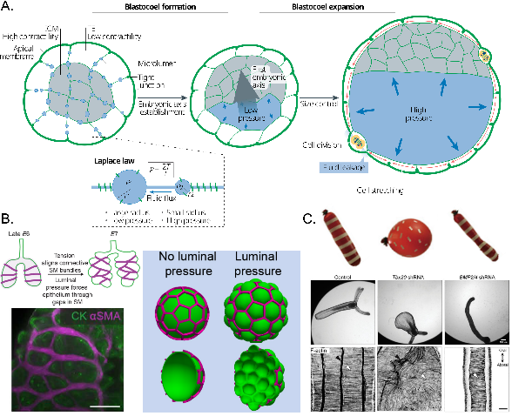

**Tissue hydraulics** plays an essential role in establishing (A) embryonic axis through lumen coarsening, and later the pressure regulates the size of the embryo. Laplace’s law acts on the spherical cavities between cells to the whole blastocyst (Dumortier et al. 2019; Chii Jou Chan et al. 2019; Collinet and Lecuit 2021). (B) Interestingly, if the inflated structure is surrounded by a mesh you see a stressball effect, where material inflates through the mesh. Similar phenomena is visible in growth and inflation of the lizard lungs. The smooth muscle constrains the deformation leading to stressball morphogenesis (Palmer et al. 2021). (C) In cnidarians, the different orientation of F-actin leads to different shapes of the organism (Stokkermans et al. 2022).

In this thesis, we focus on the role of hydraulic pressure in morphogenesis. It has been well established in the field of developmental biology that fluid pressure plays a significant role in lumen expansion. For instance, in the mouse embryo, cell aggregates form small fluid cavities in intercellular junctions, which grow and coalesce into a large lumen, breaking the symmetry of the embryo, due to the presence of an osmotic pressure gradient ((Dumortier et al. 2019); reviewed by (Torres-Sánchez, Kerr Winter, and Salbreux 2021), see fig 4.7 A). This process is powered by the pumping of ions and water by the cells, which generates pressure in the fluid-filled cavities, ultimately leading to the formation of spherical embryos. For any inflated spherical shell, the relationship between pressure ($ΔP$), curvature ($R$), and surface tension ($σ$) can be described by Laplace’s law.

$$σ=\frac{ΔPR}{2}.$$

The shape that is created under pressure depends on the material properties of the tissue. For example, a homogeneous material would create a uniform curvature, such as a spherical shape, while an anisotropic tissue with oriented cells would result in various shapes, such as cylinders or ellipsoids (Stokkermans et al. 2021) (see fig4.7 C). An interesting example of this phenomenon can be seen in the lobed epithelium of lizard lungs, which resembles the shape of a stress ball. Palmer et al. propose that the smooth muscle network functions as a mesh that constrains the epithelium, much like the outer layer of a stress ball (Palmer et al. 2021) (see fig4.7 B). Upon the application of pressure, the epithelium inflates in the regions between the gaps in the muscles.

For embryos, an increase in pressure results in an increase in tension and stretching of the cells. Once a certain threshold is reached, the cell junctions may leak, causing a reduction in luminal pressure and shrinkage of the embryonic cavity. This system of pressure regulation through leakage acts as a mechanism for size regulation (Chii Jou Chan et al. 2019). At the same time, it polarizes the embryo and promotes cell segregation and fate specification (see fig4.7 A, reviewed by (Chii J. Chan and Hiiragi 2020)).

Similar coalescence and lumen coarsening have been observed in other systems (reviewed in (Schliffka and Maître 2019)). The pressure can also be generated through secretion of the matrix, as seen in the case of the drosophila hindgut with mucins (Syed et al. 2012), or through the secretion of hyaluronic acid in the formation of ear canals in zebrafish otic vesicles (Munjal et al. 2021). Despite numerous *in vivo* experiments, there are very few systems in which epithelial tissue can be subjected to controlled shape and size *in vitro*.

#### Mechanics of domes

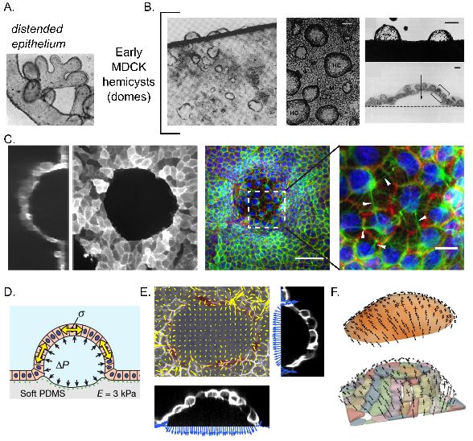

**Historical development of epithelial domes**:(A) Distended epithelium was observed in explant cultures in 1930-50s. (B) With MDCK cell line, spontaneously forming domes/hemicysts were characterized (Leighton et al. 1969; Valentich, Tchao, and Leighton 1979). (C,D) In our lab, shape and size of the domes were controlled with micropatterning adhesion protein (Latorre et al. 2018). The pressure and tension was measured with Laplace’s law and traction force microscopy. (E-F) For non-spherical domes, curved monolayer stress microscopy technique was implemented by segmenting the dome shape (Marín-Llauradó et al. 2022).

Many of the morphogenetic events are called doming because the shape vaguely resemble a spherical cap. For instance, doming of the retina in the eye or zebrafish embryo, or doming during duct formation of mammary or salivary glands. There are typically two mechanisms for these: first, an accumulation of the cells or matrix to create curvature; and second, trans-epithelial transport causing hydraulic pressure-driven shape change. The second kind is remarkable as they mimic various lumenized epithelia *in vivo*.

This is the most pertinent system to the thesis. I would briefly go into the historical developments in dome mechanics.

Fluid-filled dome formation in epithelial tissue culture has been recorded since 1933 (Cameron 1953) (see fig 4.8 A). After several decades alongside the development of cell culture techniques, microscopy, and MDCK cell line [10], in 1968, Leighton and colleagues observed that the confluent MDCK cell monolayers formed hemispherical blisters (domes) (Leighton et al. 1969) (see fig 4.8 B). They observed that these are different from renal tubules because the apical surface, with microvilli, was facing outwards. They saw that these fluid-filled structures are dynamically changing size and curvature. They would burst to deflate and leak fluid out in the medium (Valentich, Tchao, and Leighton 1979). After sometime, they could heal and form the dome again. Later, other cell lines derived from mammalian and amphibian kidneys were often observed to form domes too (Dulbecco and Okada 1980; Leighton 1981; Lever 1979)

Now the mechanism is clear as the epithelial cells perform critical barrier function alongside controlling the transepithelial flow of ions and water. It was shown that hindering sodium-potassium ion pumping reduces the likelihood of domes (Leighton et al. 1969). Thus, on forming a confluent monolayer these cells perform their function of pumping ions from apical to basal direction (Valentich, Tchao, and Leighton 1979). If the substrate is solid and impermeable the tissue accumulates enough pressure to delaminate and form a spherical structure.

Most domes observed have been spherical and circular in footprint, indicating uniform tension across the dome. This can be explained by considering the dome as a thin shell under pressure, similar to a bubble, and following Laplace’s law. Early studies attempted to infer tension through geometry and pressure measurement (Tanner, Frambach, and Misfeldt 1983), finding that the pressure was of the same order as physiological vessels (see fig 4.9 A-B).

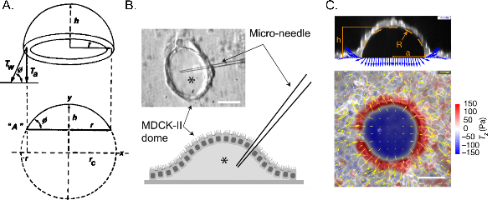

**Methods for measuring pressure and tension**: (A) Earlier studies tried to estimate tension through geometry and thickness of the monolayer (Tanner, Frambach, and Misfeldt 1983). (B) Later, pressure was measured by puncturing the dome with a micro-needle. However, the measurement of pressure is static, because the dome deflated after the puncturing (Choudhury et al. 2022). (C) Traction force microscopy technique provides a viable non-invasive solution for measuring pressure under to domes (Latorre et al. 2018).

One study (Popowicz, Kurzyca, and Popowicz 1986) identified a “dome curve” when the frequency of domes was plotted against size, observing three classes of domes in terms of size. Smaller domes were observed to swell and increase in size. It was also suggested that there could be different subpopulations of MDCK cells. In the 1990s, many strains were characterized that formed different inflated structures, ranging from normal domes to tubules (Klebe et al. 1995). One cell line, called super dome MDCK, formed larger domes.

Despite research into ion transport, hormone signaling, the role of tight junctions, and external shear stress, the understanding of the mechanics of domes and pressure has remained stagnant due to the lack of tools for measuring tension, pressure, and controlling the shape and size of these structures.

The work of Ernest Latorre in our laboratory has led to the development of a system for controlling the size of domes and studying the relationship between tension and pressure (Latorre et al. 2018) (see fig 4.8 C-D). By utilizing protein patterning techniques, Latorre was able to create non-adhesive circular regions on soft PDMS gel, which, when seeded with MDCK cells, led to the formation of domes. The gel was embedded with beads to allow for the calculation of traction forces and pressures exerted by the monolayer (see fig 4.9 C). This system allowed for a deeper understanding of the rheology of tissue and the role of the cytoskeleton. He observed that stretching the actin cortex leads to dilution, and that tension reaches a stable value regardless of strain. He also observed the surprising phenomenon of superelasticity, where cells are heterogeneously stretched in the dome when tension is uniform. To further understand the role of actin and keratin bundles in providing superelasticity, Latorre et al. developed a vertex model through which they could understand the instability triggered by actin dilution, and rescued by intermediate filaments.

Ariadna Marin-Llaurado extended Latorre’s work by examining domes of varying sizes and shapes (see fig 4.8 E). This study found that different-sized spherical domes have similar tensions, and that pressure is compensated according to curvature. Marin-Llaurado couldn’t rely on a simple formula for tension calculation, because the tension in non-spherical domes is non-uniform (Marín-Llauradó et al. 2022). They used confocal microscopy to map dome curvature and calculated stresses computationally using a novel method called cMSM (curved Monolayer Stress Microscopy) (see fig 4.8 F). This method infers stresses just through geometry and pressure as in Young-Laplace relation. It does not need to make any assumptions related to material properties. The results showed that cells tended to align along the principal stress direction.

The mechanics of osmotic and hydraulic gradients are also crucial to understand. Chaudhary et al. demonstrated that kidney cells act like a mechanobiological pump (Choudhury et al. 2022). Using a two-layer microfluidic chip, the team was able to measure and apply pressure differences across an epithelial monolayer and observe that the tissue acted like a mechanical pump that stalls at high pressure. Remarkably, they discovered that diseased kidney cells pump in a different direction than healthy ones. They were able to control both osmotic and hydraulic pressure. Another study by Ishida-Ishihara et al. investigated the connection between osmotic pressure and extracellular matrix swelling (Ishida-Ishihara et al. 2020). The researchers found that osmotic gradients trigger Aquaporin transport channels, leading to dome formation through Matrigel swelling. However, these domes are gel-filled structures that differ from fluid-filled domes.

MDCK domes provide a model system for studying transport, cell fate, and tissue dynamics with a curvature. However, control over luminal pressure in these structures remains a challenge.

## Structure of the thesis

### What is to be done?

Morphogenesis refers to the process of tissue deformation or growth, which results from the combination of both endogenous and exogenous mechanical forces (Valet, Siggia, and Brivanlou 2022; Collinet and Lecuit 2021). These forces may arise from the contractility of the epithelium and the surrounding matrix, as well as hydraulic pressure from the lumen (Torres-Sánchez, Kerr Winter, and Salbreux 2021; Chii J. Chan and Hiiragi 2020). The various stresses act on different components of the tissue, such as cells and the extracellular matrix, which exhibit unique viscoelastic properties and remodeling time scales (Cavanaugh et al. 2020; Kelkar, Bohec, and Charras 2020; Ambrosi et al. 2019). However, comprehending how these stresses interact with viscoelastic properties to bring about particular morphogenetic events in vivo presents significant technical and conceptual challenges. These obstacles include disentangling the roles played by distinct components in a system, a lack of tools for quantitative measurements of stresses and mechanical properties, and an inability to apply controlled stresses over a wide range of amplitudes and rates.

In response to these challenges, bottom-up approaches have emerged as a complementary strategy for understanding the morphogenetic potential of individual components and building complex, functional tissues (Trentesaux et al. 2023; Ingber 2018). These approaches have been successful in engineering basic morphogenetic processes such as epithelial bending or buckling (Matejčić and Trepat 2022). However, even though bottom-up approaches are proving to be successful, we still need tools that can measure and control the shape and stress of 3D epithelia simultaneously. Additionally, we lack computational models that integrate cellular and tissue shape with the subcellular determinants of epithelial mechanics, such as the contractility, turnover, and viscoelasticity of the actomyosin cortex.

This thesis seeks to address these gaps in knowledge by investigating the mechanics of epithelial tissues. A comprehensive understanding of the principles that govern tissue form and function is essential for both advancing our understanding of fundamental physical rules in biology and inspiring new engineering tools and design principles. To achieve this, we leverage cutting-edge technologies, such as 3D printing, microfluidics, and 3D cell cultures, to individually control morphogenetic driving factors.

Our approach provides a material science perspective for probing the intricate mechanisms involved in the generation of forces and shape changes at the cellular and tissue levels, and holds promise for discovering emergent phenomena and enabling the building of novel tissue forms and assemblies.

### Objectives

#### General aim of the thesis

This thesis aims to investigate the mechanics of epithelial layers under controlled pressure.

#### Specific aims of the thesis

General aims are divided into specific goals:

1. Develop a novel technology for constructing three-dimensional epithelia using lumen pressure control.
2. Characterize the material response of the pressurized epithelial tissue.
3. Explore the mechanics of epithelial folds.

### Thesis outline

Results are presented in Part 2 with four chapters that address the specific aims of the thesis and provide a understanding of the mechanics of epithelial layers subjected to controlled pressure.

* Chapter 6 details the construction of an experimental system designed to physically control epithelial monolayers. This chapter showcases the main result of the PhD, a novel microfluidic system that generates 3D epithelia with controlled pressure and shape. The chapter highlights the successful development of the microfluidic system, while also summarizing any failed or attempted methods used in constructing the device.
* Chapter 7 focuses on using the microfluidic device to understand epithelial mechanics. The chapter reports the results of rheological experiments and relates them to the computational framework. It is demonstrated that the shape and rheology of the epithelia are driven by the viscoelasticity of the actomyosin cortex.
* Chapter 8 describes the buckling instability in pressurized epithelia. It is found that rapid deflation produces a buckling instability that leads to the formation of epithelial folds. Buckling occurs across different length scales to overcome compressive stresses, and folding patterns become more complex with increasing size. The chapter discusses the potential of guiding the folds by controlling the shape and size of the epithelia.
* Finally, in Chapter 9, the findings are summarized with a list of conclusions. Along with a brief discussion on future perspectives of this thesis.

In summary, the thesis presents a microfluidic-based technique to impose a controlled deformation on an epithelial monolayer while continuously monitoring its state of stress. This technique allows for investigation of the active viscoelasticity of epithelial layers over physiological time scales. The thesis also presents a 3D model of the epithelium, which explains the observed phenomena using the active viscoelastic properties of the actomyosin cortex. Furthermore, it is demonstrated that these viscoelastic properties, along with adhesion micropatterning, can be utilized to engineer epithelial wrinkles with predictable geometry. The results provide an understanding of the mechanics of epithelial layers subjected to controlled pressure and showcase the potential of the developed techniques to further explore the synthetic morphogenesis.

# Results

## A microfluidic device for generating 3D epithelia

### Introduction

To generate three-dimensional epithelial structures in vitro from planar epithelial monolayers, we chose to utilize an existing system of epithelial domes (spontaneous domes) developed by Ernest Latorre and improved by Ariadna Marin-Llaurada (Latorre et al. 2018; Marín-Llauradó et al. 2022). This system involves seeding a Madin-Darby canine kidney (MDCK) cell monolayer on a substrate that is patterned with circular non-adhesive regions. The cells invade these regions and form a cohesive monolayer everywhere within 24 to 48 hours. Due to the active ion pumping mechanism of the MDCK cells in the apical-to-basal direction, the cells delaminate from impermeable substrates such as glass or soft PDMS gel and form spherical cap structures in the circular patterns, known as epithelial domes. Latorre and Marin-Llaurado demonstrated that they could form a variety of structures with controlled shape and size, ranging from circular to rectangular.

This system also enables the use of 3D traction force microscopy to measure pressure. The technique involves measuring the deformation of a soft PDMS gel embedded with beads to characterize the forces and pressures applied by the cells on the substrate. This method offers an innovative approach to measuring pressure compared to the previous technique of puncturing epithelial domes with a microneedle (Tanner, Frambach, and Misfeldt 1983; Choudhury et al. 2022). It allows for the characterization of the rheology of epithelia and the discovery of interesting material properties such as the superelasticity of cells during stretching (Latorre et al. 2018).

However, the formation of epithelial domes is dependent on the ion pumping mechanism of the domes, making them spontaneous structures. Therefore, the timescales for the dome stretching are not controlled. This process can be marginally accelerated by a few hours through the use of drugs like Forskolin, which can activate transepithelial channels of NA+/K+/Cl- (Klebe et al. 1995; Bourke et al. 1987). However, to build and physically control the epithelial structure, pressure control is necessary. In this chapter, we will be discussing a microfluidic chip that can inflate an epithelial monolayer into a dome while also allowing us to measure and control the forces involved.

### Monolayer Inflator

Inspired by the concept of organ-on-chip microfluidic devices, we considered them to be an ideal system for controlling pressure, cell culture, and high-resolution imaging (Huh et al. 2010; Nelson et al. 2017). For instance, the lungs-on-chip device consists of two layers separated by a porous membrane, with one channel in the top layer for epithelia and another for endothelia. The device is assembled on a thin glass substrate, enabling high-quality imaging.

Therefore, we conceived the idea of a MOnoLayer Inflator (MOLI) device, which utilizes a two-layer microfluidic channel with one side for epithelial monolayers and the other for the application of pressure (see fig 1.1). The epithelial monolayer side is micropatterned with a protein that contains non-adhesive or less-adhesive regions for dome formation. We hypothesized that the cells would attach to the protein everywhere, even in the less adhesive regions. When pressure is applied, the cells would delaminate from the weakest point of adhesion and form a dome.

We chose to use PDMS material for building the microfluidic chip due to its ease of use. We attempted to construct devices using plastic stickers and photopolymerizable glue, but these attempts were unsuccessful due to issues such as leakage and lack of biocompatibility (Sollier et al. 2011; Bartolo et al. 2008).

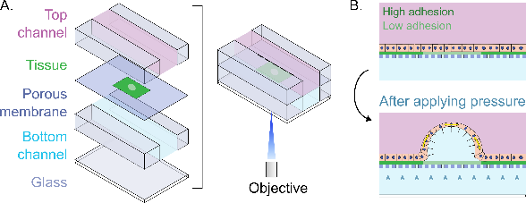

**Conceptual design of MOLI**: (A) Two layer microfluidic device with porous membrane sandwiched between. (B) Upon application of pressure, cells from low adhesion will detach to form an epithelial dome.

### Fabrication of the device

The structure of the device consists of four layers: glass, bottom channel, porous membrane, and top channel. These layers are bonded together using ozone plasma activation.

To enable high-quality imaging, the device must be mounted on a thin glass slide. Although thicker glass slides can be used, we use a glass slide # 1.5H with a thickness of $170μm$ is necessary for measuring the curvature of domes or monitoring cell stretching.

The bottom channel must also be thin enough to ensure it is as close as possible to the working distance of most confocal microscope objectives, typically between $200μm$ and $1000μm$. To achieve this, we fabricated the bottom layer using a thickness of $100μm$. This thickness is thick enough to handle manually but not too thin to cause microfluidic problems with pressure and flow. We used a spin coating method to fabricate a thin PDMS layer and then cut the channel out of it using a desktop cutting machine (Silhouette Cameo 4, Silhouette America).

The primary purpose of the porous membrane is to allow for pressure application while preventing cells from passing through from the cell channel to the pressure channel. We initially started with a $10μm$ membrane based on the literature. We attempted to use a $100μm$ thin layer of PDMS with $10μm$ pores using photolithography, but we were unsuccessful due to producing $10μm$ pillars with $100μm$ height, which resulted in an aspect ratio that was too high for us to get upright pillars. Therefore, we decided to use plastic (PET) membranes with $10μm$ pores. The thin ( $10μm$ thick) plastic sheets were easy to handle, but we experienced bonding failures and leakages due to membrane wrinkling.

Later, we decided to attach the PDMS thin layer to a small piece of membrane. The middle PDMS thin layer was constructed with a $1.2mm$ hole to expose the membrane to pressure, as this dimension is approximately the size of the field of view of a 10X objective.

The top channel was designed as a large block with a $5mm$ thickness and a $1mm$ thickness engraved channel. The thickness of the top channel was chosen arbitrarily based on the need for the block to be thick enough to plug in tubing for the application of pressure. We used a 3D printer (Solus DLP 3D Printer) to create a mold with a channel, and four inlets were added to the big block to accommodate two inlets for the bottom channel and two inlets to seed cells (see fig 1.2).

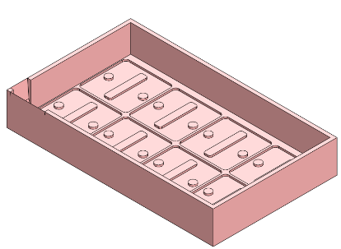

**3D printed mold for the device** patterned to prepare eight devices at a time. The thickness of the PDMS block is controlled with volume of PDMS poured into the mold.

Finally, all the layers were bonded together in two steps using an ozone plasma cleaner (see fig 1.3). First, we bonded the glass to the bottom channel and simultaneously bonded the middle layer to the top channel. Once these layers were bonded, we then bonded them to each other with the membrane sandwiched in the middle.

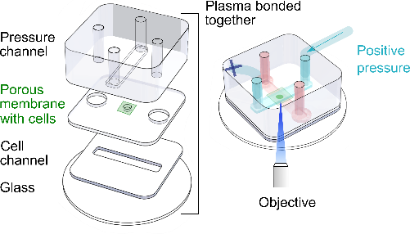

**Fabrication of MOLI**: Four layers assembled together with ozone plasma cleaning. Each channels has a inlet and outlet. Only the pressure channel is connected to the tubing; one side connects to the reservoir and other is sealed.

### Protein patterning and "upside-down" cell culture

After a few trials, we realized that the entire device needed to be contained in a Petri dish due to the cell culture medium. Placing the glass slide in a larger Petri dish resulted in liquid flowing underneath the glass, and any leakage during pressure application caused spillage in the microscope. Consequently, we designed the setup to fit within a glass-bottomed dish (35 mm, no. 0 coverslip thickness, Cellvis).

In the context of the spontaneous dome system, the upper surface was accessible for various treatments and microcontact printing using a polydimethylsiloxane (PDMS) block. However, in our case, we have a completely sealed device, which necessitated the use of the photopatterning technique known as PRIMO. The PRIMO technique had been optimized previously for substrates made of glass and soft PDMS. For our setup, we had to optimize the technique for use with a plastic porous membrane, which entailed increasing laser power and protein concentration (for details see the Appendix). In brief, we first coated the surface with poly-L-lysine (PLL) and then SVA-PEG chains. Upon illumination with blue light, selective regions could be cleaved and subsequently exposed to adhesion-promoting proteins. In our experiments, we utilized fibronectin, although other proteins such as vitronectin and collagen could also be coated onto the surface.

We also had to optimize the cell seeding. Unlike in other setups where cells could be seeded in a dish, the channel required a higher concentration of cells than typical spontaneous dome experiments. We seeded $30×{10}^{6}$ cells/ml for one hour and then washed away the cells that did not attach within that hour.

In our early experiments, we observed that while cells attached to the top side of the porous membrane, there were very few dome formations upon application of pressure. Additionally, the quality of imaging was poor due to imaging through the porous membrane. In the top channel, the cells were further away from the microscope objective, and we also noticed that cells were filtering through the membrane from top to bottom (see fig 1.4).

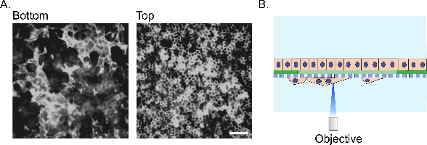

**Cells filtering through the membrane**: (A) Images of MDCK-CiBN CAAX GFP monolayer on the both sides of the membrane. Scale bar is $80μm$ (B) Schematic of imaging through the porous layer.

To prevent cells from crossing the membrane, we decided to use a membrane with smaller pore size, around $400nm$. However, imaging the green channel ($488nm$) through these pores was impossible. Therefore, we decided to change the side of seeding cells from top to bottom, which improved two things. First, imaging was better as the cells and dome were closer to the objective. Second, cells were seeded on the good side of the protein pattern.

We termed this "upside-down" cell culture, where we would flip the device immediately upon seeding cells in the bottom channel to ensure attachment on the membrane, not the glass (see fig 1.5). We had to thoroughly wash the channel to prevent cells from attaching to the glass, which would obstruct the imaging of the domes.

Despite these improvements, the ultimate challenge was ensuring that the cell monolayer covered the non-adhesive regions. To resolve this issue, we increased the protein concentration in these regions so that cells could attach there weakly and detach first to form a dome.

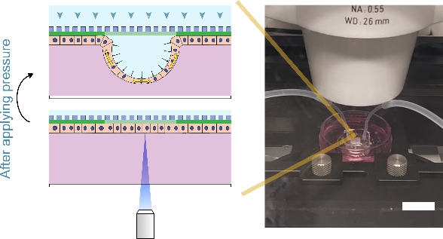

**Upside-down cell culture**: Illustration of upside-down cell culture and the experimental setup on the microscope stage.

### Pressure control

After optimizing protein patterning, cell culture conditions, and confocal microscopy, we turned our attention to pressure control. Our idea was to use hydrostatic pressure. Previous studies indicated that the pressure required to form a dome is around $100Pa$, which is equivalent to $1cm$ of water column.

In early trials, we used pipette tips to apply pressure. However, we found that they were prone to bubbles and leaks. Therefore, we switched to using Polytetrafluoroethylene tubing, which was connected to a $15ml$ reservoir (falcon tube) (see fig 1.6). This system allowed us to match the height of the device with the air-liquid interface in the tube, resulting in zero pressure on the monolayer. By increasing the height of the tube by $2cm$, we could apply $200Pa$ pressure to the monolayer, causing it to delaminate and form domes.

However, we had to be careful of cavitation or bubbles getting trapped in the cell channel. To prevent this, before the experiment we had to place the media in a vacuum chamber to get rid of nascent bubbles that could grow over time. Additionally, during tubing insertion, we could introduce bubbles again. To address this issue, we used the two inlets for each channel to flush the fresh media from the reservoir, ensuring that there were no bubbles present.

To control the pressure, we used an automatic translation stage that could be programmed to lift the reservoir. We measured the pressure by tracking the height of the stage and the zero-pressure position. With this stage, we could apply pressure in the range of $0→1500Pa$, and we could even apply negative pressure by setting it lower. For our experiments, we used the range of $-200→1300Pa$.

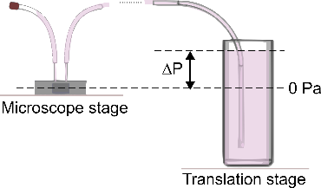

**Hydrostatic pressure application**: The device is positioned on a microscope stage and connected to a reservoir of media, which in turn is attached to a translation stage. By increasing the difference between the device and the air-liquid interface, we can measure and apply hydrostatic pressure.

### Imaging the epithelial domes

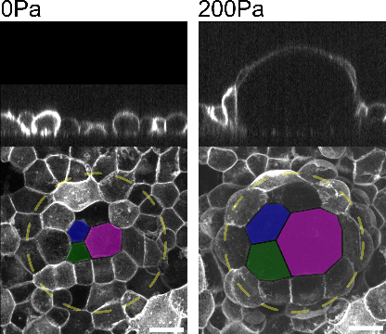

**Epithelial dome:** Representative confocal microscopy sections of domes at 0 Pa and 200 Pa. Images in the XY plane represent the dome’s maximum projection, while images in the XZ plane represent a cross section at the center plane. Three cells are highlighted with color to show the stretching during the dome inflation. Scale bar is $20μm$.

Following extensive optimization of protein patterning, cell culture conditions, and confocal microscopy techniques, we were able to generate domes in accordance with the intended pattern and exert precise control over the pressure required for their formation. To obtain images of the dome, we utilized a spinning disk confocal microscope with a 40x objective lens, which allowed us to visualize the membrane (CIBN CAAX GFP) and adhesion protein (Fibrinogen) pattern in separate channels ( $488nm$ and $644nm$, respectively). By incorporating a labeled adhesion protein, we were able to track the formation of the domes with greater ease and accuracy.

Initially, we were mainly interested in spherical domes at constant pressure to characterize the epithelial mechanics (see fig 1.7). We could monitor pressure, cell shape, and tissue curvature easily, enabling us to utilize Laplace’s law to calculate tension. However, previous studies have tracked the dynamics of the domes at a much slower rate of $5$ minutes. In contrast, our domes could be inflated and deflated in a matter of seconds, forcing us to monitor them only by looking at the base of the dome, where the monolayer would come in and out of view.

However, acquiring images of the dome stack using a step size of $0.5μm$ and height of $100μm$ in a confocal microscope required three minutes, which was slower than the rate at which we could deform the dome by changing the pressure (see fig 1.7). To investigate the rheology of the domes, it was necessary to monitor their dynamic response at faster pressure rates and shorter timescales, with a focus on measuring dome strain and curvature. Given the dome’s inherent symmetry, imaging the mid-section of the structure provided sufficient information to characterize its material response.

With the line scanning mode of a Zeiss Airy Scan Microscope, we were able to quickly image a single line of pixels across the midsection of the dome and take a confocal z-stack along the height of the dome (see fig 1.8). This provided us with a cross-section of the dome in a fraction of the time of a normal stack. By enabling piezo stage movement, we were able to image a $100μm$ tall dome in just $4s$, and could even track the dome height evolution through a kymograph of the central part of the dome. However, it is important to note that this form of imaging is primarily useful for tracking dome strain and curvature, and the quality of the cell images is often low. In cases where the fluorescent expression of cells on the top of the domes was inadequate, the data was much noisier.

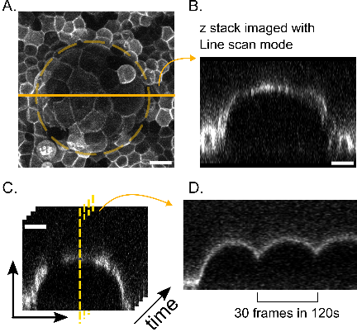

**Imaging the dome with Line scanning mode:** (A) Confocal microscopy image of a dome’s maximum projection. (B) Midsection of the same dome imaged with the line scan mode (LSM). (C-D) Timelapse of the dome in LSM and a kymograph showing dynamics of the domes when imaged at time-step of $4s$. Scale bars are $20μm$.

### Light-sheet MOLI

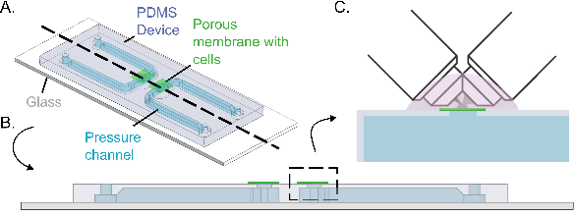

**Light sheet MOLI**: (A) Isometric illustration of a single piece PDMS block engraved with two channels, so that we can have two devices in one. (B) Cross-section of the device. (C) The device is used with 40x immersion objectives coming at $45deg$ angle. This limits to the field of view to $332×332μm^{2}$.

Later in my PhD, we used a Brucker QuVi SPIM light sheet microscope to observe rapid cellular or sub-cellular changes. It has two immersion-upright 40x objectives at 45 degrees to the horizontal plane. With our expertise in fabricating devices, we designed a new setup that exposed cells and porous membranes to the top for imaging (see fig 1.9).

To simplify the setup for fabrication, we inverted the normal MOLI device. This only required a pressure channel and middle layer with a hole and porous membrane. The device had to be thick enough to plug in the tubing. Since the device and channels were large, we could fabricate the mold using a Ultimaker 3D printer. We created a ridge-like protrusion so that the pressure channel and cell seeding hole could be manufactured in one go. We bonded the device to a microscope slide using unpolymerized PDMS. We were able to perform PRIMO patterning of the device by flipping it upside down. Seeding cells in this setup was easier as the cell seeding part was exposed.

As expected, we were able to apply pressure using the same system as before to generate domes. By using the imaging strategy we developed, we were able to obtain a full dome image within a mere 4 seconds, which allowed us to observe fast-moving features that were not discernible using other imaging techniques (see fig 1.10).

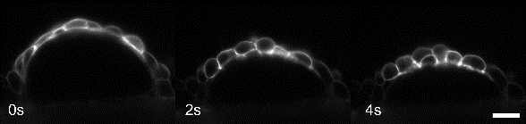

**Dome imaged with Light sheet MOLI**: Mid-section of a dome with membrane marker imaged every $2s$. Showing the shape of individual cells undergoing changes during deflation. Scale bar is $20μm$.

### Summary and Discussion

We have developed a microfluidic chip to generate 3D curved epithelia, utilizing a multilevel device consisting of two layers separated by a porous membrane. Seeding cells on the membrane in the bottom channel allowed for dome formation closer to the microscope objective, enabling high-quality confocal imaging. Hydrostatic pressure was used to control pressure under the dome dynamically, allowing for monitoring of cells and tissue behavior. Additionally, we developed imaging strategies to capture dynamics of these 3D structures faster using line scanning mode of confocal microscope or light sheet microscope.

However, it is worth acknowledging that while the method of forming 3D epithelia described here may seem straightforward, it required many iterations of the device and other attempted methods that ultimately failed.

We formed the domes and were able to monitor cells and tissue behavior. As shown in previous studies, the most interesting part of the system is that the complex material such as epithelial tissue to maintain mechanical equilibrium has to adopt a spherical cap shape for circular footprint. This uniform curvature and pressure implies uniform tension, for this we don’t even need material properties of the tissue (Latorre et al. 2018; Marín-Llauradó et al. 2022). The tissue tension can be measured easily by applying Laplace’s law for spherical cap domes. However, in case of the non-spherical geometry, there would be anisotropic stresses which would require computational model to solve an inverse problem to go from geometry to forces (Marín-Llauradó et al. 2022).

The geometry of the domes is primarily controlled by the adhesion protein pattern, but delamination can still occur. In spontaneous domes, circular footprints were found to be the most common (Tanner, Frambach, and Misfeldt 1983), while domes formed around sharp corners can blunt themselves through delamination (Latorre et al. 2018). This must be taken into consideration when creating specific geometries.

Tissue tension and adhesion forces also interact with each other. In MDCK suspended monolayer, it is seen that cell-cell junctions are stronger than cell-substrate adhesion (A. R. Harris et al. 2012), so if tension at the base of the dome exceeds the adhesion forces, it can lead to detachment and delamination.

Moreover, unintentionally, we have created a peeling system that allows us to observe tissue being peeled off from the substrate. If the dome remains spherical, we can calculate the forces required to break cell-substrate adhesion and identify the role of molecular components of focal adhesion. However, our primary interest lies in understanding the mechanics of epithelial tissue under controlled pressure.

## Dynamic material response of epithelial domes

### Introduction

The motivation of this thesis was twofold: firstly, to produce three-dimensional epithelia with controlled pressure, and secondly, to study the material response of the tissue to different regimes of tension. To achieve the first objective, we have developed a monolayer inflator (MOLI) device that allows us to create epithelial domes where cells can be stretched to more than $100\%$ of areal strain.

Epithelial tissue plays a crucial role in various physiological functions, and must therefore undergo deformation over a wide range of timescales and magnitudes. Similarly, pressure levels also vary widely in different contexts (Torres-Sánchez, Kerr Winter, and Salbreux 2021; Choudhury, Benson, and Sun 2022). For instance, the luminal pressure in blastocysts doubles over the course of its development, resulting in changes in cortical tension and strain (Chii Jou Chan et al. 2019). The MDCK dome system provides a suitable platform to investigate the interplay between cell strain, tension, and pressure. Previous studies by Latorre et al. have observed a wide range of pressure throughout the evolution of the dome, and cells have exhibited a range of deformation, including active-superelastic behavior (Latorre et al. 2018). However, the control in this system is limited to the footprint of the domes. In this chapter, we aim to utilize the MOLI system to subject tissues to a range of strain and tension regimes.

### Measurement of dome mechanics

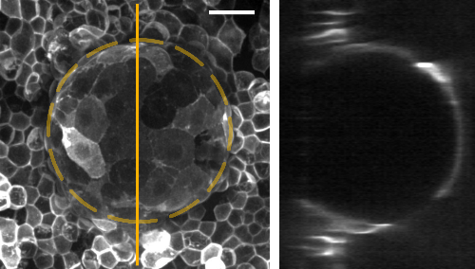

**Spherical cap**: Here is an example of an epithelial dome at 200 Pa, which has increased its surface area four times the original footprint. One can clearly appreciate the beautiful spherical shape of the dome in the cross-section. Scale bar is $20μm$.

To measure the kinematics of the domes, we analyzed the midsection of the domes, assuming symmetry of spherical caps (see fig 2.1). We measured the height ($h$) and base radius ($a$). This allowed us to calculate the radius of curvature ($R$) using trigonometry as

$$R=\frac{h^{2}+a^{2}}{2h}.$$

The measurement of pressure ($ΔP$) allowed us to compute the tension ($σ$), given by Laplace’s law

$$σ=\frac{ΔPR}{2}.$$

For the dome strain, we used the areal strain measure, which is computed based on the surface area. We compared the dome surface area ($A$) to the area of the footprint ($A_{0}$).

$$ϵ=\frac{A-A_{0}}{A_{0}}=\frac{π\left(h^{2}+a^{2}\right)-πa^{2}}{πa^{2}}=\frac{h^{2}}{a^{2}}.$$

Using the line scan method of imaging domes for fast time-lapse, we obtained a large number of frames for the analysis of the height and radius of curvature. Thus, we used kymographs of the top section of the dome. Kymographs are images with a cross-section of the dome top with respect to time. Using image processing MATLAB code, we obtained the location of the maximum intensity value for a particular time in the graph to obtain the time evolution of the height of the dome. The same method was used for the base radius as well. The kymograph of the base radius allowed us to keep track of delamination, as it could change the value of strain.

### Epithelial domes at constant pressure

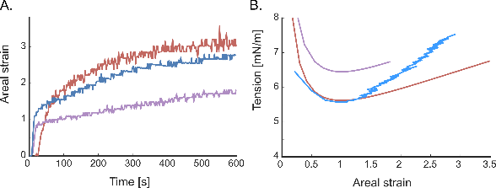

**Epithelial domes at constant pressure**:Dynamic response of the representative domes at a constant pressure of 200 Pa: (A) Areal strain increases and reaches a steady state at around 5 minutes, and we can clearly see variability in the maximum strains. (B) The same domes produce a peculiar "NIKE swish" shaped tension and strain curve.

Initially, our focus was to investigate the behavior of domes under constant pressure. We conducted experiments inflating domes at varying pressures, but observed that hardly any of the domes formed at pressures lower than $50-100Pa$. After optimizing for different pressures, we settled on using $200Pa$ which allowed domes to form without delaminating out of pattern.

Our results indicate that the areal strain of the dome increases during the first $3-5$ minutes of pressure application, and then reaches a plateau in strain until $5-10$ minutes (see fig 2.2 A). Despite large dome-to-dome variability, with strains ranging from $50\%$ to $300\%$, the stabilization in strain suggests that a steady state has been achieved by the tissue.

Further examination of the tension-strain relationship of these domes revealed a distinctive curve, resembling the swish symbol of "Nike" (see fig 2.2 B). The tension is extremely high for low strains, and then decreases to a minimum around an areal strain of one, where the dome forms a perfect hemisphere. The tension increases again, but the slope is relatively gentle as compared to the steep decline observed at low strains.

This kind of material response would be unusual for typical materials undergoing biaxial stretching. However, in our case, the underlying cause of this curve can be attributed to the geometric constraint imposed by the dome system and force balance (Laplace’s law). Since the tension in the dome is a function of its radius of curvature, the radius of curvature starts out very high, producing higher tension that then reduces to a minimum with a hemispherical shape before increasing again (see fig 2.3). The radius of curvature, areal strain, and tension are inherently interconnected, such that at a constant pressure, we can write the expression of the curve.

$$R=\frac{h^{2}+a^{2}}{2h}, \text{and} ϵ=\frac{h^{2}}{a^{2}}$$

By substituting ($ϵ$) in ($R$),

$$R=\frac{h^{2}/a^{2}+1}{2h/a^{2}}=a\frac{ϵ+1}{\sqrt{ϵ}}$$

By substituting ($R$) in Laplace’s law, we get the relation

$$\frac{σ}{a}=\frac{ΔP}{4}\left(\frac{ϵ+1}{\sqrt{ϵ}}\right)$$

Normalizing the tension with the base radius results in all domes collapsing onto one curve corresponding to a specific pressure. We call this curve the "isobaric" curve.

In terms of physics, we understand that when the step pressure is applied, the dome suddenly inflates and has to undergo non-steady state out-of-equilibrium stresses. It is clear that this curve does not represent the quasi-static constitutive relation of the epithelial tissue.

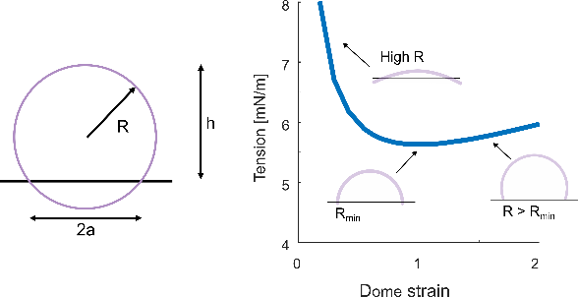

**Illustrative explanation for isobaric curve**: Tension and strain are related to each other through the geometric constraint of a spherical cap. Here, the base radius (a) is constant, so the radius of curvature is almost infinite for domes with very small strains (<0.05). As the strain increases, the radius of curvature decreases to a minimum corresponding to the base radius. Then it continues to increase again.

### Constitutive relation of epithelia

To obtain the actual constitutive relation, it is preferable to apply strain or tension to a material in a quasi-static manner. However, in our experimental system, only pressure can be controlled. Therefore, we utilized pressure control to achieve steady state tension across a range of strains. Slowly increasing pressure was not practical for domes, as they do not delaminate at low pressures. If delamination did occur, the domes would rapidly inflate and achieve the steady state at higher strains. Consequently, we would not be able to access steady state tensions at lower strains. To address this limitation, we designed experiments for capturing the steady state of the domes by deflating them.

We applied a pressure of 200 Pa for 5 minutes until the dome reached a steady state. Then, we reduced the pressure in steps of 20 Pa and waited for the dome to reach a steady state at each step (see fig 2.4 A). We repeated this process until the dome was completely deflated. In this way, the tension-strain curves captured as the dome passed through different isobarics.

Ultimately, we obtained a constitutive relation that exhibits a initial increase in tension with strain for lower strains. However, for larger strains, the tension seems to plateau consistently with earlier studies of MDCK domes (see fig 2.4 B). It is worth noting that the variability in dome-to-dome tension is significant, and the tensions recorded around $4.5mN/m$ are of the same order of magnitude as in previous studies (Latorre et al. 2018; Marín-Llauradó et al. 2022).

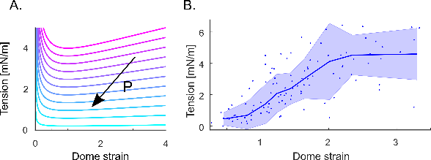

**Constitutive Relation of Epithelia**: (A) We will set up experiments to probe the steady state at different pressures. We will start from the highest pressure, move along the isobaric line and achieve a steady state, and then move down to the next isobaric line, and so on. (B) The constitutive relation between dome strain and tissue tension was experimentally obtained (n=12). The line and shaded area represent the median and standard deviation, respectively, by binning 13 points in each bin.

### Dynamics of the epithelia domes

To investigate the dynamic material response of the domes, we conducted cyclic stretching experiments by subjecting them to a triangular wave of pressure with a magnitude of 200 Pa at three different timescales (see fig 2.5). Based on the literature on cell remodeling and experimental conditions, we chose cycles of $20s$, $266s$, and $2000s$ (T. Wyatt, Baum, and Charras 2016; Khalilgharibi et al. 2019; Casares et al. 2015).

|  |  |  |  |
| --- | --- | --- | --- |
|  | Fast | Moderate | Slow |
| Time period (s) | 20 | 266 | 2000 |
| Rates (Pa/s) | 20 | 1.5 | 0.2 |

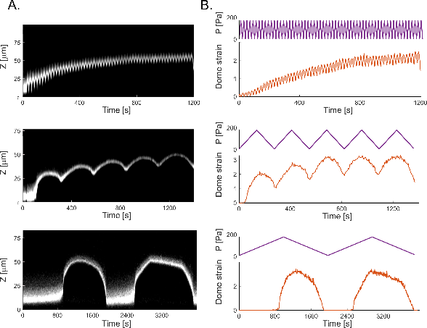

**Dynamic response of Epithelia:** (A) The XZ plane images and kymographs of domes subjected to cyclic pressure between 0 to 200 Pa with rates of 20, 1.5, and 0.2 Pa/s The kymographs generated along the midsection of the domes indicated by yellow dotted lines. These indicate the evolution of height of the domes with respect to time. (B) The strain response of domes to cyclic pressure with different rates. Magenta represents pressure and red represents strain with respect to time. For A, B, n= 7 domes for 20 Pa/s, n = 8 for 1.5 Pa/s, and n = 7 for 0.2 Pa/s.

In the case of the fastest cycles, we observed that the domes progressively stretched more as the cycles progressed until they reached a steady state oscillation. We conducted the experiment for $1200s$ (60 cycles) and noticed that the domes accumulated strain progressively. While loading, they stretched, and while unloading, they unstretched but did not return to zero strain after the first few cycles. In the last few cycles, we observed that the dome oscillated between two states of strains.

A similar response was observed for the moderate cycles, where the domes were stretched for five cycles of $266s$ each. The strain accumulated in the first cycle itself, with strains reaching higher values than those observed in the fast case. Additionally, after a few cycles, the dome appeared to have reached a steady state.

For the slowest cycles of $2000s$, we faced difficulty in forming domes at lower pressures. As previously mentioned, the domes did not detach until they reached a critical pressure of $100-150Pa$, after which they rapidly inflated to high strains of $200-300\%$. However, it was evident that the strains did not accumulate, and there was no difference in the maximum strains achieved in both cycles, indicating that the steady state was reached immediately at this timescale.

### Active gel tissue model

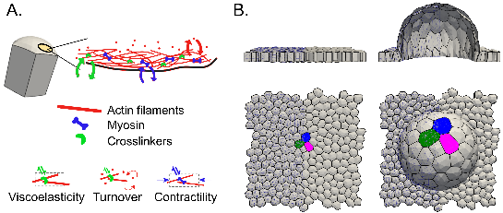

**Active gel tissue model**: (A) The cell is modeled as an active gel of cortex, which mainly comprises three aspects: viscoelasticity of the network, turnover dynamics, and active contractility. (B) These cells can be assembled into a tissue that can be used to perform in-silico experiments. An example of this is the digital dome being inflated, highlighting individual cells increasing their area.

In addition, to complement our experimental findings, we collaborated with Adam Ouzeri to develop a computational framework. Our understanding of epithelial mechanics suggests that the viscoelasticity of the actin cortex plays a crucial role in sustaining deformations at the timescale of seconds to minutes (Kelkar, Bohec, and Charras 2020; Clément et al. 2017; Khalilgharibi et al. 2019). Adam Ouzeri developed a theoretical framework that bridges active gel models of the actomyosin cortex and 3D vertex models at tissue scales (Ouzeri and Arroyo 2023). In this model, each cell is represented by an active gel surface that accounts for the physical aspects of the cortex, and a tissue is assembled from a collection of these active gel surfaces (see fig 2.6). The dynamics of the system are formulated through a balance of different potentials that represent different active internal or external forces and dissipation.

The framework accounts for the molecular dynamics of the actin filament network, myosin, and crosslinker proteins through four main components:

1. **Cortical thickness:** The cell cortex is modeled as a hyperelastic membrane with cortical thickness ($ρ_{R}$). The deformation kinematics of this model is defined by mapping a cortical patch from a reference configuration ($Γ_{0}$) to a deformed configuration ($Γ$) with metric tensor [11] () to (), respectively. To capture remodeling of cortex, the reference configuration has to be dynamic as well. Thus, there is a second reference configuration with a dynamic metric tensor ($G$). The cortical thickness in the reference configuration changes with the mapping change represented by the Jacobian ($J_{R}$). This is expressed as
$$ρ_{R}\left(ξ,t\right)=ρ\left(x,t\right)J_{R}\left(ξ,t\right).$$

2. **Network elasticity:** This potential accounts for the free energy of the system undergoing deformation. The potential is dependent on the difference between in-plane strain ($C$) and the metric ($G$) written in the format of a hyperelastic potential ($W$). Using a Neo-Hookean elastic potential, $W$ depends on two Lamé parameters, ($λ$) and ($μ$). This potential is expressed as


3. **Dissipation:** The actomyosin network remodels under tension, and the released elastic energy can be accounted for with a dissipation potential. The potential depends on a coefficient ($η$) equivalent to bulk viscosity, cortical thickness, and the rate of metric tensor given by ($\dot{G}$). This potential is expressed as


4. **Active contractility:** The model is an active gel, and the active part is included through an active power potential that adds energy to the system. The potential is dependent on the cortical tension and the rate of deformation tensor. The cortical tension is an active tension component of the network that is proportional to cortical thickness. This potential is expressed as $γ\left(ρ\right)=ρξ$ and



Additionally, we account for turnover dynamics in the cortex through a mass balance law. Here, we assume that there is a steady-state cortical thickness, and the network is constantly polymerizing and depolymerizing with cytosolic components. This is expressed as

$$\dot{ρ}+ρ tr\left(d\right)=k_{p} C-k_{d} ρ.$$

The proposed governing equations are obtained by minimizing the Rayleighian, which is given as:

$$R=\frac{dF}{dt}-D+P+P_{e}.$$

Here, $P_{e}$ is an additional potential that accounts for external forces and tractions. The model assumes that the volume of the cell is conserved during deformation, and a mechanical barrier is introduced to prevent excessive strains beyond a threshold. This barrier is implemented by adding re-stiffening at large strains, which is necessary for physiological reasons, such as activation of intermediate filaments, cell crowding, or compression of the nucleus.

The model exhibits three timescales: turnover time ($t_{to}=1/k_{d}$), viscoelastic time ($t_{ve}=η/λ$), and viscoactive time ($t_{va}=η/ξ$). At shorter timescales, the system behaves like an active hyperelastic material, while at longer timescales, it behaves like an active viscoelastic material.

Adam Ouzeri was able to implement this model in our system by creating a digital twin of the monolayer consisting of cell membranes. Non-adhesive regions were also included, which could be inflated into domes under pressure, similar to the experimental setup. Here after, we will refer to them as "digital domes" (see fig. 2.6).

### Active viscoelasticity of the epithelia

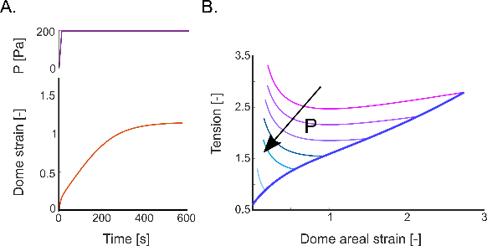

**Material response of the digital domes**: (A) When subjected to constant pressure, as in experiments, the digital dome inflated and reached a steady state. (B) These simulations also produced isobarics for different pressures, all leading to a steady state. Furthermore, subjecting it to a quasi-static increase in pressure produced a constitutive law (Navy blue curve) that can be mapped onto the locus of steady-state points.

By conducting simulations that mirror the experimental conditions, we were able to gain insights into the mechanics of the system. Specifically, we found that when digital domes were inflated with constant pressure, they reached a steady state while experiencing a reduction in cortical thickness as the cells stretched. Once the tissue tension was balanced by the applied pressure, the strain reached a stable point (see fig 2.7 A).

To evaluate the constitutive relation provided by the model, we inflated the digital dome with different pressures to obtain isobaric curves and steady state points. We also inflated a digital dome quasi-statically, though this is not feasible in experiments, to assess the model’s robustness. We discovered that the constitutive relation obtained quasi-statically was consistent with the steady state locus in the isobarics (see fig 2.7 B). The constitutive curve exhibits similar characteristics to experiments, including clear re-stiffening at large strains, which we attribute to a barrier mechanism.

We interpreted these findings in light of the concept of resting area, which refers to the area of a cell in a monolayer that is in a steady state. When the tissue is perturbed from this state, the actual area changes faster than the resting area due to the viscoelastic behavior of the tissue. The cell can dissipate elastic stresses at viscoelastic timescales through remodeling, eventually reaching a steady state. This effect of timescales is particularly evident in cyclic stretching experiments. When the cells are probed faster than viscoelastic timescales, they accumulate strains due to an inability to dissipate the elastic stress. In contrast, when stretching is slower, elastic stresses are dissipated with increasing area.

We observed that, for the slowest condition, the resting area in the digital dome almost overlapped with the actual area. This is because the pressure is changing very slowly at a rate of 0.2 Pa/s, allowing the cells sufficient time to remodel and dissipate elastic stresses. Viscoelastic and turnover timescales in simulations are around 10-30s, which means that over a period of 2000s, the dome stretches considerably and returns to original flat state.

However, when pressure is applied rapidly in cycles of 20 seconds, strains accumulate due to insufficient time for cells to dissipate stored elastic energy. Our simulations show that the resting area marginally changes relative to the actual area. Notably, creep experiments, where tissue is stretched at constant tension, demonstrate strain accumulation at the visco-active timescale, where both contractility and viscosity play a role.

Interestingly, our simulations indicate that due to active viscoelasticity, there would be a lag between the peak of pressure and the peak of strain. This lag is clearly reflected in the comparison of resting area and actual area, where the delay decreases with increasing pressure rates. The slowest pressure rate results in the least amount of delay, while the fastest pressure rate results in the most delay. although we can only experimentally observe this at moderate rates. The experimental data from faster cycles is too noisy to observe the lag.

To sum up, the digital dome model explains the different behaviors of epithelial tissue depending on the rate at which pressure is applied. Slower rates allow for cell remodeling and dissipation of elastic stresses, while faster rates result in strain accumulation due to insufficient time for dissipation.

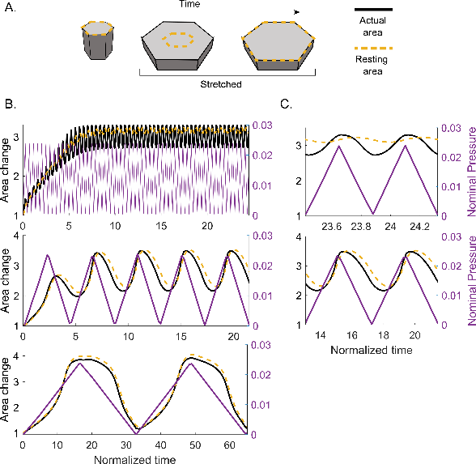

**Concept of resting area**: (A) Illustration of a resting and actual are of a cell in a monolayer during stretching. (B) Differences in results of resting and actual area when subjected to different rates of pressure. (C) Inset of the last two cycles.

### Summary and Discussion

In this study, we investigated the mechanics of epithelial tissue by applying pressure at varying rates. Initially, we applied a constant pressure of $200Pa$, which led to the dynamic inflation of domes and eventually reached a steady-state in strain. Due to the spherical geometry of the tissue, we observed a non-monotonous tension-strain curve in response to the constant pressure. However, we found that the true tension-strain curve exhibited increasing tension with respect to strains at lower values, but at higher strains, the tension appeared to be independent of the strains.

Furthermore, our results showed that the domes accumulated strain through the cycles when probed with fast-changing pressure and reached a steady-state in later cycles. However, when stretched slowly, the domes stretched to high strains without accumulating strain.

To understand the behavior of epithelial tissue, we developed an active viscoelastic fluid model, which allowed us to probe the time-dependent response of the tissue to pressure. Our experimental and computational framework show that the response of the domes to cyclic pressure is dependent on active viscoelasticity.

The tissue stretches to balance the tissue tension with externally applied pressure timescale and reaches a steady-state strain by actively remodeling the cortex. Our digital dome studies indicated that different timescales play a role together in producing the tissue’s response to pressure. These timescales are the reflection of interplay between cortical turnover, crosslinkers, and network reorganization which allows for large deformations and rapid shape changes.

Our results can be interpreted using a multidimensional Maxwell model, which is a model that describes viscoelasticity. The classical Maxwell model consists of a spring and a dashpot, which represent the elastic and viscous elements, respectively. In our case, we can imagine a similar model with two branches: one branch includes a spring and a dashpot to represent the passive viscoelasticity, and a second branch includes an active spring to represent the active component (see fig 2.9). The active spring is always present, but if the stretching is done slowly, the dashpot would be driving the dominant mechanical response. Conversely, if the stretching is done rapidly, the elastic spring deformation would dominate. By separating the passive and active components, we can better understand how each contributes to the overall viscoelastic behavior and associated timescales.

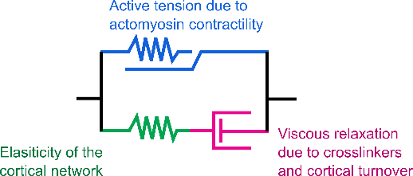

**Representational viscoelasticity model**: The model can be understood using a spring and dashpot analogy with two branches: The first branch is an active spring representing the contractile forces applied by the actomyosin cortex. The second branch has two components, one for the elasticity of the network and the second for the viscous relaxation that occurs due to turnover of the network.

Previous research has approached the system in a similar manner, where epithelial tissue was modeled using viscoelastic models of springs and dashpots. One particularly interesting model was developed by Khalilgharibi et. al., which characterizes the response of a suspended monolayer to stretch and demonstrates that the dynamics are similar to that of a single cell, due to the role of the actomyosin cortex (Khalilgharibi et al. 2019). They used a model with two springs in parallel, one of which can change its length dynamically. This explains the relaxation of the monolayer, where the active contractility of the cortex changes the resting length of the active spring in the model, which closely relates to our "resting area" concept.

Another study found that viscoelastic dissipation could explain the shortening or elongation of cell junctions in drosophila embryos (Clément et al. 2017). They demonstrated that the dissipation occurs at the minute timescale, at the same timescale as myosin pulses. It is also interesting that they found actin turnover plays a key role in this dissipation.

Applying tensions and strains to suspended cells in vitro is a challenging task, and it is important to note that adherent monolayers may exhibit different behaviors from suspended cells (A. R. Harris et al. 2012). The tissue matrix provides additional stiffness and can alter the cytoskeletal structure of cells, which further complicates the understanding of cell mechanics (Humphrey, Dufresne, and Schwartz 2014; Kechagia, Ivaska, and Roca-Cusachs 2019). In this thesis, we focus specifically on the actin cortex and short timescales (minutes).

The timescale of actin remodeling is on the order of tens of seconds, and we did not observe any cellular rearrangement or division at this timescale in our system (with rare exceptions). Long-term experiments were not performed due to suspected involvement of other cytoskeletal components, such as intermediate filaments. In a study by Latorre et al., activation of intermediate filaments was observed in extremely stretched cells ($>300\%$), which caused re-stiffening and prevented the cells from stretching too much (Latorre et al. 2018). This motivated the strain limiting mechanism imposed in our model. However, in our experiments, we did not observe any indication of superelasticity, as all cells were super-stretched at the same time. This might be due to the relatively shorter timescales in our experiments compared to long term quasi-static deformation of spontaneous domes.

**About strain stiffning and results of (Duque et al. 2023). About racheting of contractile force (Clément et al. 2017; Mason and Martin 2011) and strain accumulation or creep**

In the next chapter, we will endeavor to apply our understanding of viscoelasticity to generate radical transformation of domes into various structures.

## Epithelial Buckling: Transforming Domes into Folds

### Introduction

Epithelial structures in biology exhibit a diverse range of shapes and sizes, including curved or folded forms. Understanding these structures can be complicated, particularly in the context of developmental biology. Interestingly, the etymology of the terms "development" and "complicated" provides insight into the importance of folding and unfolding processes. "Development" comes from "desvelopemens," meaning "unfolding," which describes the morphogenesis of an organism. In contrast, "complicated" comes from "com-plicare," meaning "folded together," which is fitting for describing the emergence of complex, folded structures in epithelial tissues.

In our experimental system, 3D epithelial structures can be generated by inflating domes, transforming a planar monolayer into a curved structure. In this chapter, we will discuss how these structures can be made even more "complicated". By studying the mechanics of epithelial tissue, we have discovered that the dome can be deflated into folds by rapidly depressurizing it. We will explore the process of epithelial buckling and discuss how this knowledge has enabled us to transform domes into folded structures.

### Rapid deflation produces a buckling instability

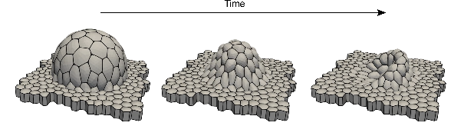

**Digital dome undergoing buckling**:Here, a digital dome at a steady state is rapidly deflated to a negative pressure of $-50Pa$. As the cells don’t have enough time to reduce their area, they collapse into a fold.

In our experiments involving constant pressure, we observed that the dome reached a steady state through cytoskeletal remodeling. Specifically, the original footprint area increased to areal strains exceeding $100\%$, more than double the original area. Moreover, when subjected to cyclic stretching, we observed that rapid inflation-deflation cycles accumulated strains in the tissue. Given our precise control over pressure, we decided to expose the tissue to extreme rates of pressure, allowing no time for relaxation and could lead to buckling instability.

First by using the computational model, we were able to examine the mechanical effects of the digital dome on both tissue and cell scales. Our analysis revealed that active viscoelastic dissipation through cortical remodeling allowed the dome to achieve high strains. When we subjected the dome to cyclic stretching at rapid rates, we noticed a discrepancy between the actual and resting areas. This observation suggested that fast deflation could induce negative viscoelastic stress, leading to buckling.

Our findings showed that digital domes gradually returned to a flat monolayer when deflated at a rate slower than the remodeling timescale. However, deflating the domes more quickly than the remodeling timescales resulted in buckling (see fig 3.1). Simulations revealed that the negative pressure was necessary for inducing buckling, which affected only rapidly deflating domes. This was due to negative stresses, as the pressure became negative while the curvature remained positive. In contrast, slowly deflating domes reached zero strain as the pressure approached zero.

To systematically test our hypothesis regarding the factors affecting buckling events, we designed experiments with pressure profiles consisting of three stages (see fig 3.2). Firstly, we initiated a linear increase in pressure from 0 to 200 Pa over a period of 10 seconds. Secondly, we applied constant pressure for varying "hold times," which were chosen based on the timescales associated with actomyosin cytoskeletal remodeling. Finally, we decreased the pressure to -50Pa at varying "deflation rates."

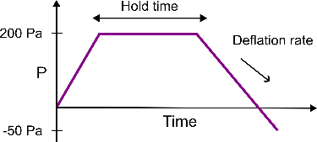

**Buckling protocol**: The pressure is increased to 200Pa for inflating the dome, and then the dome is given different amounts of time (hold time) to remodel before being deflated to -50Pa at different rates (deflation rate) to observe whether the dome buckles or not.

It is important to note that we relied on qualitative characterization of buckling events, assuming that smooth and continuous curvature of the monolayer indicates the absence of buckling. However, in cases where it was difficult to make an unbiased judgment, we enlisted the help of Thomas Wilson and Tom Golde to categorize the data. We performed the experiments for all conditions and quantified the data by tracking the fraction of domes that underwent buckling.

Our results showed that buckling occurred for all hold times, ranging from 6s to 600s, at the fastest deflation rate of 200 Pa/s. This confirmed our hypothesis that rapid deflation would induce compressive stresses and cause buckling (see fig 3.3 A-B). On the other hand, slow deflation at a rate of 0.2 Pa/s rarely led to buckling, regardless of the hold time (see fig 3.3 C-D). This suggests that the tissue can effectively remodel its cytoskeleton and adapt to drastic changes in area to avoid buckling.

As seen in previous experiments, longer "hold times" allowed for more cytoskeletal remodeling, resulting in higher strains and a higher likelihood of buckling, even for slower deflation rates. Results plotted in a phase diagram illustrates the trend: as hold time increases, buckling becomes more likely at faster deflation rates and less likely at slower deflation rates with a shorter hold time (see fig 3.3 E).

Interestingly, the data showed that domes with a 6s hold time had smaller strains compared to those with a 600s hold time, which is consistent with results from domes subjected to constant pressure (see fig 3.3 F). Strain increase requires time for the dome to remodel and balance active tension with the externally applied pressure. However, even at 6s hold time, we still observed buckling. Expectation for this condition was to allow us for inflation and deflation of the dome before it could remodel. We selected a 6s hold time based on imaging speeds, but it remained too slow for the remodeling timescales.

It is important to note that we observed a wide variety of buckling patterns when examining midsections of the tissue through a line scan method. Some domes exhibited minor kinks in the folds, while others showed drastic buckling modes similar to those of plates.

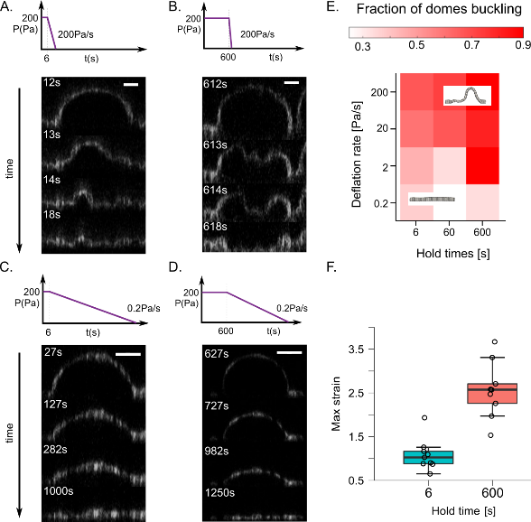

**Buckling conditions**: (A-D) Representative montages of dome deflation for experiments and model at different deflation rates of 200 and 0.2 Pa/s after holding pressure constant of 200 Pa for 6 and 600 s. Scale bars are 20 µm for XZ. (E) Diagram representing fraction of domes buckling for different deflation rates and hold time. Showing the optimum conditions for the buckling. (F) The maximum strain achieved is lower for 6s hold time compared to 600s conditions.

### Multiscale buckling

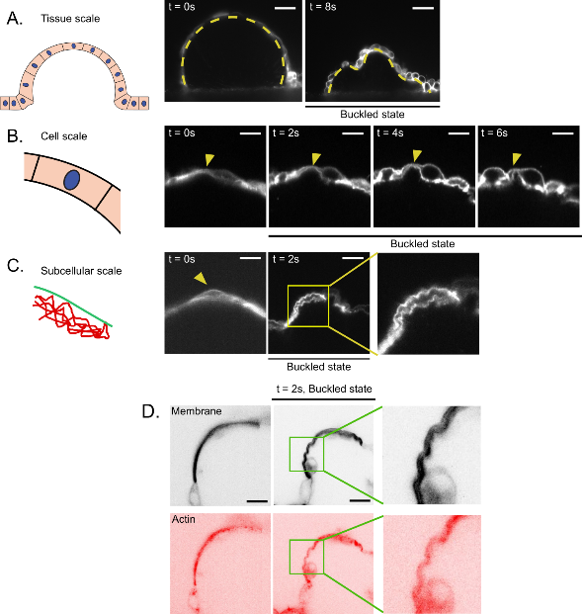

**Multiscale buckling**: (A-C) Representative images of the domes undergoing buckling at different scales. Buckled and unbuckled states of the dome with zoom in section buckled component. Dotted yellow line represents uniform curvature in unbuckled state and non-uniform curvature in buckled state. Scale bar is $20μm$. (B) Evolution of a single cell in the dome during buckling. Highlighted by yellow arrow. (C) Some parts of cells undergo buckling producing short wavelength folds. (D) These folds are also present in the cortex too. Scale bar is $5μm$ for (B-D).

The observation of tissue buckling was evident in the confocal line scan images. In order to gain a clearer understanding of the shape of the cells, we adapted a variation of MOLI for use with light sheet microscopy. The higher resolution 3D images of the dome revealed a variety of thicknesses, with thicker regions caused by the bulging of the nucleus and very thin regions at the cell periphery (see fig 3.5 B).

To further investigate the phenomenon of buckling, we repeated the experiments described in the previous section, this time with rapid deflation and a long hold time. We discovered additional features beyond tissue-scale buckling, including kinks and crimps at cellular and subcellular scales. Upon closer inspection, we classified three levels of buckling:

At the tissue scale, buckling was visible with cells collectively transitioning from a uniform curvature to a distorted shape (see fig 3.5 A). At this level, we observed cell deformation at a larger scale, including at the junctions between cells.

At shorter scales, we observed individual cells undergoing buckling (see fig 3.5 B). The buckling of the cell resulted in the cell doubling up around itself, with the apical side at the top. The length scale at which cell buckling occurred was much shorter than that observed at the tissue level. It appears as though the cell buckles as a single unit.

In some cases, buckling occurred at even shorter length scales, which we refer to as subcellular buckling, as the folds in the membrane were distinct from the cell level buckling. These folds occurred in the thinnest parts of the stretched cells, where the membrane buckled at much shorter wavelengths (see fig 3.5 C). Interestingly, these folds occurred on both the apical and basal sides of the cells.

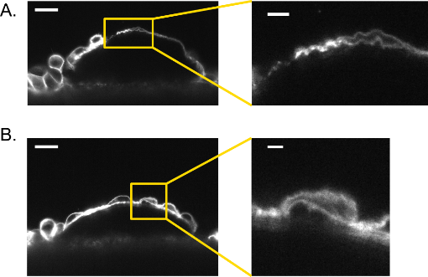

**Cell level buckling**: In many instances where the tissue does not buckle, we observe individual cells buckling. Here is an example of cell buckling (A) and subcellular buckling (B).

In epithelial cells, the membrane is typically attached to the cortex through membrane-cortex attachment proteins such as ezrin, radixin, and moesin. It is reasonable to assume that the subcellular buckling observed in our experiments is due to actin cortex buckling. To confirm this, we imaged the actin cortex while the dome was undergoing buckling using SPY actin staining (see fig 3.5 D). Our results showed that the actin cortex followed the exact shape of the membrane during buckling.

We also observed interesting results where some domes did not appear to be buckling at the tissue scale, but were still exhibiting buckling at the cell or subcellular level (see fig 3.8). These categories are not strictly separated, as we observed multiple instances of tissue, cell, and subcellular level buckling (see fig 3.5 A).

### Generating epithelial folds

After optimizing the buckling conditions, we embarked on exploring epithelial folds. We have been imaging only the cross-section of the dome to capture the fast dynamics. We see the buckling in form of the squiggly lines. However, these buckling events are three-dimensional (see fig 3.3 B). During tissue buckling, a large area squeezed into original footprint area resulted in the formation of folds and wrinkles in the monolayer. Monitoring the base of the dome deflating, we observed that the tissue made contact with the substrate in certain regions first and others later. This led to the formation of folds in the regions where it made contact last (see fig 3.7 A-C).

To investigate if there was any pattern to these folds, we looked at spherical domes of various sizes. Broadly, we observed three types of folding patterns emerging (see fig 3.6):

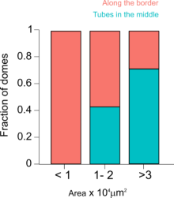

**Buckling patterns**: Buckling patterns observed in differently sized digital domes. The domes were grouped into three size categories and two categories based on location of folds (along the border and in the middle). We found that larger domes are more likely to buckle into a network of folds compared to smaller ones.

For domes with a footprint diameter smaller than $∼110μm$, we repeatedly observed that most of the buckling resulted in an accumulation around the periphery (see fig 3.7 A). The confocal timelapse from the base gave the impression of a donut-like structure, but three-dimensional imaging of the folds revealed a crescent-shaped fold like a croissant, taller on one side than the other. For larger domes with a footprint diameter greater than $∼300μm$, we observed more instances of domes forming a network of folds in the middle, with multiple folds connecting each other by forming junctions (see fig 3.7 C). Finally, for domes of intermediate size, we observed a mixture of accumulation and folds, although the proportion of folds along the periphery decreased (see fig 3.6).

Interestingly, we observed the same folding patterns in our digital domes when performing the same deflation experiments (see fig 3.7 D). Larger digital domes produced more radial folds, and small digital domes formed an accumulation on the side. Intermediate-sized digital domes showed a mixture of both patterns.

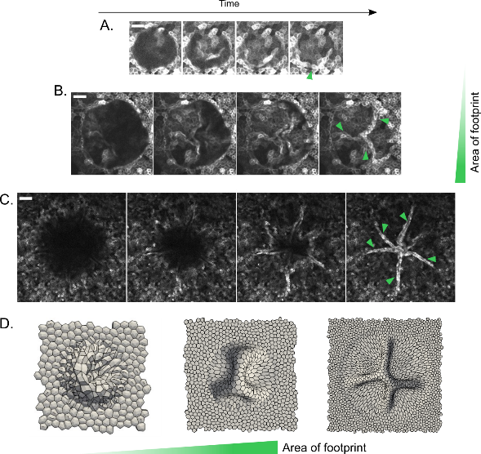

**Buckling patterns in spherical domes of varied size**: Representative examples of digital domes undergoing buckling with time-lapse of their basal cross-section (A-C). In the first frame, the onset of buckling is visible where the dome makes contact in the middle. Subsequent frames show more of the fold coming into view, and when the dome completely deflates, a fold is formed (indicated by the green arrow). Panel (D) shows the final outcome of buckling for digital domes of different sizes. Scale bar is $20μm$

### Forming predictable folds

We were curious about how the geometry of the domes could affect the pattern formation of folds. Although we observed that different sizes of spherical domes produced different beautiful buckling patterns, the axis-symmetric shape made it difficult to predict the patterns. To address this, we decided to generate ellipsoidal domes of different sizes using MOLI. Interestingly, we found that the ellipsoidal domes would buckle into a fold along their major axis, with smaller ellipsoidal domes producing a similar peripheral accumulation as spherical domes and larger ellipsoidal domes producing a fold in the center along the major axis (see fig 3.8 B). This suggested that only larger domes, regardless of their shape, could produce folds.

To further explore the possibility of creating more complex folds, we decided to buckle a dome with a triangular shape, anticipating that the vertices of the triangle could push the buckling along the medians of the triangle (see fig 3.8 C). As expected, the domes did buckle into forming a Y-shaped network of the fold (see fig 3.8 D). We also repeated the triangular and ellipsoidal shapes with digital domes and found similar patterns (see fig 3.8 A-B).

We also investigated the stability of these folded structures. We found that not all folds were alike, some would dissipate into the monolayer while others would last longer by forming attachments with each other, and they were stable for hours and could be imaged for more than 12 hours (see fig 3.8 E-F). Interestingly, if immediately inflated these folds would unfurl themselves into a dome again.

These results suggest that the MOLI system could provide a novel way of producing folds, with potential applications in tissue engineering, by simply controlling a few mechanical parameters such as geometry and pressure.

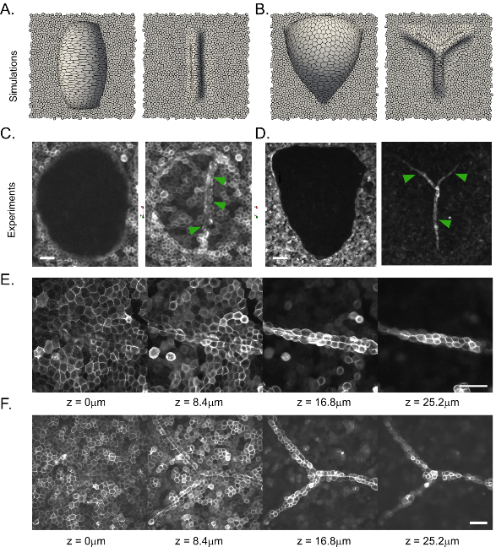

**Controling the patterns of fold**: A-B Simulations show digital models of ellipsoidal and triangular domes buckled into line and Y-shaped junctions. C-D Experimental results confirm the simulation findings. E-F Confocal z-stack images show the folds in the case of a line and Y-shaped junction. Scale bar is $50μm$.

### Summary and Discussion

We utilized our device to generate dome from a flat monolayer then transform it into folds, alongside investigating the buckling response in relation to actin remodeling timescales. We discovered that buckling occurs at various scales, starting from the tissue level down to the actin cortex of individual cells, and is triggered when deflation occurs more rapidly than actin can remodel. We then explored the patterns of folding that emerge from different sized and shaped domes, and proposed a new method of creating controlled folds from planar monolayer. With the aid of computational models, we demonstrated the engineering potential of the dome system to produce structured folds by manipulating the geometry and pressure.

As mentioned earlier, mechanical instabilities are ubiquitous in biological systems, and the phenomenon of buckling has been observed in MDCK epithelial monolayers through various methods, such as growth in confinement or direct application of compression (T. P. J. Wyatt et al. 2020; Trushko et al. 2020). Wyatt et al. demonstrated that compressive stress greater than 35% strain can cause epithelial monolayers to buckle out of plane, and showed that active contractility can recover the out-of-plane deformation within tens of seconds.

Our study, on the other hand, is the first to offer visual insights into the minute details of the buckling process and its implications for tissue architecture at multiple scales.

From a mechanistic perspective, our result are a consequence of the hierarchical structure of the epithelial tissue, which comprises various components that sustain deformations and forces at different levels. Notably, the actin cytoskeleton plays a critical role in defining the shape of cells and tissues at multiple scales (Clarke and Martin 2021). Additionally, a cell monolayer can be considered as an assembly of cells with their own surface tension and material properties, indicating a material with different length scales would buckle at different length scales. Therefore, if there is a local weakness in a cell or subcellular feature, it is expected to locally buckle. For instance, we only observed subcellular-level buckling in very thin cells while overall tissue doesn’t buckle.

Furthermore, the short-wavelength folds resulting from subcellular buckling are intriguing to consider. It is worth noting that actin buckling is not a new phenomenon in the field, and there are minimal models of actin filaments with myosin motors on a lipid membrane demonstrating that myosin-induced contraction leads to actin filament buckling (Murrell and Gardel 2012; Costa, Hucker, and Yin 2002; Wang and Qian 2019). In membrane-actin droplets, researchers have reported multiple modes in the form of buckling and wrinkling, depending on the thickness (Kusters et al. 2019). Interestingly, they found that thin shells undergo buckling and thin shells produce wrinkles in the membrane but not in actin, which could indicate different modes of buckling within a cell.

In the context of tissue-scale buckling, our results can be understood in terms of modes of buckling in thin shells. Our computational model suggests that the cortex behaves like a hyperelastic material, as evidenced by the rate at which we are deflating these tissues. Similar results would be obtained if we repeated the experiment with elastic shells. The literature on thin shell buckling reveals similar aspects, such as the folds and patterns that emerge when different sized shells buckle.

The slenderness, defined as the ratio of dome radius to thickness, intuitively guides the different modes of buckling. Thin shells with high slenderness would lead to a higher mode of buckling compared to thicker shells. However, our experiments go beyond understanding the system and show that we can program folds by minimally controlling two parameters: geometry and pressure. For non-spherical domes, anisotropic stresses are observed along the axes of the elliptical footprint for ellipsoidal domes. These stresses can orient the folding in a particular direction to generate a programmed fold, such as Y junctions on the sides of a rectangular footprint.

In summary, this thesis presents a novel experimental system that allows us to inflate epithelial domes and deflate them into tubes. We demonstrate that the timescales of actomyosin cytoskeleton remodeling play a key role in this transformation. By controlling the geometry of the epithelia and the rate of deflation, we show that we can engineer epithelial folds of desired geometry.

## Conclusions and Future Perspectives

### Conclusions

The main conclusions of this study are as follows:

1. We have developed a microfluidics-based system for generating 3D epithelia using micropatterning technique PRIMO to create a non-adhesive region from which epithelial monolayers can detach and inflate into a dome.
2. Using the MOLI technique, we probed the mechanics of epithelial domes subjected to constant pressure and found that the dome reaches a steady state after five minutes of applying pressure. These experiments revealed a non-monotonic tension-strain response due to geometric constraints.
3. The constitutive response of the epithelial tissue showed that the domes exhibit an initial increase in tension with strain, tending to a tensional plateau at high strains, consistent with earlier studies demonstrating superelastic behavior in epithelia.
4. Dynamic material testing of domes with varying inflation/deflation rates demonstrated that the active viscoelasticity of the cortical network directs epithelial rheology.
5. We developed a complementary model to understand the different timescales involved in the tissue stretching process.
6. The epithelial tissue behaves like an active viscoelastic fluid, exhibiting hyperelastic behavior at short timescales and viscoelastic behavior at slower scales.
7. Rapid deflation to -50 Pa, faster than the remodeling timescales, leads to buckling instability.
8. Buckling occurs at multiple scales, from the subcellular level to the tissue level, with differing characteristic lengths of the folds. The shortest folds occur at the membrane cortex level, and the longest at the tissue scale.
9. Different sized spherical domes create different patterns. Smaller domes buckle into a fold along their periphery, while larger ones tend to create a network of folds in the center.
10. Folds can be programmed by controlling the shape of the dome. Elliptical domes produce a fold along the major axis, while triangular domes produce a Y-shaped network in the middle.

### Future Perspectives

The experiments and theory presented in this thesis focus on the active viscoelasticity of tissues and the generation of folds using buckling instability. However, this experimental setup has implications for several projects within our research group.

For example, the current experiments only examined short timescales (<10-30 minutes) and focused solely on the actin cytoskeleton. Investigating the role of other cytoskeletal components, such as intermediate filaments, would be of great interest. Past studies have shown that intermediate filaments are critical in tissue re-stiffening. My colleague, Tom Golde, is currently using MOLI to study intermediate filament networks.

In addition, we are also utilizing the MOLI device to study a variety of different tissues, including stem-cell tissues, cancer tissue, and organoids. This could enable us to investigate the interplay between geometry, pressure, and cell fate. The inverted cell culture method we use also allows for high-resolution imaging. Two-channel system provides a conducive environment for maintaining complex culture conditions as well as allow for co-culture possibilities.

For the mechanobiology community, our setup is particularly intriguing because, when the domes are stretched beyond 100%, the nucleus becomes compressed, which triggers various mechanotransduction pathways. We could easily examine the role of the nucleus and different mechanosensitive proteins when subjected to deformation. Additionally, we could use pharmacological treatments to alter tissue tension and understand the specific molecular pathways involved in maintaining tissue shape.

At the molecular scale, we could also investigate focal adhesions during delamination. Our experimental system delaminates tissue from the substrate, which presents an opportunity to study cell-substrate adhesion using protein patterning and live-cell imaging with focal adhesion markers. Furthermore, experiments conducted over longer timescales could allow us to explore the mechanics of cell-cell junctions and cellular rearrangements in response to prolonged stretching.

I must note the tissue hydraulic aspect, which has been largely overlooked in this thesis. Specifically, we have not extensively explored the trans-epithelial flow due to its negligible effect on our timescale. However, recent studies have demonstrated that the epithelial tissue can function as an active mechano-biological pump, generating its own pressure gradient over longer timescales. Thus, it would be worthwhile to investigate the role of fluid transport under controlled pressure in our microfluidic system.

Through my work with this system, I have identified numerous promising directions for future research. One particularly intriguing project, led by Thomas Wilson, involves the implementation of concepts such as shape changing, self-healing, and flexible epithelia in the creation of biohybrid devices. Our initial approach will involve the construction of a microfluidic chip, where the channels are composed of epithelial tissues that can be manipulated using optogenetic tools to open or close specific segments, akin to valves. This endeavor will enable us to generate novel synthetic epithelial tissue systems and develop a more comprehensive understanding of the underlying physical principles driving morphogenesis.

# Appendices

## Methods and Materials

### Fabrication of microfluidic devices

Polydimethylsiloxane (PDMS) gels (Sylgard PDMS kit, Dow Corning) were used to make the microfluidic devices. PDMS was synthesized by mixing the curing agent and elastomer in $1:9$ weight ratio. This mixture was centrifuged for $2min$ at $900rpm$ to remove air bubbles. The unpolymerized PDMS was poured into a mold or spun to obtain the desired shape. There are four parts to the device (fig S1X showing device scheme). First is the top block, a thick PDMS block with four inlets and one channel for the application of hydraulic pressure. The second is a $200μm$ thin PDMS layer with a $1.2mm$ diameter hole in the center with a $400nm$ porous membrane (Polycarbonate filtration membrane $0.4μm$, Whatman membranes) attached to it. The third is another $200μm$ thin PDMS layer with a channel for seeding the cells. Lastly, all these PDMS parts are attached to, the fourth part, a glass-bottomed $35mm$ dish ($35mm$, no. 0 coverslip thickness, Cellvis). The top block was made using replica molding in a 3D printed mold. This mold was 3D printed with vat polymerization and a digital light processing 3D printer (Solus DLP 3D Printer with SolusProto resin). The mold’s surface was then silanized using Trichlorosilane (Trichloro(1H,1H,2H,2H-perfluorooctyl) silane, Merck) for preventing adhesion with unpolymerized PDMS. PDMS was poured into the mold and degassed for one hour. PDMS is cured with a hot plate at $100degC$ for $30min$. Once cured, PDMS is removed, cut into devices, and punched with $1.5mm$. $200μm$ thin PDMS layers were made by spin coating $4.5ml$ unpolymerized PDMS on a $15cm$ dish at $500rpm$ for $1min$. These dishes were incubated in an oven at $80degC$ to polymerize for $12hr$. These thin sheets were cut into the parts of devices using a Silhouette cutting machine (Silhouette Cameo 4, Silhouette America). The sheets were attached to a Silhouette cutting mat and then Silhouette software was fed with the pattern of the device layers. A sharp cutting tool in the machine cut the PDMS along the pattern. These cut PDMS were peeled off with help of $70\%$ ethanol. These devices are assembled with the aid of ozone plasma cleaner (PCD-002-CE, Harrick Plasma). Glass bottomed dishes and thin PDMS layers with cell channels were treated for 1 min under plasma. Then bonded together by placing the layers in contact for 2 hr at 80 C. Similarly, the top block and thin membrane with porous membrane were also bonded. These layers were later bonded together again using plasma cleaner.

### Patterning protein on the device

The devices were filled with $96\%$ ethanol for removing air bubbles. Then, devices are treated with $5\%$ v/v (3-aminopropyl) triethoxysilane (Merck) diluted in $96\%$ ethanol for $3min$ and rinse three times with $96\%$ ethanol. Later the devices were filled with MilliQ water to remove ethanol traces. PRIMO (Alveole Lab) was used to pattern adhesion-promoting protein. For this setup, devices were incubated with PLL (Poly-L-lysine solution, Merck) for $1hr$, subsequently with SVA PEG ( $50mg/ml$ in $8.24pH$ HEPES) for $30min$, and rinsed with HEPES. Before using PRIMO, devices were filled with a photoinitiator. Desired protein pattern was loaded into the PRIMO software (Leonardo, Alveole Lab). PRIMO uses a microscope to shine the laser in the specific region according to the loaded pattern to cut PEG chains. Samples were rinsed with phosphate-buffered saline (PBS, Merck). Then the samples were filled with fibronectin and fibrinogen ( $100μg/ml$ Fibronectin in $2\%$ Far-red fibrinogen solution in 1X PBS) solution for 5 min. Then samples were rinsed again with 1X PBS. Fibrinogen labels the fibronectin with Far-red signal to image the coated protein pattern.

### Cell culture in the device

To image cell shape and tissue structure Madin-Darby Canine Kidney (MDCK) cells expressing CIBN-GFP-CAAX were used for the experiments. CIBN-GFP-CAAX labels plasma membrane. These cells were cultured in Dulbecco’s Modified Eagle Medium (DMEM, Gibco Thermofisher) with $10\%$ v/v fetal bovine serum (FBS, Gibco, Thermofisher), L-glutamine (Thermofisher), $100μg/ml$ streptomycin and penicillin. Cells were incubated at $37degC$ with a $5\%$ $CO_{2}$ condition. Before seeding cells in the device, it is filled with a cell culture medium. Cells are trypsinized and diluted at a concentration of $25x{10}^{6}$ cells/ml. The cell channel of the device is filled with $30μl$ of cell solution and incubated for cell adhesion. After one hour of incubation, devices are rinsed with media to remove unattached cells. Devices were kept $24hr$ in the incubation for the growth of a monolayer before the experiment. Application and measurement of the pressure The pressure is applied via hydrostatic forces similar to the previous studies (Choudhury et al. 2022; Palmer et al. 2021). The two channels in the chip were separated by the porous membrane. Cells are on the bottom side of the membrane. The pressure in the channel (top side of the membrane) is used to inflate the structures on the top. This channel has one inlet and one outlet for removing bubbles. The inlet is connected to a 35 ml reservoir of cell culture medium (in a 50 ml falcon tube) by tubing (PTFE Tubing 1/16" OD for Microfluidics, Darwin microfluidics) and the outlet is connected to a shutoff valve (Microfluidic Sample Injection / Shut-off Valve, Darwin microfluidics). Once bubbles are removed, closing the valve would apply the pressure on the basal side of the cells according to the difference between the height of the fluid level. All tubings are connected to the chip with a steel insert (Stainless steel $90deg$ Bent PDMS Couplers, Darwin microfluidics). We are able to find zero by matching the height of the device to the liquid and air interface in the reservoir. This is confirmed with the experiments, where on applying pressure domes form but on reduction in pressure to zero domes deflate.

### Confocal Microscopy

For timelapse imaging of domes at a larger time interval (> 1 min), an inverted Nikon microscope with a spinning disk confocal unit (CSU-W1, Yokogawa) was used with Nikon 40x, 20x, and 10x air lenses. For shorter time intervals (< 10 s), a Zeiss LSM880 inverted confocal microscope was used with laser scanning mode. Fast imaging was enabled by imaging a single line in the middle of the dome. Fabrication method for the Light-Sheet device The devices used with the light-sheet microscope consisted of a single PDMS block bonded to a glass microscope slide (76x26 mm, RS Components BPB016). The blocks were made using a 3D printed mold (Ultimaker 3 with Ultimaker PLA Printer Filament 1616). PDMS was mixed, centrifuged, degassed, and cured as described above for the normal devices. Once cured, the PDMS was removed, cut into individual devices and punched with a 1.5mm biopsy punch. The PDMS blocks were then attached glass slides using a thin layer of unpolymerized PDMS, that was coated onto the glass slides using a spatula. The devices were then kept on a hotplate at 100C for 30mins to allow the PDMS bonding to fully cure. The 400nm porous membranes were then attached to the devices. The edges of the membrane were carefully dipped into unpolymerized PDMS, before being placed flat on the top of the device. Particular care was taken to ensure the centre of the membrane over the punched pressure-application hole remained free of PDMS. The devices were then kept at 65C for 1 hour to allow the PDMS bonding to fully cure.

### Device protein patterning and cell culture in Light-Sheet device

The light-sheet devices were protein patterned and cell cultured using the same methods and steps as outlined above for the normal devices, with the one minor addition of the use of a simple PDMS and glass cap for a few critical steps. The porous membrane for pressure application, and thus the site of protein patterning and cell seeding, for the light-sheet devices is exposed and on the top side of the devices. This mostly allowed for easy application of reagents as a droplet could be applied and aspirated directly, however for the more sensitive steps in the procedure, a simple PDMS and glass device was used to create a temporary covered channel over the porous membrane to regulate the procedure and ensure the treatment of the devices was highly standardized. Specifically, the cap was used for the application of photoinhibitor during PRIMO, and for the application of cell solution during cell attachment. The caps were fabricated using $2cm×2cm$ squares of a $400μm$ thick PDMS layer, with a keyhole shape cut in from the side. Each PDMS piece was then stuck to a 18mm diameter coverslip (18mm, no.1 Cover glasses circular, Marienfeld 0111580) using the innate attraction between the surfaces. The experimental apparatus and measurements for the light-sheet devices were the same as the normal devices as outlined above.

### Light-sheet microscopy

The imaging of the light-sheet devices was done with a dual-illumination inverted Selective Plane Illumination Microscope (diSPIM) (QuVi SPIM, Luxendo, Brucker) with Nikon 40x immersion lenses (Nikon CFI Apo 40x W 0.8 NA NIR water immersion objective). For the buckling experiments, only single objective illumination and detection was used. Quantification of the dome areal strain and tension

As mentioned earlier, the domes were imaged in 3D with confocal microscopy. We used ImageJ to manually section the dome in the middle in the YZ plane, XZ plane is a plane parallel to the monolayer, with Reslice function along the Z axis. This section was used to calculate the height $h$, radius of curvature $R$, and base radius $a$. Strain $ϵ$ and tension $σ$ were calculated as,

$$\begin{matrix}ϵ=h^{2}/a^{2} \\ σ=0.5PR\end{matrix}$$

The raw data was extracted in ImageJ and then MATLAB was used to compute and plot the strain and tension.

### Analysis of the kymographs

For cyclic pressure or buckling experiments, the domes were imaged at low resolution and high noise levels to capture fast dynamics. The previous method of manually quantifying each time point is not feasible. Thus, we used the ImageJ function of the Reslice function along the time axis. We resliced it along the Y-time axis in the middle of the dome, such that we get a kymograph of height as a function of time. Also, we performed the reslicing along the XT axis at the plane of the monolayer, such that we get the kymograph of the base radius with respect to time. These kymographs were in form of images save manually with ImageJ. A custom-built MATLAB code was used to digitize the kymographs, where maximum intensity along each time was considered as the current dome height position. The first 30 s of the experiment pressure is zero, so the unstretched monolayer position is determined from those time points. Dome height is calculated with the difference between the current position and the initial position. Base radius is calculated similarly by subtracting two sides. The radius of curvature is calculated using the relation between the base and height of the dome.

$$R=\frac{h^{2}+a^{2}}{2h}$$

### Qualitative analysis of the buckling event

Whether domes are buckling or not was determined manually checking every frame during the deflation. If dome maintains the smooth circular geometry in XZ plane during the deflation, we mark the dome as “not buckling”. However, if the dome has a visual discontinuity in the curvature or a kink it is then considered to be “buckling”.

Imaging the fast events in XY plane was done in an ad hoc manner. To capture the folds, the dome as imaged closer to the apical surface of the monolayer. The type of fold was determined by carefully observing the way which monolayer makes contact with the imaging plane. If there is one point of contact in the centre and spreads outwards, it is considered as accumulation along the periphery. In case where there are multiple points of contact and they all join in the middle, it is considered as a network of folds.

**References:**

“A Ton for Thompson’s Tome.” 2017. *Nature Physics* 13 (4): 315–15. <https://doi.org/10.1038/nphys4096>.

Adriaen Backer Wikipedia. 1670. “Dutch: Anatomische Les van Dr. Frederik Ruysch Anatomy Lesson by Prof. Frederik Ruysch.label QS:Lnl,"Anatomische Les van Prof. Frederik Ruysch.".”

Alberts, Bruce. 2015. *Molecular Biology of the Cell*. Sixth edition. New York, NY: Garland Science, Taylor and Francis Group.

Alt, Silvanus, Poulami Ganguly, and Guillaume Salbreux. 2017. “Vertex Models: From Cell Mechanics to Tissue Morphogenesis.” *Philosophical Transactions of the Royal Society B: Biological Sciences* 372 (1720): 20150520. <https://doi.org/10.1098/rstb.2015.0520>.

Ambrosi, Davide, Martine Ben Amar, Christian J. Cyron, Antonio DeSimone, Alain Goriely, Jay D. Humphrey, and Ellen Kuhl. 2019. “Growth and Remodelling of Living Tissues: Perspectives, Challenges and Opportunities.” *Journal of The Royal Society Interface* 16 (157): 20190233. <https://doi.org/10.1098/rsif.2019.0233>.

“Animal Tissues. Covering Epithelium. Atlas of Plant and Animal Histology.” n.d. https://mmegias.webs.uvigo.es/02-english/guiada_a_revestimiento.php.

“Are All Fish the Same Shape If You Stretch Them? The Victorian Tale of On Growth and Form.” n.d. https://writings.stephenwolfram.com/2017/10/are-all-fish-the-same-shape-if-you-stretch-them-the-victorian-tale-of-on-growth-and-form/.

Arif, Zia Ullah, Muhammad Yasir Khalid, Waqas Ahmed, and Hassan Arshad. 2022. “A Review on Four-Dimensional (4D) Bioprinting in Pursuit of Advanced Tissue Engineering Applications.” *Bioprinting* 27 (August): e00203. <https://doi.org/10.1016/j.bprint.2022.e00203>.

Balasubramaniam, Lakshmi, Amin Doostmohammadi, Thuan Beng Saw, Gautham Hari Narayana Sankara Narayana, Romain Mueller, Tien Dang, Minnah Thomas, et al. 2021. “Investigating the Nature of Active Forces in Tissues Reveals How Contractile Cells Can Form Extensile Monolayers.” *Nature Materials* 20 (8): 1156–66. <https://doi.org/10.1038/s41563-021-00919-2>.

Bao, G., and S. Suresh. 2003. “Cell and Molecular Mechanics of Biological Materials.” *Nature Materials* 2 (11): 715–25. <https://doi.org/10.1038/nmat1001>.

Barker, Nick. 2014. “Adult Intestinal Stem Cells: Critical Drivers of Epithelial Homeostasis and Regeneration.” *Nature Reviews Molecular Cell Biology* 15 (1): 19–33. <https://doi.org/10.1038/nrm3721>.

Bartolo, Denis, Guillaume Degré, Philippe Nghe, and Vincent Studer. 2008. “Microfluidic Stickers.” *Lab on a Chip* 8 (2): 274–79. <https://doi.org/10.1039/B712368J>.

Blanch-Mercader, C., V. Yashunsky, S. Garcia, G. Duclos, L. Giomi, and P. Silberzan. 2018. “Turbulent Dynamics of Epithelial Cell Cultures.” *Physical Review Letters* 120 (20): 208101. <https://doi.org/10.1103/PhysRevLett.120.208101>.

Blonski, Slawomir, Julien Aureille, Sara Badawi, Damian Zaremba, Lydia Pernet, Alexei Grichine, Sandrine Fraboulet, et al. 2021. “Direction of Epithelial Folding Defines Impact of Mechanical Forces on Epithelial State.” *Developmental Cell* 56 (23): 3222–3234.e6. <https://doi.org/10.1016/j.devcel.2021.11.008>.

Bourke, J. R., T. Matainaho, G. J. Huxham, and S. W. Manley. 1987. “Cyclic AMP-stimulated Fluid Transport in the Thyroid: Influence of Thyroid Stimulators, Amiloride and Acetazolamide on the Dynamics of Domes in Monolayer Cultures of Porcine Thyroid Cells.” *Journal of Endocrinology* 115 (1): 19–NP. <https://doi.org/10.1677/joe.0.1150019>.

Braga, Vania. 2016. “Spatial Integration of E-cadherin Adhesion, Signalling and the Epithelial Cytoskeleton.” *Current Opinion in Cell Biology*, Cell dynamics, 42 (October): 138–45. <https://doi.org/10.1016/j.ceb.2016.07.006>.

Brassard, Jonathan A., Mike Nikolaev, Tania Hübscher, Moritz Hofer, and Matthias P. Lutolf. 2021. “Recapitulating Macro-Scale Tissue Self-Organization Through Organoid Bioprinting.” *Nature Materials* 20 (1): 22–29. <https://doi.org/10.1038/s41563-020-00803-5>.

Breau, Keith A., Meryem T. Ok, Ismael Gomez-Martinez, Joseph Burclaff, Nathan P. Kohn, and Scott T. Magness. 2022. “Efficient Transgenesis and Homology-Directed Gene Targeting in Monolayers of Primary Human Small Intestinal and Colonic Epithelial Stem Cells.” *Stem Cell Reports* 17 (6): 1493–1506. <https://doi.org/10.1016/j.stemcr.2022.04.005>.

Brown, Theodore M., and Elizabeth Fee. 2006. “Rudolf Carl Virchow.” *American Journal of Public Health* 96 (12): 2104–5. <https://doi.org/10.2105/AJPH.2005.078436>.

Brugués, Agustí, Ester Anon, Vito Conte, Jim H. Veldhuis, Mukund Gupta, Julien Colombelli, José J. Muñoz, G. Wayne Brodland, Benoit Ladoux, and Xavier Trepat. 2014. “Forces Driving Epithelial Wound Healing.” *Nature Physics* 10 (9): 683–90. <https://doi.org/10.1038/nphys3040>.

Bryant, David M., and Keith E. Mostov. 2008. “From Cells to Organs: Building Polarized Tissue.” *Nature Reviews Molecular Cell Biology* 9 (11): 887–901. <https://doi.org/10.1038/nrm2523>.

Calzolari, Simone, Javier Terriente, and Cristina Pujades. 2014. “Cell Segregation in the Vertebrate Hindbrain Relies on Actomyosin Cables Located at the Interhombomeric Boundaries.” *The EMBO Journal* 33 (7): 686–701. <https://doi.org/10.1002/embj.201386003>.

Cameron, Gladys. 1953. “Secretory Activity of the Chorioid Plexus in Tissue Culture.” *The Anatomical Record* 117 (1): 115–25. <https://doi.org/10.1002/ar.1091170109>.

Campàs, Otger, Tadanori Mammoto, Sean Hasso, Ralph A. Sperling, Daniel O’Connell, Ashley G. Bischof, Richard Maas, David A. Weitz, L. Mahadevan, and Donald E. Ingber. 2014. “Quantifying Cell-Generated Mechanical Forces Within Living Embryonic Tissues.” *Nature Methods* 11 (2): 183–89. <https://doi.org/10.1038/nmeth.2761>.

Carlier, François M., Charlotte de Fays, and Charles Pilette. 2021. “Epithelial Barrier Dysfunction in Chronic Respiratory Diseases.” *Frontiers in Physiology* 12.

Cartagena-Rivera, Alexander X., Jeremy S. Logue, Clare M. Waterman, and Richard S. Chadwick. 2016. “Actomyosin Cortical Mechanical Properties in Nonadherent Cells Determined by Atomic Force Microscopy.” *Biophysical Journal* 110 (11): 2528–39. <https://doi.org/10.1016/j.bpj.2016.04.034>.

Casares, Laura, Romaric Vincent, Dobryna Zalvidea, Noelia Campillo, Daniel Navajas, Marino Arroyo, and Xavier Trepat. 2015. “Hydraulic Fracture During Epithelial Stretching.” *Nature Materials* 14 (3): 343–51. <https://doi.org/10.1038/nmat4206>.

Cavanaugh, Kate E, Michael F Staddon, Shiladitya Banerjee, and Margaret L Gardel. 2020. “Adaptive Viscoelasticity of Epithelial Cell Junctions: From Models to Methods.” *Current Opinion in Genetics & Development* 63 (August): 86–94. <https://doi.org/10.1016/j.gde.2020.05.018>.

Cederquist, Gustav Y., James J. Asciolla, Jason Tchieu, Ryan M. Walsh, Daniela Cornacchia, Marilyn D. Resh, and Lorenz Studer. 2019. “Specification of Positional Identity in Forebrain Organoids.” *Nature Biotechnology* 37 (4): 436–44. <https://doi.org/10.1038/s41587-019-0085-3>.

Cetera, Maureen, Guillermina R. Ramirez-San Juan, Patrick W. Oakes, Lindsay Lewellyn, Michael J. Fairchild, Guy Tanentzapf, Margaret L. Gardel, and Sally Horne-Badovinac. 2014. “Epithelial Rotation Promotes the Global Alignment of Contractile Actin Bundles During Drosophila Egg Chamber Elongation.” *Nature Communications* 5 (1): 5511. <https://doi.org/10.1038/ncomms6511>.

Chan, Chii J., and Takashi Hiiragi. 2020. “Integration of Luminal Pressure and Signalling in Tissue Self-Organization.” *Development* 147 (5): dev181297. <https://doi.org/10.1242/dev.181297>.

Chan, Chii Jou, Maria Costanzo, Teresa Ruiz-Herrero, Gregor Mönke, Ryan J. Petrie, Martin Bergert, Alba Diz-Muñoz, L. Mahadevan, and Takashi Hiiragi. 2019. “Hydraulic Control of Mammalian Embryo Size and Cell Fate.” *Nature* 571 (7763): 112–16. <https://doi.org/10.1038/s41586-019-1309-x>.

Chan, Hon Fai, Ruike Zhao, German A. Parada, Hu Meng, Kam W. Leong, Linda G. Griffith, and Xuanhe Zhao. 2018. “Folding Artificial Mucosa with Cell-Laden Hydrogels Guided by Mechanics Models.” *Proceedings of the National Academy of Sciences* 115 (29): 7503–8. <https://doi.org/10.1073/pnas.1802361115>.

Choudhury, Mohammad Ikbal, Morgan A. Benson, and Sean X. Sun. 2022. “Trans-Epithelial Fluid Flow and Mechanics of Epithelial Morphogenesis.” *Seminars in Cell & Developmental Biology*, Special issue: Human embryogenesis by Naomi Moris and Marta Shahbazi / Special Issue: Luminogenesis and Hydraulics in Development by Chii Jou Chan, 131 (November): 146–59. <https://doi.org/10.1016/j.semcdb.2022.05.020>.

Choudhury, Mohammad Ikbal, Yizeng Li, Panagiotis Mistriotis, Ana Carina N. Vasconcelos, Eryn E. Dixon, Jing Yang, Morgan Benson, et al. 2022. “Kidney Epithelial Cells Are Active Mechano-Biological Fluid Pumps.” *Nature Communications* 13 (1): 2317. <https://doi.org/10.1038/s41467-022-29988-w>.

Clarke, D. Nathaniel, and Adam C. Martin. 2021. “Actin-Based Force Generation and Cell Adhesion in Tissue Morphogenesis.” *Current Biology* 31 (10): R667–80. <https://doi.org/10.1016/j.cub.2021.03.031>.

Clément, Raphaël, Benoît Dehapiot, Claudio Collinet, Thomas Lecuit, and Pierre-François Lenne. 2017. “Viscoelastic Dissipation Stabilizes Cell Shape Changes During Tissue Morphogenesis.” *Current Biology* 27 (20): 3132–3142.e4. <https://doi.org/10.1016/j.cub.2017.09.005>.

Collinet, Claudio, and Thomas Lecuit. 2021. “Programmed and Self-Organized Flow of Information During Morphogenesis.” *Nature Reviews Molecular Cell Biology* 22 (4): 245–65. <https://doi.org/10.1038/s41580-020-00318-6>.

Collinet, Claudio, Matteo Rauzi, Pierre-François Lenne, and Thomas Lecuit. 2015. “Local and Tissue-Scale Forces Drive Oriented Junction Growth During Tissue Extension.” *Nature Cell Biology* 17 (10): 1247–58. <https://doi.org/10.1038/ncb3226>.

Cont, Alice, Tamara Rossy, Zainebe Al-Mayyah, and Alexandre Persat. 2020. “Biofilms Deform Soft Surfaces and Disrupt Epithelia.” Edited by Petra Anne Levin, Gisela Storz, and Howard A Stone. *eLife* 9 (October): e56533. <https://doi.org/10.7554/eLife.56533>.

Costa, Kevin D., William J. Hucker, and Frank C.-P. Yin. 2002. “Buckling of Actin Stress Fibers: A New Wrinkle in the Cytoskeletal Tapestry.” *Cell Motility* 52 (4): 266–74. <https://doi.org/10.1002/cm.10056>.

Deforet, M., V. Hakim, H. G. Yevick, G. Duclos, and P. Silberzan. 2014. “Emergence of Collective Modes and Tri-Dimensional Structures from Epithelial Confinement.” *Nature Communications* 5 (1): 3747. <https://doi.org/10.1038/ncomms4747>.

Demers, Christopher J., Prabakaran Soundararajan, Phaneendra Chennampally, Gregory A. Cox, James Briscoe, Scott D. Collins, and Rosemary L. Smith. 2016. “Development-on-Chip: In Vitro Neural Tube Patterning with a Microfluidic Device.” *Development* 143 (11): 1884–92. <https://doi.org/10.1242/dev.126847>.

Deng, Linhong, Xavier Trepat, James P. Butler, Emil Millet, Kathleen G. Morgan, David A. Weitz, and Jeffrey J. Fredberg. 2006. “Fast and Slow Dynamics of the Cytoskeleton.” *Nature Materials* 5 (8): 636–40. <https://doi.org/10.1038/nmat1685>.

Dervaux, Julien, and Martine Ben Amar. 2012. “Mechanical Instabilities of Gels.” *Annual Review of Condensed Matter Physics* 3 (1): 311–32. <https://doi.org/10.1146/annurev-conmatphys-062910-140436>.

Dessalles, Claire A., Clara Ramón-Lozano, Avin Babataheri, and Abdul I. Barakat. 2021. “Luminal Flow Actuation Generates Coupled Shear and Strain in a Microvessel-on-Chip.” *Biofabrication* 14 (1): 015003. <https://doi.org/10.1088/1758-5090/ac2baa>.

Dolega, M. E., M. Delarue, F. Ingremeau, J. Prost, A. Delon, and G. Cappello. 2017. “Cell-Like Pressure Sensors Reveal Increase of Mechanical Stress Towards the Core of Multicellular Spheroids Under Compression.” *Nature Communications* 8 (1): 14056. <https://doi.org/10.1038/ncomms14056>.

Ducuing, Antoine, and Stéphane Vincent. 2016. “The Actin Cable Is Dispensable in Directing Dorsal Closure Dynamics but Neutralizes Mechanical Stress to Prevent Scarring in the Drosophila Embryo.” *Nature Cell Biology* 18 (11): 1149–60. <https://doi.org/10.1038/ncb3421>.

Dudin, Omaya, Andrej Ondracka, Xavier Grau-Bové, Arthur AB Haraldsen, Atsushi Toyoda, Hiroshi Suga, Jon Bråte, and Iñaki Ruiz-Trillo. 2019. “A Unicellular Relative of Animals Generates a Layer of Polarized Cells by Actomyosin-Dependent Cellularization.” Edited by Mukund Thattai, K VijayRaghavan, and Mukund Thattai. *eLife* 8 (October): e49801. <https://doi.org/10.7554/eLife.49801>.

Dulbecco, Renato, and Sharon Okada. 1980. “Differentiation and Morphogenesis of Mammary Cells in Vitro.” *Proceedings of the Royal Society of London. Series B. Biological Sciences* 208 (1173): 399–408. <https://doi.org/10.1098/rspb.1980.0058>.

Dumortier, Julien G., Mathieu Le Verge-Serandour, Anna Francesca Tortorelli, Annette Mielke, Ludmilla de Plater, Hervé Turlier, and Jean-Léon Maître. 2019. “Hydraulic Fracturing and Active Coarsening Position the Lumen of the Mouse Blastocyst.” *Science*, August. <https://doi.org/10.1126/science.aaw7709>.

Duque, Julia, Alessandra Bonfanti, Jonathan Fouchard, Emma Ferber, Andrew Harris, Alexandre J. Kabla, and Guillaume T. Charras. 2023. “Fracture in Living Cell Monolayers.” bioRxiv. <https://doi.org/10.1101/2023.01.05.522736>.

Eisenhoffer, George T., and Jody Rosenblatt. 2013. “Bringing Balance by Force: Live Cell Extrusion Controls Epithelial Cell Numbers.” *Trends in Cell Biology* 23 (4): 185–92. <https://doi.org/10.1016/j.tcb.2012.11.006>.

Elosegui-Artola, Alberto, Ion Andreu, Amy E. M. Beedle, Ainhoa Lezamiz, Marina Uroz, Anita J. Kosmalska, Roger Oria, et al. 2017. “Force Triggers YAP Nuclear Entry by Regulating Transport Across Nuclear Pores.” *Cell* 171 (6): 1397–1410.e14. <https://doi.org/10.1016/j.cell.2017.10.008>.

Elosegui-Artola, Alberto, Anupam Gupta, Alexander J. Najibi, Bo Ri Seo, Ryan Garry, Christina M. Tringides, Irene de Lázaro, et al. 2022. “Matrix Viscoelasticity Controls Spatiotemporal Tissue Organization.” *Nature Materials*, December, 1–11. <https://doi.org/10.1038/s41563-022-01400-4>.

Elosegui-Artola, Alberto, Roger Oria, Yunfeng Chen, Anita Kosmalska, Carlos Pérez-González, Natalia Castro, Cheng Zhu, Xavier Trepat, and Pere Roca-Cusachs. 2016. “Mechanical Regulation of a Molecular Clutch Defines Force Transmission and Transduction in Response to Matrix Rigidity.” *Nature Cell Biology* 18 (5): 540–48. <https://doi.org/10.1038/ncb3336>.

Engler, Adam J., Shamik Sen, H. Lee Sweeney, and Dennis E. Discher. 2006. “Matrix Elasticity Directs Stem Cell Lineage Specification.” *Cell* 126 (4): 677–89. <https://doi.org/10.1016/j.cell.2006.06.044>.

Fasano, A, B Baudry, D W Pumplin, S S Wasserman, B D Tall, J M Ketley, and J B Kaper. 1991. “Vibrio Cholerae Produces a Second Enterotoxin, Which Affects Intestinal Tight Junctions.” *Proceedings of the National Academy of Sciences* 88 (12): 5242–46. <https://doi.org/10.1073/pnas.88.12.5242>.

Fernández, Pablo A., Benedikt Buchmann, Andriy Goychuk, Lisa K. Engelbrecht, Marion K. Raich, Christina H. Scheel, Erwin Frey, and Andreas R. Bausch. 2021. “Surface-Tension-Induced Budding Drives Alveologenesis in Human Mammary Gland Organoids.” *Nature Physics* 17 (10): 1130–36. <https://doi.org/10.1038/s41567-021-01336-7>.

Fierling, Julien, Alphy John, Barthélémy Delorme, Alexandre Torzynski, Guy B. Blanchard, Claire M. Lye, Anna Popkova, et al. 2022. “Embryo-Scale Epithelial Buckling Forms a Propagating Furrow That Initiates Gastrulation.” *Nature Communications* 13 (1): 3348. <https://doi.org/10.1038/s41467-022-30493-3>.

Firmin, Julie, Nicolas Ecker, Diane Rivet Danon, Virginie Barraud Lange, Hervé Turlier, Catherine Patrat, and Jean-Léon Maître. 2022. “Mechanics of Human Embryo Compaction.” bioRxiv. <https://doi.org/10.1101/2022.01.09.475429>.

Fletcher, Daniel A., and R. Dyche Mullins. 2010. “Cell Mechanics and the Cytoskeleton.” *Nature* 463 (7280): 485–92. <https://doi.org/10.1038/nature08908>.

Fortunato, Isabela C., and Raimon Sunyer. 2022. “The Forces Behind Directed Cell Migration.” *Biophysica* 2 (4): 548–63. <https://doi.org/10.3390/biophysica2040046>.

Fouchard, Jonathan, Tom P. J. Wyatt, Amsha Proag, Ana Lisica, Nargess Khalilgharibi, Pierre Recho, Magali Suzanne, Alexandre Kabla, and Guillaume Charras. 2020. “Curling of Epithelial Monolayers Reveals Coupling Between Active Bending and Tissue Tension.” *Proceedings of the National Academy of Sciences* 117 (17): 9377–83. <https://doi.org/10.1073/pnas.1917838117>.

Gallaire, François, and P.-T. Brun. 2017. “Fluid Dynamic Instabilities: Theory and Application to Pattern Forming in Complex Media.” *Philosophical Transactions of the Royal Society A: Mathematical, Physical and Engineering Sciences* 375 (2093): 20160155. <https://doi.org/10.1098/rsta.2016.0155>.

Gjorevski, Nikolce, Norman Sachs, Andrea Manfrin, Sonja Giger, Maiia E. Bragina, Paloma Ordóñez-Morán, Hans Clevers, and Matthias P. Lutolf. 2016. “Designer Matrices for Intestinal Stem Cell and Organoid Culture.” *Nature* 539 (7630): 560–64. <https://doi.org/10.1038/nature20168>.

Gjorevski, N., M. Nikolaev, T. E. Brown, O. Mitrofanova, N. Brandenberg, F. W. DelRio, F. M. Yavitt, P. Liberali, K. S. Anseth, and M. P. Lutolf. 2022. “Tissue Geometry Drives Deterministic Organoid Patterning.” *Science*, January. <https://doi.org/10.1126/science.aaw9021>.

Godard, Benoit G, and Carl-Philipp Heisenberg. 2019. “Cell Division and Tissue Mechanics.” *Current Opinion in Cell Biology*, Cell Dynamics, 60 (October): 114–20. <https://doi.org/10.1016/j.ceb.2019.05.007>.

Gómez-Gálvez, Pedro, Pablo Vicente-Munuera, Samira Anbari, Javier Buceta, and Luis M. Escudero. 2021. “The Complex Three-Dimensional Organization of Epithelial Tissues.” *Development* 148 (1): dev195669. <https://doi.org/10.1242/dev.195669>.

Gómez-González, Manuel, Ernest Latorre, Marino Arroyo, and Xavier Trepat. 2020. “Measuring Mechanical Stress in Living Tissues.” *Nature Reviews Physics* 2 (6): 300–317. <https://doi.org/10.1038/s42254-020-0184-6>.

Good, Matthew, and Xavier Trepat. 2018. “Cell Parts to Complex Processes, from the Bottom Up.” *Nature* 563 (7730): 188–89. <https://doi.org/10.1038/d41586-018-07246-8>.

Gorfinkiel, Nicole, and Alfonso Martinez Arias. 2021. “The Cell in the Age of the Genomic Revolution: Cell Regulatory Networks.” *Cells & Development*, Quantitative Cell and Developmental Biology, 168 (December): 203720. <https://doi.org/10.1016/j.cdev.2021.203720>.

Graner, François, and Daniel Riveline. 2017. “‘The Forms of Tissues, or Cell-aggregates’: D’Arcy Thompson’s Influence and Its Limits.” *Development* 144 (23): 4226–37. <https://doi.org/10.1242/dev.151233>.

Guillamat, Pau, Carles Blanch-Mercader, Guillaume Pernollet, Karsten Kruse, and Aurélien Roux. 2022. “Integer Topological Defects Organize Stresses Driving Tissue Morphogenesis.” *Nature Materials* 21 (5): 588–97. <https://doi.org/10.1038/s41563-022-01194-5>.

Guillot, Charlène, and Thomas Lecuit. 2013. “Mechanics of Epithelial Tissue Homeostasis and Morphogenesis.” *Science* 340 (6137): 1185–89. <https://doi.org/10.1126/science.1235249>.

Guimarães, Carlos F., Luca Gasperini, Alexandra P. Marques, and Rui L. Reis. 2020. “The Stiffness of Living Tissues and Its Implications for Tissue Engineering.” *Nature Reviews Materials* 5 (5): 351–70. <https://doi.org/10.1038/s41578-019-0169-1>.

Guo, Hanqing, Michael Swan, and Bing He. 2022. “Optogenetic Inhibition of Actomyosin Reveals Mechanical Bistability of the Mesoderm Epithelium During Drosophila Mesoderm Invagination.” Edited by Michel Bagnat, Utpal Banerjee, Sebastian J Streichan, and Magali Suzanne. *eLife* 11 (February): e69082. <https://doi.org/10.7554/eLife.69082>.

Gutzman, Jennifer H., Ellie Graeden, Isabel Brachmann, Sayumi Yamazoe, James K. Chen, and Hazel Sive. 2018. “Basal Constriction During Midbrainhindbrain Boundary Morphogenesis Is Mediated by Wnt5b and Focal Adhesion Kinase.” *Biology Open* 7 (11): bio034520. <https://doi.org/10.1242/bio.034520>.

Guyon, Joris, Pierre-Olivier Strale, Irati Romero-Garmendia, Andreas Bikfalvi, Vincent Studer, and Thomas Daubon. 2021. “Co-Culture of Glioblastoma Stem-like Cells on Patterned Neurons to Study Migration and Cellular Interactions.” *Journal of Visualized Experiments*, no. 168 (February): 62213. <https://doi.org/10.3791/62213>.

Haigo, Saori L., and David Bilder. 2011. “Global Tissue Revolutions in a Morphogenetic Movement Controlling Elongation.” *Science* 331 (6020): 1071–74. <https://doi.org/10.1126/science.1199424>.

Halley, Catherine. 2019. “Public Dissection Was a Gruesome Spectacle.” *JSTOR Daily*. https://daily.jstor.org/public-dissection-gruesome-spectacle/.

Hannezo, Edouard, and Carl-Philipp Heisenberg. 2022. “Rigidity Transitions in Development and Disease.” *Trends in Cell Biology* 32 (5): 433–44. <https://doi.org/10.1016/j.tcb.2021.12.006>.

Harris, Albert K., Patricia Wild, and David Stopak. 1980. “Silicone Rubber Substrata: A New Wrinkle in the Study of Cell Locomotion.” *Science* 208 (4440): 177–79. <https://doi.org/10.1126/science.6987736>.

Harris, Andrew R., Loic Peter, Julien Bellis, Buzz Baum, Alexandre J. Kabla, and Guillaume T. Charras. 2012. “Characterizing the Mechanics of Cultured Cell Monolayers.” *Proceedings of the National Academy of Sciences* 109 (41): 16449–54. <https://doi.org/10.1073/pnas.1213301109>.

Hatzfeld, Mechthild, René Keil, and Thomas M. Magin. 2017. “Desmosomes and Intermediate Filaments: Their Consequences for Tissue Mechanics.” *Cold Spring Harbor Perspectives in Biology* 9 (6): a029157. <https://doi.org/10.1101/cshperspect.a029157>.

He, Qian, Takaharu Okajima, Hiroaki Onoe, Agus Subagyo, Kazuhisa Sueoka, and Kaori Kuribayashi-Shigetomi. 2018. “Origami-Based Self-Folding of Co-Cultured NIH/3T3 and HepG2 Cells into 3D Microstructures.” *Scientific Reports* 8 (1): 4556. <https://doi.org/10.1038/s41598-018-22598-x>.

Heer, Natalie C., and Adam C. Martin. 2017. “Tension, Contraction and Tissue Morphogenesis.” *Development* 144 (23): 4249–60. <https://doi.org/10.1242/dev.151282>.

Helm, Patrick, Mirza Faisal Beg, Michael I. Miller, and Raimond L. Winslow. 2005. “Measuring and Mapping Cardiac Fiber and Laminar Architecture Using Diffusion Tensor MR Imaging.” *Annals of the New York Academy of Sciences* 1047 (1): 296–307. <https://doi.org/10.1196/annals.1341.026>.

Hofer, Moritz, and Matthias P. Lutolf. 2021. “Engineering Organoids.” *Nature Reviews Materials* 6 (5): 402–20. <https://doi.org/10.1038/s41578-021-00279-y>.

Holzapfel, Gerhard A. 2000. *Nonlinear Solid Mechanics: A Continuum Approach for Engineering*. Wiley.

Holzapfel, Gerhard A., Ray W. Ogden, and Selda Sherifova. 2019. “On Fibre Dispersion Modelling of Soft Biological Tissues: A Review.” *Proceedings of the Royal Society A: Mathematical, Physical and Engineering Sciences* 475 (2224): 20180736. <https://doi.org/10.1098/rspa.2018.0736>.

Houssin, Nathalie S., Jessica B. Martin, Vincenzo Coppola, Sung Ok Yoon, and Timothy F. Plageman. 2020. “Formation and Contraction of Multicellular Actomyosin Cables Facilitate Lens Placode Invagination.” *Developmental Biology* 462 (1): 36–49. <https://doi.org/10.1016/j.ydbio.2020.02.014>.

Hughes, Alex J., Hikaru Miyazaki, Maxwell C. Coyle, Jesse Zhang, Matthew T. Laurie, Daniel Chu, Zuzana Vavrušová, Richard A. Schneider, Ophir D. Klein, and Zev J. Gartner. 2018. “Engineered Tissue Folding by Mechanical Compaction of the Mesenchyme.” *Developmental Cell* 44 (2): 165–178.e6. <https://doi.org/10.1016/j.devcel.2017.12.004>.

Huh, Dongeun, Benjamin D. Matthews, Akiko Mammoto, Martín Montoya-Zavala, Hong Yuan Hsin, and Donald E. Ingber. 2010. “Reconstituting Organ-Level Lung Functions on a Chip.” *Science* 328 (5986): 1662–68. <https://doi.org/10.1126/science.1188302>.

Humphrey, Jay D. 2002. *Cardiovascular Solid Mechanics*. New York, NY: Springer New York. <https://doi.org/10.1007/978-0-387-21576-1>.

Humphrey, Jay D., Eric R. Dufresne, and Martin A. Schwartz. 2014. “Mechanotransduction and Extracellular Matrix Homeostasis.” *Nature Reviews Molecular Cell Biology* 15 (12): 802–12. <https://doi.org/10.1038/nrm3896>.

Ingber, Donald E. 2018. “From Mechanobiology to Developmentally Inspired Engineering.” *Philosophical Transactions of the Royal Society B: Biological Sciences* 373 (1759): 20170323. <https://doi.org/10.1098/rstb.2017.0323>.

Ishida-Ishihara, Sumire, Masakazu Akiyama, Kazuya Furusawa, Isao Naguro, Hiroki Ryuno, Takamichi Sushida, Seiichiro Ishihara, and Hisashi Haga. 2020. “Osmotic Gradient Induces Stable Dome Morphogenesis on Extracellular Matrix.” *Journal of Cell Science*, January, jcs.243865. <https://doi.org/10.1242/jcs.243865>.

Ishiguro, Tatsuya, Hirokazu Ohata, Ai Sato, Kaoru Yamawaki, Takayuki Enomoto, and Koji Okamoto. 2017. “Tumor-Derived Spheroids: Relevance to Cancer Stem Cells and Clinical Applications.” *Cancer Science* 108 (3): 283–89. <https://doi.org/10.1111/cas.13155>.

Ishihara, Keisuke, and Elly M. Tanaka. 2018. “Spontaneous Symmetry Breaking and Pattern Formation of Organoids.” *Current Opinion in Systems Biology*, Big data acquisition and analysis Development and differentiation, 11 (October): 123–28. <https://doi.org/10.1016/j.coisb.2018.06.002>.

Izquierdo, Emiliano, Theresa Quinkler, and Stefano De Renzis. 2018. “Guided Morphogenesis Through Optogenetic Activation of Rho Signalling During Early Drosophila Embryogenesis.” *Nature Communications* 9 (1): 2366. <https://doi.org/10.1038/s41467-018-04754-z>.

Jalal, Salma, Shidong Shi, Vidhyalakshmi Acharya, Ruby Yun-Ju Huang, Virgile Viasnoff, Alexander D. Bershadsky, and Yee Han Tee. 2019. “Actin Cytoskeleton Self-Organization in Single Epithelial Cells and Fibroblasts Under Isotropic Confinement.” *Journal of Cell Science* 132 (5): jcs220780. <https://doi.org/10.1242/jcs.220780>.

Jülicher, Frank, Stephan W. Grill, and Guillaume Salbreux. 2018. “Hydrodynamic Theory of Active Matter.” *Reports on Progress in Physics* 81 (7): 076601. <https://doi.org/10.1088/1361-6633/aab6bb>.

Karzbrun, Eyal, Aimal H. Khankhel, Heitor C. Megale, Stella M. K. Glasauer, Yofiel Wyle, George Britton, Aryeh Warmflash, et al. 2021. “Human Neural Tube Morphogenesis in Vitro by Geometric Constraints.” *Nature* 599 (7884): 268–72. <https://doi.org/10.1038/s41586-021-04026-9>.

Karzbrun, Eyal, Aditya Kshirsagar, Sidney R. Cohen, Jacob H. Hanna, and Orly Reiner. 2018. “Human Brain Organoids on a Chip Reveal the Physics of Folding.” *Nature Physics* 14 (5): 515–22. <https://doi.org/10.1038/s41567-018-0046-7>.

Kechagia, Jenny Z., Johanna Ivaska, and Pere Roca-Cusachs. 2019. “Integrins as Biomechanical Sensors of the Microenvironment.” *Nature Reviews Molecular Cell Biology* 20 (8): 457–73. <https://doi.org/10.1038/s41580-019-0134-2>.

Kelkar, Manasi, Pierre Bohec, and Guillaume Charras. 2020. “Mechanics of the Cellular Actin Cortex: From Signalling to Shape Change.” *Current Opinion in Cell Biology* 66 (October): 69–78. <https://doi.org/10.1016/j.ceb.2020.05.008>.

Khalilgharibi, Nargess, Jonathan Fouchard, Nina Asadipour, Ricardo Barrientos, Maria Duda, Alessandra Bonfanti, Amina Yonis, et al. 2019. “Stress Relaxation in Epithelial Monolayers Is Controlled by the Actomyosin Cortex.” *Nature Physics* 15 (8): 839–47. <https://doi.org/10.1038/s41567-019-0516-6>.

Khoromskaia, Diana, and Guillaume Salbreux. 2023. “Active Morphogenesis of Patterned Epithelial Shells.” Edited by Michael M Kozlov, Naama Barkai, Benoit Ladoux, Madan Rao, and Jean-Francois Joanny. *eLife* 12 (January): e75878. <https://doi.org/10.7554/eLife.75878>.

Kim, Esther Jeong Yoon, Ekaterina Korotkevich, and Takashi Hiiragi. 2018. “Coordination of Cell Polarity, Mechanics and Fate in Tissue Self-organization.” *Trends in Cell Biology* 28 (7): 541–50. <https://doi.org/10.1016/j.tcb.2018.02.008>.

Klebe, Robert J., Anne Grant, George Grant, and Paramita Ghosh. 1995. “Cyclic-AMP Deficient MDCK Cells Form Tubules.” *Journal of Cellular Biochemistry* 59 (4): 453–62. <https://doi.org/10.1002/jcb.240590406>.

Kollmannsberger, Philip, and Ben Fabry. 2011. “Linear and Nonlinear Rheology of Living Cells.” *Annual Review of Materials Research* 41 (1): 75–97. <https://doi.org/10.1146/annurev-matsci-062910-100351>.

Kourouklis, Andreas P., and Celeste M. Nelson. 2018. “Modeling Branching Morphogenesis Using Materials with Programmable Mechanical Instabilities.” *Current Opinion in Biomedical Engineering*, Tissue Engineering and Regenerative Medicine / Biomaterials, 6 (June): 66–73. <https://doi.org/10.1016/j.cobme.2018.03.007>.

Kumar, Aditya, Jesse K. Placone, and Adam J. Engler. 2017. “Understanding the Extracellular Forces That Determine Cell Fate and Maintenance.” *Development* 144 (23): 4261–70. <https://doi.org/10.1242/dev.158469>.

Kusters, Remy, Camille Simon, Rogério Lopes Dos Santos, Valentina Caorsi, Sangsong Wu, Jean-Francois Joanny, Pierre Sens, and Cecile Sykes. 2019. “Actin Shells Control Buckling and Wrinkling of Biomembranes.” *Soft Matter* 15 (47): 9647–53. <https://doi.org/10.1039/C9SM01902B>.

Labernadie, Anna, and Xavier Trepat. 2018. “Sticking, Steering, Squeezing and Shearing: Cell Movements Driven by Heterotypic Mechanical Forces.” *Current Opinion in Cell Biology* 54 (October): 57–65. <https://doi.org/10.1016/j.ceb.2018.04.008>.

Ladoux, Benoit, and René-Marc Mège. 2017. “Mechanobiology of Collective Cell Behaviours.” *Nature Reviews Molecular Cell Biology* 18 (12): 743–57. <https://doi.org/10.1038/nrm.2017.98>.

Latorre, Ernest, Sohan Kale, Laura Casares, Manuel Gómez-González, Marina Uroz, Léo Valon, Roshna V. Nair, et al. 2018. “Active Superelasticity in Three-Dimensional Epithelia of Controlled Shape.” *Nature* 563 (7730): 203–8. <https://doi.org/10.1038/s41586-018-0671-4>.

Lecuit, Thomas, Pierre-François Lenne, and Edwin Munro. 2011. “Force Generation, Transmission, and Integration During Cell and Tissue Morphogenesis.” *Annual Review of Cell and Developmental Biology* 27 (1): 157–84. <https://doi.org/10.1146/annurev-cellbio-100109-104027>.

Leggett, Susan E., Alex M. Hruska, Ming Guo, and Ian Y. Wong. 2021. “The Epithelial-Mesenchymal Transition and the Cytoskeleton in Bioengineered Systems.” *Cell Communication and Signaling* 19 (1): 32. <https://doi.org/10.1186/s12964-021-00713-2>.

Leighton, Joseph. 1981. “BRIEF HISTORY OF ACTIVE TRANSPORT IN CULTURE.” *Annals of the New York Academy of Sciences* 372 (1 Hormonal Regu): 352–53. <https://doi.org/10.1111/j.1749-6632.1981.tb15487.x>.

Leighton, Joseph, Zbynek Brada, Larry W. Estes, and Gerald Justh. 1969. “Secretory Activity and Oncogenicity of a Cell Line (MDCK) Derived from Canine Kidney.” *Science* 163 (3866): 472–73. <https://doi.org/10.1126/science.163.3866.472>.

Lenne, Pierre-François, and Vikas Trivedi. 2022. “Sculpting Tissues by Phase Transitions.” *Nature Communications* 13 (1): 664. <https://doi.org/10.1038/s41467-022-28151-9>.

Lever, Julia E. 1979. “Regulation of Dome Formation in Differentiated Epithelial Cell Cultures.” *Journal of Supramolecular Structure* 12 (2): 259–72. <https://doi.org/10.1002/jss.400120210>.

Liang, Haiyi, and L. Mahadevan. 2009. “The Shape of a Long Leaf.” *Proceedings of the National Academy of Sciences* 106 (52): 22049–54. <https://doi.org/10.1073/pnas.0911954106>.

Lomakin, A. J., C. J. Cattin, D. Cuvelier, Z. Alraies, M. Molina, G. P. F. Nader, N. Srivastava, et al. 2020. “The Nucleus Acts as a Ruler Tailoring Cell Responses to Spatial Constraints.” *Science* 370 (6514): eaba2894. <https://doi.org/10.1126/science.aba2894>.

Luciano, Marine, Shi-Lei Xue, Winnok H. De Vos, Lorena Redondo-Morata, Mathieu Surin, Frank Lafont, Edouard Hannezo, and Sylvain Gabriele. 2021. “Cell Monolayers Sense Curvature by Exploiting Active Mechanics and Nuclear Mechanoadaptation.” *Nature Physics* 17 (12): 1382–90. <https://doi.org/10.1038/s41567-021-01374-1>.

MacCord, Kate. 2012. “Epithelium,” November.

Mailand, Erik, Ece Özelçi, Jaemin Kim, Matthias Rüegg, Odysseas Chaliotis, Jon Märki, Nikolaos Bouklas, and Mahmut Selman Sakar. 2022. “Tissue Engineering with Mechanically Induced Solid-Fluid Transitions.” *Advanced Materials* 34 (2): 2106149. <https://doi.org/10.1002/adma.202106149>.

Malandrino, Andrea, Michael Mak, Roger D. Kamm, and Emad Moeendarbary. 2018. “Complex Mechanics of the Heterogeneous Extracellular Matrix in Cancer.” *Extreme Mechanics Letters* 21 (May): 25–34. <https://doi.org/10.1016/j.eml.2018.02.003>.

Marchiando, Amanda M., W. Vallen Graham, and Jerrold R. Turner. 2010. “Epithelial Barriers in Homeostasis and Disease.” *Annual Review of Pathology: Mechanisms of Disease* 5 (1): 119–44. <https://doi.org/10.1146/annurev.pathol.4.110807.092135>.

Marín-Llauradó, Ariadna, Sohan Kale, Adam Ouzeri, Raimon Sunyer, Alejandro Torres-Sánchez, Ernest Latorre, Manuel Gómez-González, Pere Roca-Cusachs, Marino Arroyo, and Xavier Trepat. 2022. “Mapping Mechanical Stress in Curved Epithelia of Designed Size and Shape.” bioRxiv. <https://doi.org/10.1101/2022.05.03.490382>.

Maroudas-Sacks, Yonit, Liora Garion, Lital Shani-Zerbib, Anton Livshits, Erez Braun, and Kinneret Keren. 2021. “Topological Defects in the Nematic Order of Actin Fibres as Organization Centres of Hydra Morphogenesis.” *Nature Physics* 17 (2): 251–59. <https://doi.org/10.1038/s41567-020-01083-1>.

Martin, Adam C., Matthias Kaschube, and Eric F. Wieschaus. 2009. “Pulsed Contractions of an Actinmyosin Network Drive Apical Constriction.” *Nature* 457 (7228): 495–99. <https://doi.org/10.1038/nature07522>.

Martínez-Ara, Guillermo, Núria Taberner, Mami Takayama, Elissavet Sandaltzopoulou, Casandra E. Villava, Miquel Bosch-Padrós, Nozomu Takata, Xavier Trepat, Mototsugu Eiraku, and Miki Ebisuya. 2022. “Optogenetic Control of Apical Constriction Induces Synthetic Morphogenesis in Mammalian Tissues.” *Nature Communications* 13 (1): 5400. <https://doi.org/10.1038/s41467-022-33115-0>.

Mason, Frank M, and Adam C Martin. 2011. “Tuning Cell Shape Change with Contractile Ratchets.” *Current Opinion in Genetics & Development*, Developmental mechanisms, patterning and evolution, 21 (5): 671–79. <https://doi.org/10.1016/j.gde.2011.08.002>.

Matejčić, Marija, and Xavier Trepat. 2020. “Buckling Up from the Bottom.” *Developmental Cell* 54 (5): 569–71. <https://doi.org/10.1016/j.devcel.2020.08.010>.

———. 2022. “Mechanobiological Approaches to Synthetic Morphogenesis: Learning by Building.” *Trends in Cell Biology*, July. <https://doi.org/10.1016/j.tcb.2022.06.013>.

Mertz, Aaron F., Yonglu Che, Shiladitya Banerjee, Jill M. Goldstein, Kathryn A. Rosowski, Stephen F. Revilla, Carien M. Niessen, M. Cristina Marchetti, Eric R. Dufresne, and Valerie Horsley. 2013. “Cadherin-Based Intercellular Adhesions Organize Epithelial Cellmatrix Traction Forces.” *Proceedings of the National Academy of Sciences* 110 (3): 842–47. <https://doi.org/10.1073/pnas.1217279110>.

Messal, Hendrik A., Silvanus Alt, Rute M. M. Ferreira, Christopher Gribben, Victoria Min-Yi Wang, Corina G. Cotoi, Guillaume Salbreux, and Axel Behrens. 2019. “Tissue Curvature and Apicobasal Mechanical Tension Imbalance Instruct Cancer Morphogenesis.” *Nature* 566 (7742): 126–30. <https://doi.org/10.1038/s41586-019-0891-2>.

Moeendarbary, Emad, Léo Valon, Marco Fritzsche, Andrew R. Harris, Dale A. Moulding, Adrian J. Thrasher, Eleanor Stride, L. Mahadevan, and Guillaume T. Charras. 2013. “The Cytoplasm of Living Cells Behaves as a Poroelastic Material.” *Nature Materials* 12 (3): 253–61. <https://doi.org/10.1038/nmat3517>.

Mofrad, Mohammad R. K. 2009. “Rheology of the Cytoskeleton.” *Annual Review of Fluid Mechanics* 41 (1): 433–53. <https://doi.org/10.1146/annurev.fluid.010908.165236>.

Mongera, Alessandro, Marie Pochitaloff, Hannah J. Gustafson, Georgina A. Stooke-Vaughan, Payam Rowghanian, Sangwoo Kim, and Otger Campàs. 2023. “Mechanics of the Cellular Microenvironment as Probed by Cells in Vivo During Zebrafish Presomitic Mesoderm Differentiation.” *Nature Materials* 22 (1): 135–43. <https://doi.org/10.1038/s41563-022-01433-9>.

Monier, Bruno, Melanie Gettings, Guillaume Gay, Thomas Mangeat, Sonia Schott, Ana Guarner, and Magali Suzanne. 2015. “Apico-Basal Forces Exerted by Apoptotic Cells Drive Epithelium Folding.” *Nature* 518 (7538): 245–48. <https://doi.org/10.1038/nature14152>.

Morizane, Ryuji, and Joseph V. Bonventre. 2017. “Generation of Nephron Progenitor Cells and Kidney Organoids from Human Pluripotent Stem Cells.” *Nature Protocols* 12 (1): 195–207. <https://doi.org/10.1038/nprot.2016.170>.

Mullin, James M., Nicole Agostino, Erika Rendon-Huerta, and James J. Thornton. 2005. “Keynote Review: Epithelial and Endothelial Barriers in Human Disease.” *Drug Discovery Today* 10 (6): 395–408. <https://doi.org/10.1016/S1359-6446(05)03379-9>.

Muncie, Jonathon M., Nadia M. E. Ayad, Johnathon N. Lakins, Xufeng Xue, Jianping Fu, and Valerie M. Weaver. 2020. “Mechanical Tension Promotes Formation of Gastrulation-like Nodes and Patterns Mesoderm Specification in Human Embryonic Stem Cells.” *Developmental Cell* 55 (6): 679–694.e11. <https://doi.org/10.1016/j.devcel.2020.10.015>.

Munjal, Akankshi, Edouard Hannezo, Tony Y. -C. Tsai, Timothy J. Mitchison, and Sean G. Megason. 2021. “Extracellular Hyaluronate Pressure Shaped by Cellular Tethers Drives Tissue Morphogenesis.” *Cell* 184 (26): 6313–6325.e18. <https://doi.org/10.1016/j.cell.2021.11.025>.

Murrell, Michael P., and Margaret L. Gardel. 2012. “F-Actin Buckling Coordinates Contractility and Severing in a Biomimetic Actomyosin Cortex.” *Proceedings of the National Academy of Sciences* 109 (51): 20820–25. <https://doi.org/10.1073/pnas.1214753109>.

Nelson, Celeste M., Jason P. Gleghorn, Mei-Fong Pang, Jacob M. Jaslove, Katharine Goodwin, Victor D. Varner, Erin Miller, Derek C. Radisky, and Howard A. Stone. 2017. “Microfluidic Chest Cavities Reveal That Transmural Pressure Controls the Rate of Lung Development.” *Development* 144 (23): 4328–35. <https://doi.org/10.1242/dev.154823>.

Nelson, Celeste M., Jamie L. Inman, and Mina J. Bissell. 2008. “Three-Dimensional Lithographically Defined Organotypic Tissue Arrays for Quantitative Analysis of Morphogenesis and Neoplastic Progression.” *Nature Protocols* 3 (4): 674–78. <https://doi.org/10.1038/nprot.2008.35>.

Nelson, Celeste M., Ronald P. Jean, John L. Tan, Wendy F. Liu, Nathan J. Sniadecki, Alexander A. Spector, and Christopher S. Chen. 2005. “Emergent Patterns of Growth Controlled by Multicellular Form and Mechanics.” *Proceedings of the National Academy of Sciences* 102 (33): 11594–99. <https://doi.org/10.1073/pnas.0502575102>.

Odell, G. M., G. Oster, P. Alberch, and B. Burnside. 1981. “The Mechanical Basis of Morphogenesis.” *Developmental Biology* 85 (2): 446–62. <https://doi.org/10.1016/0012-1606(81)90276-1>.

Okuda, S., N. Takata, Y. Hasegawa, M. Kawada, Y. Inoue, T. Adachi, Y. Sasai, and M. Eiraku. 2018. “Strain-Triggered Mechanical Feedback in Self-Organizing Optic-Cup Morphogenesis.” *Science Advances* 4 (11): eaau1354. <https://doi.org/10.1126/sciadv.aau1354>.

Oriola, David, Miquel Marin-Riera, Kerim Anlaş, Nicola Gritti, Marina Sanaki-Matsumiya, Germaine Aalderink, Miki Ebisuya, James Sharpe, and Vikas Trivedi. 2022. “Arrested Coalescence of Multicellular Aggregates.” *Soft Matter* 18 (19): 3771–80. <https://doi.org/10.1039/D2SM00063F>.

Osterfield, Miriam, Celeste A. Berg, and Stanislav Y. Shvartsman. 2017. “Epithelial Patterning, Morphogenesis, and Evolution: Drosophila Eggshell as a Model.” *Developmental Cell* 41 (4): 337–48. <https://doi.org/10.1016/j.devcel.2017.02.018>.

Ouzeri, Adam, and Marino Arroyo. 2023. “Theory of Multiscale Epithelial Mechanics Under Stretch: From Active Gels to Vertex Models.”

Oyama, Tomoko Gowa, Kotaro Oyama, Hiromi Miyoshi, and Mitsumasa Taguchi. 2021. “3D Cell Sheets Formed via Cell-Driven Buckling-Delamination of Patterned Thin Films.” *Materials & Design* 208 (October): 109975. <https://doi.org/10.1016/j.matdes.2021.109975>.

Özgüç, Özge, Ludmilla de Plater, Varun Kapoor, Anna Francesca Tortorelli, Andrew G. Clark, and Jean-Léon Maître. 2022. “Cortical Softening Elicits Zygotic Contractility During Mouse Preimplantation Development.” *PLOS Biology* 20 (3): e3001593. <https://doi.org/10.1371/journal.pbio.3001593>.

Pal, Aniket, Vanessa Restrepo, Debkalpa Goswami, and Ramses V. Martinez. 2021. “Exploiting Mechanical Instabilities in Soft Robotics: Control, Sensing, and Actuation.” *Advanced Materials* 33 (19): 2006939. <https://doi.org/10.1002/adma.202006939>.

Pallarès, Macià Esteve, Irina Pi-Jaumà, Isabela Corina Fortunato, Valeria Grazu, Manuel Gómez-González, Pere Roca-Cusachs, Jesus M. de la Fuente, et al. 2022. “Stiffness-Dependent Active Wetting Enables Optimal Collective Cell Durotaxis.” *Nature Physics*, December, 1–11. <https://doi.org/10.1038/s41567-022-01835-1>.

Palmer, Michael A., Bryan A. Nerger, Katharine Goodwin, Anvitha Sudhakar, Sandra B. Lemke, Pavithran T. Ravindran, Jared E. Toettcher, Andrej Košmrlj, and Celeste M. Nelson. 2021. “Stress Ball Morphogenesis: How the Lizard Builds Its Lung.” *Science Advances* 7 (52): eabk0161. <https://doi.org/10.1126/sciadv.abk0161>.

Palmquist, Karl H., Sydney F. Tiemann, Farrah L. Ezzeddine, Sichen Yang, Charlotte R. Pfeifer, Anna Erzberger, Alan R. Rodrigues, and Amy E. Shyer. 2022. “Reciprocal Cell-ECM Dynamics Generate Supracellular Fluidity Underlying Spontaneous Follicle Patterning.” *Cell* 185 (11): 1960–1973.e11. <https://doi.org/10.1016/j.cell.2022.04.023>.

Park, Jin-Ah, Jae Hun Kim, Dapeng Bi, Jennifer A. Mitchel, Nader Taheri Qazvini, Kelan Tantisira, Chan Young Park, et al. 2015. “Unjamming and Cell Shape in the Asthmatic Airway Epithelium.” *Nature Materials* 14 (10): 1040–48. <https://doi.org/10.1038/nmat4357>.

Pérez-González, Carlos, Ricard Alert, Carles Blanch-Mercader, Manuel Gómez-González, Tomasz Kolodziej, Elsa Bazellieres, Jaume Casademunt, and Xavier Trepat. 2019. “Active Wetting of Epithelial Tissues.” *Nature Physics* 15 (1): 79–88. <https://doi.org/10.1038/s41567-018-0279-5>.

Pérez-González, Carlos, Gerardo Ceada, Francesco Greco, Marija Matejčić, Manuel Gómez-González, Natalia Castro, Anghara Menendez, et al. 2021. “Mechanical Compartmentalization of the Intestinal Organoid Enables Crypt Folding and Collective Cell Migration.” *Nature Cell Biology* 23 (7): 745–57. <https://doi.org/10.1038/s41556-021-00699-6>.

Popowicz, P., J. Kurzyca, and S. Popowicz. 1986. “‘Dome-curve’ Three Size Classes of Domes of MDCK Epithelial Monolayer.” *Experimental Pathology* 29 (3): 147–51. <https://doi.org/10.1016/S0232-1513(86)80010-X>.

Porazinski, Sean, Huijia Wang, Yoichi Asaoka, Martin Behrndt, Tatsuo Miyamoto, Hitoshi Morita, Shoji Hata, et al. 2015. “YAP Is Essential for Tissue Tension to Ensure Vertebrate 3D Body Shape.” *Nature* 521 (7551): 217–21. <https://doi.org/10.1038/nature14215>.

Prahl, Louis S., Catherine M. Porter, Jiageng Liu, John M. Viola, and Alex J. Hughes. 2022. “Independent Control over Cell Patterning and Adhesion on Hydrogel Substrates for Tissue Interface Mechanobiology.” bioRxiv. <https://doi.org/10.1101/2022.11.16.516785>.

Roca-Cusachs, Pere, Vito Conte, and Xavier Trepat. 2017. “Quantifying Forces in Cell Biology.” *Nature Cell Biology* 19 (7): 742–51. <https://doi.org/10.1038/ncb3564>.

Salbreux, Guillaume, and Frank Jülicher. 2017. “Mechanics of Active Surfaces.” *Physical Review E* 96 (3): 032404. <https://doi.org/10.1103/PhysRevE.96.032404>.

Samal, Pinak, Clemens van Blitterswijk, Roman Truckenmüller, and Stefan Giselbrecht. 2019. “Grow with the Flow: When Morphogenesis Meets Microfluidics.” *Advanced Materials* 31 (17): 1805764. <https://doi.org/10.1002/adma.201805764>.

Sances, Samuel, Ritchie Ho, Gad Vatine, Dylan West, Alex Laperle, Amanda Meyer, Marlesa Godoy, et al. 2018. “Human iPSC-Derived Endothelial Cells and Microengineered Organ-Chip Enhance Neuronal Development.” *Stem Cell Reports* 10 (4): 1222–36. <https://doi.org/10.1016/j.stemcr.2018.02.012>.

Saw, Thuan Beng, Wang Xi, Benoit Ladoux, and Chwee Teck Lim. 2018. “Biological Tissues as Active Nematic Liquid Crystals.” *Advanced Materials* 30 (47): 1802579. <https://doi.org/10.1002/adma.201802579>.

Schamberger, B., A. Roschger, R. Ziege, K. Anselme, M. B. Amar, M. Bykowski, A. P. G. Castro, et al. 2022. “Curvature in Biological Systems: Its Quantification, Emergence and Implications Across the Scales.” *Advanced Materials*, December, e2206110.

Schliffka, Markus Frederik, and Jean-Léon Maître. 2019. “Stay Hydrated: Basolateral Fluids Shaping Tissues.” *Current Opinion in Genetics & Development*, Developmental mechanisms, patterning and evolution, 57 (August): 70–77. <https://doi.org/10.1016/j.gde.2019.06.015>.

Schöck, Frieder, and Norbert Perrimon. 2002. “Molecular Mechanisms of Epithelial Morphogenesis.” *Annual Review of Cell and Developmental Biology* 18 (1): 463–93. <https://doi.org/10.1146/annurev.cellbio.18.022602.131838>.

Serra-Picamal, Xavier, Vito Conte, Romaric Vincent, Ester Anon, Dhananjay T. Tambe, Elsa Bazellieres, James P. Butler, Jeffrey J. Fredberg, and Xavier Trepat. 2012. “Mechanical Waves During Tissue Expansion.” *Nature Physics* 8 (8): 628–34. <https://doi.org/10.1038/nphys2355>.

Serwane, Friedhelm, Alessandro Mongera, Payam Rowghanian, David A. Kealhofer, Adam A. Lucio, Zachary M. Hockenbery, and Otger Campàs. 2017. “In Vivo Quantification of Spatially Varying Mechanical Properties in Developing Tissues.” *Nature Methods* 14 (2): 181–86. <https://doi.org/10.1038/nmeth.4101>.

Shah, Gopi, Konstantin Thierbach, Benjamin Schmid, Johannes Waschke, Anna Reade, Mario Hlawitschka, Ingo Roeder, Nico Scherf, and Jan Huisken. 2019. “Multi-Scale Imaging and Analysis Identify Pan-Embryo Cell Dynamics of Germlayer Formation in Zebrafish.” *Nature Communications* 10 (1): 5753. <https://doi.org/10.1038/s41467-019-13625-0>.

Shellard, Adam, and Roberto Mayor. 2021. “Collective Durotaxis Along a Self-Generated Stiffness Gradient in Vivo.” *Nature* 600 (7890): 690–94. <https://doi.org/10.1038/s41586-021-04210-x>.

Shyer, Amy E., Alan R. Rodrigues, Grant G. Schroeder, Elena Kassianidou, Sanjay Kumar, and Richard M. Harland. 2017. “Emergent Cellular Self-Organization and Mechanosensation Initiate Follicle Pattern in the Avian Skin.” *Science* 357 (6353): 811–15. <https://doi.org/10.1126/science.aai7868>.

Shyer, Amy E., Tuomas Tallinen, Nandan L. Nerurkar, Zhiyan Wei, Eun Seok Gil, David L. Kaplan, Clifford J. Tabin, and L. Mahadevan. 2013. “Villification: How the Gut Gets Its Villi.” *Science* 342 (6155): 212–18. <https://doi.org/10.1126/science.1238842>.

Sidhaye, Jaydeep, and Caren Norden. 2017. “Concerted Action of Neuroepithelial Basal Shrinkage and Active Epithelial Migration Ensures Efficient Optic Cup Morphogenesis.” Edited by Didier YR Stainier. *eLife* 6 (April): e22689. <https://doi.org/10.7554/eLife.22689>.

Sollier, Elodie, Coleman Murray, Pietro Maoddi, and Dino Di Carlo. 2011. “Rapid Prototyping Polymers for Microfluidic Devices and High Pressure Injections.” *Lab on a Chip* 11 (22): 3752–65. <https://doi.org/10.1039/C1LC20514E>.

Stanton, Alice E., Xinming Tong, and Fan Yang. 2019. “Extracellular Matrix Type Modulates Mechanotransduction of Stem Cells.” *Acta Biomaterialia* 96 (September): 310–20. <https://doi.org/10.1016/j.actbio.2019.06.048>.

Stokkermans, Anniek, Aditi Chakrabarti, Kaushikaram Subramanian, Ling Wang, Sifan Yin, Prachiti Moghe, Petrus Steenbergen, et al. 2022. “Muscular Hydraulics Drive Larva-Polyp Morphogenesis.” *Current Biology* 32 (21): 4707–4718.e8. <https://doi.org/10.1016/j.cub.2022.08.065>.

Stokkermans, Anniek, Aditi Chakrabarti, Ling Wang, Prachiti Moghe, Kaushikaram Subramanian, Petrus Steenbergen, Gregor Mönke, et al. 2021. “Ethology of Morphogenesis Reveals the Design Principles of Cnidarian Size and Shape Development.” Cold Spring Harbor Laboratory. <https://doi.org/10.1101/2021.08.19.456976>.

Sui, Liyuan, Silvanus Alt, Martin Weigert, Natalie Dye, Suzanne Eaton, Florian Jug, Eugene W. Myers, Frank Jülicher, Guillaume Salbreux, and Christian Dahmann. 2018. “Differential Lateral and Basal Tension Drive Folding of Drosophila Wing Discs Through Two Distinct Mechanisms.” *Nature Communications* 9 (1): 4620. <https://doi.org/10.1038/s41467-018-06497-3>.

Sunyer, Raimon, Vito Conte, Jorge Escribano, Alberto Elosegui-Artola, Anna Labernadie, Léo Valon, Daniel Navajas, et al. 2016. “Collective Cell Durotaxis Emerges from Long-Range Intercellular Force Transmission.” *Science* 353 (6304): 1157–61. <https://doi.org/10.1126/science.aaf7119>.

Syed, Zulfeqhar A., Anne-Laure Bougé, Sunitha Byri, Tina M. Chavoshi, Erika Tång, Hervé Bouhin, Iris F. van Dijk-Härd, and Anne Uv. 2012. “A Luminal Glycoprotein Drives Dose-Dependent Diameter Expansion of the Drosophila Melanogaster Hindgut Tube.” *PLOS Genetics* 8 (8): e1002850. <https://doi.org/10.1371/journal.pgen.1002850>.

Tallinen, Tuomas, Jun Young Chung, François Rousseau, Nadine Girard, Julien Lefèvre, and L. Mahadevan. 2016. “On the Growth and Form of Cortical Convolutions.” *Nature Physics* 12 (6): 588–93. <https://doi.org/10.1038/nphys3632>.

Tambe, Dhananjay T., C. Corey Hardin, Thomas E. Angelini, Kavitha Rajendran, Chan Young Park, Xavier Serra-Picamal, Enhua H. Zhou, et al. 2011. “Collective Cell Guidance by Cooperative Intercellular Forces.” *Nature Materials* 10 (6): 469–75. <https://doi.org/10.1038/nmat3025>.

Tang, Wenhui, Amit Das, Adrian F. Pegoraro, Yu Long Han, Jessie Huang, David A. Roberts, Haiqian Yang, et al. 2022. “Collective Curvature Sensing and Fluidity in Three-Dimensional Multicellular Systems.” *Nature Physics* 18 (11): 1371–78. <https://doi.org/10.1038/s41567-022-01747-0>.

Tanner, C., D. A. Frambach, and D. S. Misfeldt. 1983. “Transepithelial Transport in Cell Culture. A Theoretical and Experimental Analysis of the Biophysical Properties of Domes.” *Biophysical Journal* 43 (2): 183–90. <https://doi.org/10.1016/S0006-3495(83)84339-2>.

“The 100-Year-Old Challenge to Darwin That Is Still Making Waves in Research.” 2017. *Nature* 544 (7649): 138–39. <https://doi.org/10.1038/544138a>.

Thiery, Jean Paul, Hervé Acloque, Ruby Y. J. Huang, and M. Angela Nieto. 2009. “Epithelial-Mesenchymal Transitions in Development and Disease.” *Cell* 139 (5): 871–90. <https://doi.org/10.1016/j.cell.2009.11.007>.

Thompson, D’Arcy Wentworth. 1979. *On Growth and Form*. Repr. Cambridge: Univ. Pr.

Tlili, Sham, Estelle Gauquelin, Brigitte Li, Olivier Cardoso, Benoît Ladoux, Hélène Delanoë-Ayari, and François Graner. 2018. “Collective Cell Migration Without Proliferation: Density Determines Cell Velocity and Wave Velocity.” *Royal Society Open Science* 5 (5): 172421. <https://doi.org/10.1098/rsos.172421>.

Tomba, Caterina, Valeriy Luchnikov, Luca Barberi, Carles Blanch-Mercader, and Aurélien Roux. 2022. “Epithelial Cells Adapt to Curvature Induction via Transient Active Osmotic Swelling.” *Developmental Cell* 57 (10): 1257–1270.e5. <https://doi.org/10.1016/j.devcel.2022.04.017>.

Torras, Núria, María García-Díaz, Vanesa Fernández-Majada, and Elena Martínez. 2018. “Mimicking Epithelial Tissues in Three-Dimensional Cell Culture Models.” *Frontiers in Bioengineering and Biotechnology* 6.

Torres-Sánchez, Alejandro, Max Kerr Winter, and Guillaume Salbreux. 2021. “Tissue Hydraulics: Physics of Lumen Formation and Interaction.” *Cells & Development*, Quantitative Cell and Developmental Biology, 168 (December): 203724. <https://doi.org/10.1016/j.cdev.2021.203724>.

Trentesaux, Coralie, Toshimichi Yamada, Ophir D. Klein, and Wendell A. Lim. 2023. “Harnessing Synthetic Biology to Engineer Organoids and Tissues.” *Cell Stem Cell* 30 (1): 10–19. <https://doi.org/10.1016/j.stem.2022.12.013>.

Trepat, Xavier, and Erik Sahai. 2018. “Mesoscale Physical Principles of Collective Cell Organization.” *Nature Physics* 14 (7): 671–82. <https://doi.org/10.1038/s41567-018-0194-9>.

Trushko, Anastasiya, Ilaria Di Meglio, Aziza Merzouki, Carles Blanch-Mercader, Shada Abuhattum, Jochen Guck, Kevin Alessandri, et al. 2020. “Buckling of an Epithelium Growing Under Spherical Confinement.” *Developmental Cell* 54 (5): 655–668.e6. <https://doi.org/10.1016/j.devcel.2020.07.019>.

Valentich, J. D., R. Tchao, and J. Leighton. 1979. “Hemicyst Formation Stimulated by Cyclic AMP in Dog Kidney Cell Line MDCK.” *Journal of Cellular Physiology* 100 (2): 291–304. <https://doi.org/10.1002/jcp.1041000210>.

Valet, Manon, Eric D. Siggia, and Ali H. Brivanlou. 2022. “Mechanical Regulation of Early Vertebrate Embryogenesis.” *Nature Reviews Molecular Cell Biology* 23 (3): 169–84. <https://doi.org/10.1038/s41580-021-00424-z>.

Valon, Léo, Ariadna Marín-Llauradó, Thomas Wyatt, Guillaume Charras, and Xavier Trepat. 2017. “Optogenetic Control of Cellular Forces and Mechanotransduction.” *Nature Communications* 8 (1): 14396. <https://doi.org/10.1038/ncomms14396>.

Varner, Victor D., Jason P. Gleghorn, Erin Miller, Derek C. Radisky, and Celeste M. Nelson. 2015. “Mechanically Patterning the Embryonic Airway Epithelium.” *Proceedings of the National Academy of Sciences* 112 (30): 9230–35. <https://doi.org/10.1073/pnas.1504102112>.

Vedula, Sri Ram Krishna, Man Chun Leong, Tan Lei Lai, Pascal Hersen, Alexandre J. Kabla, Chwee Teck Lim, and Benoît Ladoux. 2012. “Emerging Modes of Collective Cell Migration Induced by Geometrical Constraints.” *Proceedings of the National Academy of Sciences* 109 (32): 12974–79. <https://doi.org/10.1073/pnas.1119313109>.

Veenvliet, Jesse V., Pierre-François Lenne, David A. Turner, Iftach Nachman, and Vikas Trivedi. 2021. “Sculpting with Stem Cells: How Models of Embryo Development Take Shape.” *Development* 148 (24): dev192914. <https://doi.org/10.1242/dev.192914>.

Venturini, Valeria, Fabio Pezzano, Frederic Català Castro, Hanna-Maria Häkkinen, Senda Jiménez-Delgado, Mariona Colomer-Rosell, Monica Marro, et al. 2020. “The Nucleus Measures Shape Changes for Cellular Proprioception to Control Dynamic Cell Behavior.” *Science* 370 (6514): eaba2644. <https://doi.org/10.1126/science.aba2644>.

Vianello, Stefano, and Matthias P. Lutolf. 2019. “Understanding the Mechanobiology of Early Mammalian Development Through Bioengineered Models.” *Developmental Cell* 48 (6): 751–63. <https://doi.org/10.1016/j.devcel.2019.02.024>.

Vignaud, Timothée, Laurent Blanchoin, and Manuel Théry. 2012. “Directed Cytoskeleton Self-Organization.” *Trends in Cell Biology*, Special Issue Synthetic Cell Biology, 22 (12): 671–82. <https://doi.org/10.1016/j.tcb.2012.08.012>.

Virchow, Rudolf, Frank Chance, John Goodsir, King’s College London, and Pathological Institute of Berlin. 1860. *Cellular Pathology as Based Upon Physiological and Pathological Histology; Twenty Lectures Delivered in the Pathological Institute of Berlin During the Months of February, March, and April, 1858*. London: John Churchill. <https://doi.org/10.5962/bhl.title.110759>.

Voss-Böhme, Anja. 2012. “Multi-Scale Modeling in Morphogenesis: A Critical Analysis of the Cellular Potts Model.” *PLOS ONE* 7 (9): e42852. <https://doi.org/10.1371/journal.pone.0042852>.

Wagh, Kaustubh, Momoko Ishikawa, David A. Garcia, Diana A. Stavreva, Arpita Upadhyaya, and Gordon L. Hager. 2021. “Mechanical Regulation of Transcription: Recent Advances.” *Trends in Cell Biology* 31 (6): 457–72. <https://doi.org/10.1016/j.tcb.2021.02.008>.

Walma, David A. Cruz, and Kenneth M. Yamada. 2020. “The Extracellular Matrix in Development.” *Development* 147 (10): dev175596. <https://doi.org/10.1242/dev.175596>.

Wang, Yanzhong, and Jin Qian. 2019. “Buckling of Filamentous Actin Bundles in Filopodial Protrusions.” *Acta Mechanica Sinica* 35 (2): 365–75. <https://doi.org/10.1007/s10409-019-00838-1>.

Warmflash, Aryeh, Benoit Sorre, Fred Etoc, Eric D. Siggia, and Ali H. Brivanlou. 2014. “A Method to Recapitulate Early Embryonic Spatial Patterning in Human Embryonic Stem Cells.” *Nature Methods* 11 (8): 847–54. <https://doi.org/10.1038/nmeth.3016>.

Waters, Christopher M., Esra Roan, and Daniel Navajas. 2012. “Mechanobiology in Lung Epithelial Cells: Measurements, Perturbations, and Responses.” *Comprehensive Physiology* 2 (1): 1–29. <https://doi.org/10.1002/cphy.c100090>.

Wen, Qi, and Paul A. Janmey. 2011. “Polymer Physics of the Cytoskeleton.” *Current Opinion in Solid State and Materials Science* 15 (5): 177–82. <https://doi.org/10.1016/j.cossms.2011.05.002>.

Wensink, Henricus H., Jörn Dunkel, Sebastian Heidenreich, Knut Drescher, Raymond E. Goldstein, Hartmut Löwen, and Julia M. Yeomans. 2012. “Meso-Scale Turbulence in Living Fluids.” *Proceedings of the National Academy of Sciences* 109 (36): 14308–13. <https://doi.org/10.1073/pnas.1202032109>.

Wolfram, Stephen. 2017. “The Scientist Who Cracked Biological Mysteries With Math | Backchannel.” *Wired*.

Wright, Nicholas A, and Richard Poulsom. 2012. “Omnis Cellula e Cellula Revisited: Cell Biology as the Foundation of Pathology.” *The Journal of Pathology* 226 (2): 145–47. <https://doi.org/10.1002/path.3030>.

Wyatt, Tom P. J., Jonathan Fouchard, Ana Lisica, Nargess Khalilgharibi, Buzz Baum, Pierre Recho, Alexandre J. Kabla, and Guillaume T. Charras. 2020. “Actomyosin Controls Planarity and Folding of Epithelia in Response to Compression.” *Nature Materials* 19 (1): 109–17. <https://doi.org/10.1038/s41563-019-0461-x>.

Wyatt, Tom P. J., Andrew R. Harris, Maxine Lam, Qian Cheng, Julien Bellis, Andrea Dimitracopoulos, Alexandre J. Kabla, Guillaume T. Charras, and Buzz Baum. 2015. “Emergence of Homeostatic Epithelial Packing and Stress Dissipation Through Divisions Oriented Along the Long Cell Axis.” *Proceedings of the National Academy of Sciences* 112 (18): 5726–31. <https://doi.org/10.1073/pnas.1420585112>.

Wyatt, Tom, Buzz Baum, and Guillaume Charras. 2016. “A Question of Time: Tissue Adaptation to Mechanical Forces.” *Current Opinion in Cell Biology*, Cell architecture, 38 (February): 68–73. <https://doi.org/10.1016/j.ceb.2016.02.012>.

Xi, Wang, Thuan Beng Saw, Delphine Delacour, Chwee Teck Lim, and Benoit Ladoux. 2018. “Material Approaches to Active Tissue Mechanics.” *Nature Reviews Materials* 4 (1): 23–44. <https://doi.org/10.1038/s41578-018-0066-z>.

Yeung, Tony, Penelope C. Georges, Lisa A. Flanagan, Beatrice Marg, Miguelina Ortiz, Makoto Funaki, Nastaran Zahir, Wenyu Ming, Valerie Weaver, and Paul A. Janmey. 2005. “Effects of Substrate Stiffness on Cell Morphology, Cytoskeletal Structure, and Adhesion.” *Cell Motility* 60 (1): 24–34. <https://doi.org/10.1002/cm.20041>.

Yevick, Hannah G., Pearson W. Miller, Jörn Dunkel, and Adam C. Martin. 2019. “Structural Redundancy in Supracellular Actomyosin Networks Enables Robust Tissue Folding.” *Developmental Cell* 50 (5): 586–598.e3. <https://doi.org/10.1016/j.devcel.2019.06.015>.

Yu, Jessica C, and Rodrigo Fernandez-Gonzalez. 2016. “Local Mechanical Forces Promote Polarized Junctional Assembly and Axis Elongation in Drosophila.” Edited by John B Wallingford. *eLife* 5 (January): e10757. <https://doi.org/10.7554/eLife.10757>.

Zampieri, Fabio, Matteo Coen, and Giulio Gabbiani. 2014. “The Prehistory of the Cytoskeleton Concept.” *Cytoskeleton* 71 (8): 464–71. <https://doi.org/10.1002/cm.21177>.

Zhang, Liucheng, Yi Xiang, Hongbo Zhang, Liying Cheng, Xiyuan Mao, Ning An, Lu Zhang, et al. 2020. “A Biomimetic 3D-Self-Forming Approach for Microvascular Scaffolds.” *Advanced Science* 7 (9): 1903553. <https://doi.org/10.1002/advs.201903553>.

1. Ruysch is referred to as a “Artist of death” because of his famous anatomical collection. He was the first to use arterial embalming, which allowed for visualizing and dissecting smallest arteries. He also was part of the macabre practice of public dissections (Halley 2019).
2. Finding a fundamental unit of living entities comes from the philosophy of Gottfried W. Leibniz. It was based on the idea of “monad”. Thanks to progress in microscopy and philosophy, naturalists were able to put together ideas for cells, fibers, and even cytoskeleton!(Zampieri, Coen, and Gabbiani 2014)
3. The famous epigram was coined by François-Vincent Raspail. Virchow is regarded as influential biomedical scientist of 19th century, but more interesting part is as a radical who took part in the March revolution of 1848. He was one of the first to advocate for the social origins of illness (Wright and Poulsom 2012; Brown and Fee 2006).
4. Funnily, He criticized the zoologists and morphologists of the time of assigning shapes to psychical instinct of the organism or some divine interference for creating the perfect shapes: “He finds a simple geometric construction, for instance in the honeycomb structure, he would fain refer it to psychical instinct or design rather than in the operation of physical forces. ... When he sees in snail, or nautilus, or tiny foraminiferal or radiolarian shell a close approach to sphere or spiral, he is prone of old habit to believe that after all it is something more than a spiral or a sphere, and that in this "something more" there lies what neither mathematics nor physics can explain
5. "we recognize the appearance of a "froth," precisely resembling that which we can construct by imprisoning a mass of soap-bubbles in a narrow vessel with flat sides of glass; in both cases we see the cell-walls everywhere meeting, by threes, at angles of $120deg$, irrespective of the size of the individual cells: whose relative size, on the other hand, determines the curvature of the partition-walls", writes Thompson
6. Matthew Good’s commentary provides an insightful perspective on the complexity involved in building cells from interacting molecules. Meanwhile, Xavier Trepat argues that a bottom-up approach does not fully explain the emergent behavior of higher-level structures and emphasizes the need for constructing tissues at the mesoscale. Trepat uses the analogy of traffic jams to illustrate the importance of considering the collective behavior of cells in tissue engineering (Good and Trepat 2018).
7. . Thompson writes,’...to seek not for ends but for antecedents is the way of the physicists, who finds causes in what he has learned to recognize as fundamental properties, or inseparable concomitants, or unchanging laws, of matter and of energy.” (Thompson 1979)
8. "Mechanical instabilities have provided a unique approach to imbue “material intelligence” into soft machines without requiring the addition of rigid components. For example, binary actuators relying on mechanical instabilities can recreate logic modules and reproduce valving functionality using entirely soft elements.
9. I cannot recommend enough the chapter “the forms of cell”. He states “Many forms are capable of realization under surface-tension, … The subject is a very general one; it is, in its essence, more mathematical than physical; it is part of the mathematics of surfaces, and only comes into relation with surface-tension because this physical phenomenon illustrates and exemplifies, in a concrete way, the simple and symmetrical conditions with which the mathematical theory is capable of dealing.”
10. It is very important to acknowledge the contribution of Madin-Darby canine kidney (MDCK) cells to the field of mechanobiology and enhancing our understanding of tissues *in vitro*. Stewart H. Madin and Norman B. Darby, Jr. isolated female cocker spaniel dog’s kidney tubules cells in 1958. MDCK cells can self-organize in 2D and 3D; form monolayers and stratified layers; and undergo collective migrations. These cells are incredibly robust for experimentation.
11. Metric tensor, a mathematical object used in differential geometry, can be used to measure distances, angles, and volumes in curved spaces. Here, its measuring the cortical surface.